Filed by: LivePerson, Inc.
Pursuant to Rule 425 under the Securities Act of 1933
Subject Company: LivePerson, Inc.
Commission File No. 001-41926
Date: August 20, 2026

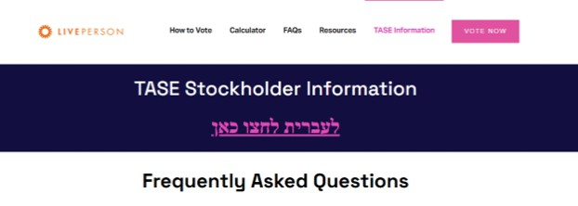

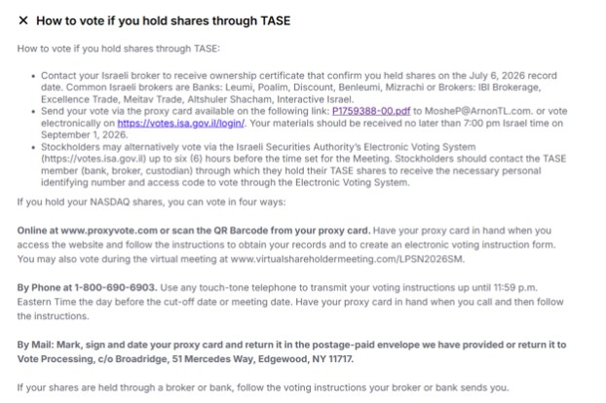

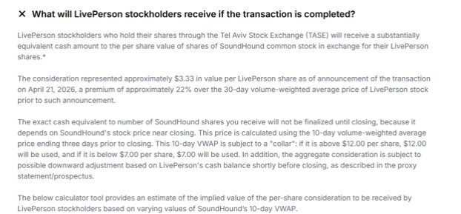

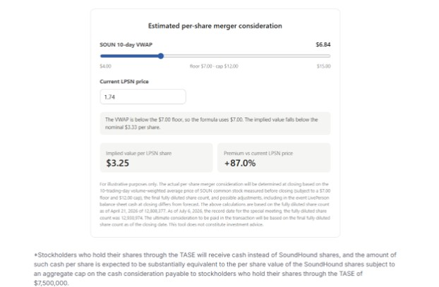

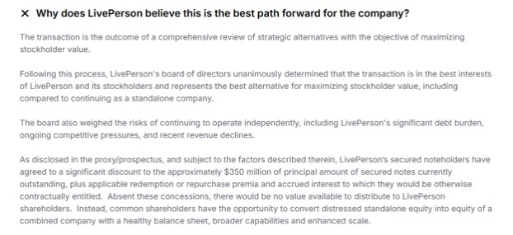

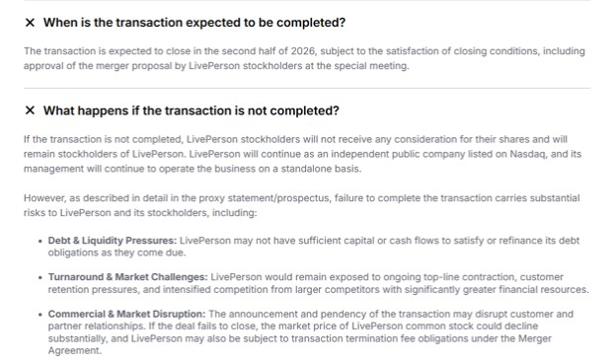

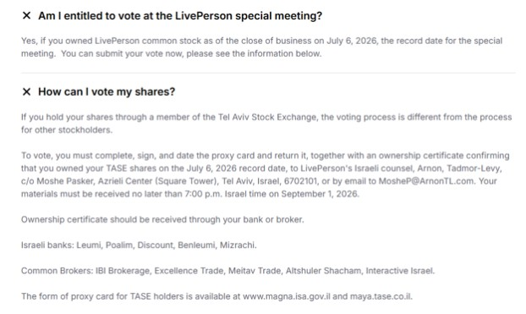

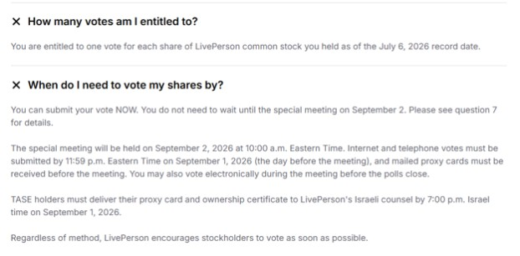

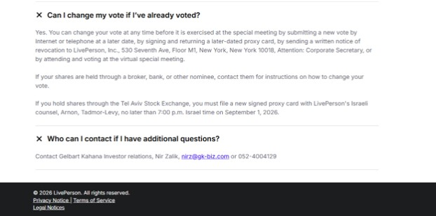

Forward-Looking Statements
This website contains “forward-looking statements” within the meaning of the U.S. federal securities laws about the expectations, beliefs, plans, intentions, prospects, financial results and strategies relating to SoundHound AI’s proposed acquisition of LivePerson. Such forward-looking statements include, among others, statements regarding the timing of filing the definitive proxy/prospectus and timing of LivePerson’s special meeting, obtaining regulatory approvals, the timing of closing of the proposed acquisition, and the parties’ expectations, intentions, strategies, assumptions or beliefs about future events, results of operations or performance or that do not solely relate to historical or current facts. Forward-looking statements are predictions, projections and other statements about future events or conditions that are based on current expectations and assumptions and, as a result, are subject to risks and uncertainties. Many factors could cause actual future events to differ materially from the forward-looking statements in this communication, including: (1) the occurrence of any event, change, or other circumstance that could give rise to the right of one or both of the parties to terminate the definitive merger agreement between LivePerson and SoundHound; (2) the possibility that the transaction does not close when expected or at all due to the failure to satisfy all of the conditions to closing on a timely basis or at all, including the failure to obtain the required shareholder approvals or to consummate the notes restructuring transactions contemplated by the Notes Restructuring Agreement; (3) the risk that the benefits from the transaction may not be fully realized or may take longer to realize than expected, including as a result of changes in, or problems arising from, general economic and market conditions, interest and exchange rates, monetary policy, trade policy (including tariff levels), laws and regulations and their enforcement, and the degree of competition in the geographic and business areas in which LivePerson and SoundHound operate; (4) any failure to promptly and effectively integrate the businesses of LivePerson and SoundHound; (5) the possibility that the transaction may be more expensive to complete than anticipated, including as a result of unexpected factors or events; (6) reputational risk and potential adverse reactions of LivePerson’s or SoundHound’s customers, employees or other business partners, including those resulting from the announcement, pendency or completion of the transaction; (7) the diversion of management’s attention and time to the transaction from ongoing business operations and opportunities; and (8) the outcome of any legal proceedings that may be instituted against LivePerson or SoundHound or in connection with the transaction. Further information on factors that could affect the forward-looking statements and expectations above are contained in the filings that LivePerson and/or SoundHound AI have filed, or that will be filed, with the U.S. Securities and Exchange Commission (the “SEC”), including as set forth in the Form S-4 and the proxy statement/prospectus contained therein, as well as the documents incorporated by reference therein.
All forward-looking statements are expressly qualified in their entirety by the cautionary statements set forth above. Forward-looking statements speak only as of the date they are made, and LivePerson does not undertake or assume any obligation to update publicly any of these statements to reflect actual results, new information or future events, changes in assumptions, or changes in other factors affecting forward-looking statements, except to the extent required by applicable law.

No Offer or Solicitation
This communication is not intended to be, and shall not constitute, an offer to sell, buy or exchange or the solicitation of an offer to sell, buy or exchange any securities, or a solicitation of any vote or approval, nor shall there be any sale of securities in any jurisdiction in which such offer, solicitation or sale would be unlawful prior to registration or qualification under the securities laws of any such jurisdiction. No offering of securities shall be made except by means of a prospectus meeting the requirements of Section 10 of the Securities Act.
Additional Information and Where to Find It
In connection with the proposed transaction, SoundHound AI has filed with the U.S. Securities and Exchange Commission (the “SEC”) a registration statement on Form S-4 (the “Form S-4”) that includes a definitive proxy statement of LivePerson and that constitutes a prospectus of SoundHound AI with respect to the shares of the SoundHound AI common stock to be issued in the proposed transaction, dated July 9, 2026 (the “proxy statement/prospectus”). The proxy statement/prospectus was filed with the SEC on July 9, 2026 by LivePerson, and the mailing of the proxy statement/prospectus to LivePerson’s stockholders began on or about the same date. Each of SoundHound AI and LivePerson may also file other relevant documents with the SEC regarding the proposed transaction.
This communication is not a substitute for the Form S-4, the proxy statement/prospectus or any other document that SoundHound AI or LivePerson has filed, or may file, with the SEC in connection with the proposed transaction. INVESTORS AND SECURITY HOLDERS OF SOUNDHOUND AI AND LIVEPERSON ARE URGED TO READ THE FORM S-4, THE PROXY STATEMENT/PROSPECTUS AND ANY OTHER RELEVANT DOCUMENTS FILED WITH THE SEC, AS WELL AS ANY AMENDMENTS OR SUPPLEMENTS TO THOSE DOCUMENTS, CAREFULLY IN THEIR ENTIRETY IF AND WHEN THEY BECOME AVAILABLE BECAUSE THEY WILL CONTAIN IMPORTANT INFORMATION ABOUT THE PROPOSED TRANSACTION. Investors and security holders will be able to obtain copies of these documents (if and when available), as well as other filings containing information about SoundHound AI and LivePerson, free of charge on the SEC’s website at www.sec.gov. Copies of the documents filed with, or furnished to, the SEC by the Company will be available free of charge on SoundHound AI’s website at https://investors.soundhound.com/financial-information/sec-filings. Copies of the documents filed with, or furnished to, the SEC by LivePerson will be available free of charge on LivePerson’s website at https://ir.liveperson.com/financial-information/sec-filings. The information included on, or accessible through, SoundHound AI’s or LivePerson’s website is not incorporated by reference into this communication.
Participants in the Solicitation
SoundHound, LivePerson and their respective directors and executive officers may be deemed to be participants in the solicitation of proxies with respect to the proposed transaction under the rules of the SEC. Information about the directors and executive officers of SoundHound, including a description of their direct or indirect interests, by security holdings or otherwise, is set forth in SoundHound’s definitive proxy statement for its 2026 annual meeting of stockholders under the heading “Proposal 1 – Election of Directors”, which was filed with the SEC on April 9, 2026 and is available at https://www.sec.gov/ix?doc=/Archives/edgar/data/0001840856/000121390026041978/ea0285618-01.htm . Information about the directors and executive officers of LivePerson and their ownership of

LivePerson equity interests can be found in the section entitled “Interests of LivePerson Directors and Executive Officers in the Mergers” and “Owners and Management of LivePerson” included in the proxy/prospectus, which was filed with the SEC on July 9, 2026 and is available at https://www.sec.gov/Archives/edgar/data/1102993/000121390026076759/ea0297465-01.htm. Further information about the directors and executive officers of LivePerson may be found in its amendment to its Annual Report on Form 10-K for the year ended December 31, 2025 under the headings “Directors, Executive Officers and Corporate Governance,” “Executive Compensation,” “Security Ownership of Certain Beneficial Owners and Management and Related Stockholder Matters” and is available at:
https://www.sec.gov/ix?doc=/Archives/edgar/data/0001102993/000110299326000020/lpsn-20251231.htm; in the Form 3 and Form 4 statements of beneficial ownership and statements of changes in beneficial ownership filed with the SEC by LivePerson’s directors and executive officers; and is in other documents filed by LivePerson with the SEC. Additional information regarding the interests of the participants in the solicitation of proxies will be included in other relevant materials to be filed with the SEC if and when they become available. You should read the Form S-4 and the proxy statement/prospectus carefully before making any voting or investment decisions. You may obtain free copies of these documents using the sources indicated above.

