UNITED STATES
SECURITIES AND EXCHANGE COMMISSION
Washington, D.C. 20549

SCHEDULE 14A
PROXY STATEMENT PURSUANT TO SECTION 14(a) OF THE
SECURITIES EXCHANGE ACT OF 1934

Filed by the Registrant ☒
Filed by a party other than the Registrant ☐
Check the appropriate box:

☐ | Preliminary Proxy Statement

☐ | Confidential, for Use of the Commission Only (as permitted by Rule 14a-6(e)(2))

☐ | Definitive Proxy Statement

☒ | Definitive Additional Materials

☐ | Soliciting Material Under §240.14a-12
LIVEPERSON, INC.
(Name of Registrant as Specified In Its Charter)
(Name of Person(s) Filing Proxy Statement, if other than the Registrant)
Payment of Filing Fee (Check all boxes that apply):

☒ | No fee required

☐ | Fee paid previously with preliminary materials

☐ | Fee computed on the table in exhibit required by Item 25(b) per Exchange Act Rules 14a-6(i)(1) and 0-11

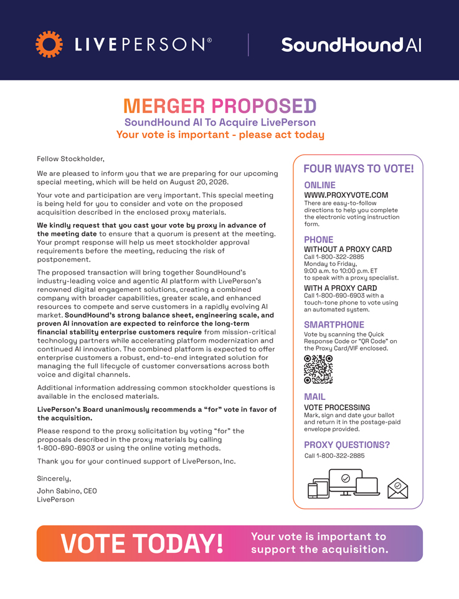
Fellow Stockholder, We are pleased to inform you that we are preparing for our upcoming FOUR WAYS TO VOTE! special meeting, which will be held on August 20, 2026. ONLINE Your vote and participation are very important. This special meeting WWW.PROXYVOTE.COM is being held for you to consider and vote on the proposed directions There are easy to help -to -you follow complete acquisition described in the enclosed proxy materials. the form electronic . voting instruction We kindly request that you cast your vote by proxy in advance of the meeting date to ensure that a quorum is present at the meeting. Your prompt response will help us meet stockholder approval PHONE requirements before the meeting, reducing the risk of WITHOUT Call 1-800-322 A PROXY -2885 CARD postponement. Monday 9:00 a.m .to to Friday, 10:00 p.m. ET The proposed transaction will bring together SoundHound’s industry-leading voice and agentic AI platform with LivePerson’s to speak with a proxy specialist. renowned digital engagement solutions, creating a combined Call WITH 1-800 A PROXY -690-6903 CARD with a company with broader capabilities, greater scale, and enhanced touch-tone phone to vote using resources to compete and serve customers in a rapidly evolving AI an automated system. market. SoundHound’s strong balance sheet, engineering scale, and proven AI innovation are expected to reinforce the long-term SMARTPHONE financial stability enterprise customers require from mission-critical Vote by scanning the Quick technology partners while accelerating platform modernization and Response Code or “QR Code” on continued AI innovation. The combined platform is expected to offer the Proxy Card/VIF enclosed. enterprise customers a robust, end-to-end integrated solution for managing the full lifecycle of customer conversations across both voice and digital channels. Additional information addressing common stockholder questions is available in the enclosed materials. MAIL LivePerson’s Board unanimously recommends a “for” vote in favor of VOTE Mark, sign PROCESSING and date your ballot the acquisition. envelope and return provided it in the. postage-paid Please respond to the proxy solicitation by voting “for” the proposals described in the proxy materials by calling PROXY QUESTIONS? 1-800-690-6903 or using the online voting methods. Call 1-800-322-2885 Thank you for your continued support of LivePerson, Inc. Sincerely, John Sabino, CEO LivePerson Your vote is important to support the acquisition.

