UNITED STATES

SECURITIES AND EXCHANGE COMMISSION

WASHINGTON, D.C. 20549

FORM 10-Q

(Mark One)

- QUARTERLY REPORT PURSUANT TO SECTION 13 OR 15(d) OF THE SECURITIES EXCHANGE ACT OF 1934

For the quarterly period ended September 30, 2023

or

- TRANSITION REPORT PURSUANT TO SECTION 13 OR 15(d) OF THE SECURITIES EXCHANGE ACT OF 1934 For the transition period from __________ to __________.

Commission File Number: 000-30141

 |  |  | LIVEPERSON, INC.
 | (Exact name of registrant as specified in its charter)
Delaware |  |  |  |  |  |  | 13-3861628
(State or other jurisdiction of |  |  |  |  |  |  | (IRS Employer Identification No.)
incorporation or organization)
530 7th Ave, Floor M1
New York, New York |  |  |  |  |  |  | 10018
(Address of principal executive offices) |  |  |  |  |  |  | (Zip Code)
 | (212) 609-4200
 | (Registrant’s telephone number, including area code)
Securities registered pursuant to Section 12(b) of the Act:
Title of each class |  |  | Trading Symbol(s) |  |  |  | Name of each exchange on which registered
Common Stock, par value $0.001 per share |  |  | LPSN |  |  |  | The Nasdaq Stock Market LLC

Indicate by check mark whether the registrant: (1) has filed all reports required to be filed by Section 13 or 15(d) of the Securities Exchange Act of 1934 during the preceding 12 months (or for such shorter period that the registrant was required to file such reports), and (2) has been subject to such filing requirements for the past 90 days. Yes ☒ No ☐

Indicate by check mark whether the registrant has submitted electronically every Interactive Data File required to be submitted pursuant to Rule 405 of Regulation S-T during the preceding 12 months (or for such shorter period that the registrant was required to submit such files). Yes ☒ No ☐

Indicate by check mark whether the registrant is a large accelerated filer, an accelerated filer, a non-accelerated filer, a smaller reporting company, or an emerging growth company. See the definitions of “large accelerated filer,” “accelerated filer,” “smaller reporting company,” and “emerging growth company” in Rule 12b-2 of the Exchange Act.

Large Accelerated Filer | ☒ | Accelerated Filer | ☐
Non-accelerated Filer | ☐ | Smaller Reporting Company | ☐
 |  | Emerging Growth Company | ☐

If an emerging growth company, indicate by check mark if the registrant has elected not to use the extended transition period for complying with any new or revised financial accounting standards provided pursuant to Section 13(a) of the Exchange Act. ☐

Indicate by check mark whether the registrant is a shell company (as defined in Rule 12b-2 of the Exchange Act). Yes ☐ No ☒ On November 3, 2023, 80,842,202 shares of the registrant’s common stock were outstanding.

1

LIVEPERSON, INC.

FORM 10-Q

FOR THE QUARTERLY PERIOD ENDED SEPTEMBER 30, 2023

INDEX

 |  |  |  |  |  |  |  |  |  |  |  |  |  |  | PART I. FINANCIAL INFORMATION |  |  |  |  |  |  |  |  |  | Page
Item 1. |  |  | Financial Statements (Unaudited): |  |  |  |  |  |  |  |  |  |  |  |  |  |  |  |  |  |  |  |  |  | 3
 |  |  |  | Condensed Consolidated Balance Sheets as of September 30, 2023 and December 31, 2022 |  |  |  |  |  |  |  |  |  |  |  |  |  |  |  |  |  |  |  |  | 4
 |  |  |  | Condensed Consolidated Statements of Operations for the Three and Nine Months Ended September 30, 2023 and 2022 |  |  |  |  |  |  |  |  |  |  |  |  |  |  |  |  |  |  |  |  | 5
 |  |  |  | Condensed Consolidated Statements of Comprehensive Loss for the Three and Nine Months Ended September 30, 2023 and 2022 |  |  |  |  |  |  |  |  |  |  |  |  |  |  |  |  |  |  |  |  | 6
 |  |  |  | Condensed Consolidated Statements of Stockholders’ Equity for the Three and Nine Months Ended September 30, 2023 and 2022 |  |  |  |  |  |  |  |  |  |  |  |  |  |  |  |  |  |  |  |  | 7
 |  |  |  | Condensed Consolidated Statements of Cash Flows for the Nine Months Ended September 30, 2023 and 2022 |  |  |  |  |  |  |  |  |  |  |  |  |  |  |  |  |  |  |  |  | 9
 |  |  |  | Notes to Condensed Consolidated Financial Statements |  |  |  |  |  |  |  |  |  |  |  |  |  |  |  |  |  |  |  |  | 11
Item 2. |  |  | Management’s Discussion and Analysis of Financial Condition and Results of Operations |  |  |  |  |  |  |  |  |  |  |  |  |  |  |  |  |  |  |  |  |  | 38
Item 3. |  |  | Quantitative and Qualitative Disclosures about Market Risk |  |  |  |  |  |  |  |  |  |  |  |  |  |  |  |  |  |  |  |  |  | 50
Item 4. |  |  | Controls and Procedures |  |  |  |  |  |  |  |  |  |  |  |  |  |  |  |  |  |  |  |  |  | 51
 |  |  |  |  |  |  |  |  |  |  |  |  |  |  |  | PART II. OTHER INFORMATION
Item 1. |  |  | Legal Proceedings |  |  |  |  |  |  |  |  |  |  |  |  |  |  |  |  |  |  |  |  |  | 51
Item 1A. |  |  | Risk Factors |  |  |  |  |  |  |  |  |  |  |  |  |  |  |  |  |  |  |  |  |  | 52
Item 2. |  |  | Unregistered Sales of Equity Securities and Use of Proceeds |  |  |  |  |  |  |  |  |  |  |  |  |  |  |  |  |  |  |  |  |  | 52
Item 3. |  |  | Defaults Upon Senior Securities |  |  |  |  |  |  |  |  |  |  |  |  |  |  |  |  |  |  |  |  |  | 53
Item 4. |  |  | Mine Safety Disclosures |  |  |  |  |  |  |  |  |  |  |  |  |  |  |  |  |  |  |  |  |  | 53
Item 5. |  |  | Other Information |  |  |  |  |  |  |  |  |  |  |  |  |  |  |  |  |  |  |  |  |  | 53
Item 6. |  |  | Exhibits |  |  |  |  |  |  |  |  |  |  |  |  |  |  |  |  |  |  |  |  |  | 54
Signatures |  |  |  |  |  |  |  |  |  |  |  |  |  |  |  |  |  |  |  |  |  |  |  |  | 55
 |  |  | 2

FORWARD-LOOKING STATEMENTS

Statements in this Quarterly Report on Form 10-Q about LivePerson, Inc. (“LivePerson”, the “Company,” “we,” “our” or “us”) that are not historical facts are forward-looking statements. These forward-looking statements are based on our current expectations, assumptions, estimates and projections about LivePerson and our industry. Our expectations, assumptions, estimates and projections are expressed in good faith, and we believe there is a reasonable basis for them, but we cannot assure you that our expectations, assumptions, estimates and projections will be realized. Examples of forward-looking statements include, but are not limited to, statements regarding future business, future results of operations or financial condition (including based on examinations of historical operating trends) and management strategies. Many of these statements are found in the “Business” and “Management’s Discussion and Analysis of Financial Condition and Results of Operations” sections of this Quarterly Report on Form 10-Q. When used in this Quarterly Report on Form 10-Q, the words “anticipates,” “believes,” “estimates,” “expects,” “intends,” “plans,” “projects” and variations of such words or similar expressions are intended to identify forward-looking statements. However, not all forward-looking statements contain these words. Forward-looking statements are subject to risks and uncertainties that could cause actual future events or results to differ materially from those expressed or implied in the forward-looking statements. Important factors that could cause our actual results to differ materially from the forward-looking statements we make in this Quarterly Report on Form 10-Q include those set forth our Annual Report on Form 10-K filed with the Securities and Exchange Commission (the “SEC”) on March 16, 2023 (as amended on May 1, 2023) in the section entitled Part I, Item 1A. “Risk Factors”. It is routine for our internal projections and expectations to change as the year or each quarter in the year progresses, and therefore it should be clearly understood that the internal projections and beliefs upon which we base our expectations may change prior to the end of each quarter or the year. Although these expectations may change, we are under no obligation to inform you if they do. Our policy is generally to provide our expectations only once per quarter, and not to update that information until the next quarter. We do not undertake any obligation to revise forward-looking statements to reflect future events or circumstances. All forward-looking statements are made pursuant to the safe harbor provisions of the Private Securities Litigation Reform Act of 1995.

Part I — FINANCIAL INFORMATION

Item 1. Financial Statements

3

LIVEPERSON, INC.

CONDENSED CONSOLIDATED BALANCE SHEETS

(UNAUDITED)

 |  | September 30, |  |  | December 31,
 |  | 2023 |  |  | 2022
 |  | (In thousands)
ASSETS
Current assets:
Cash and cash equivalents | $ | 212,189 |  | $ | 391,781
Restricted cash |  | 2,143 |  |  | 417
Accounts receivable, net of allowance for credit losses of $8,728 and $9,239 as of September 30, 2023 and December 31, 2022, respectively |  | 99,867 |  |  | 86,537
Prepaid expenses and other current assets |  | 41,201 |  |  | 23,747
Assets held for sale |  | — |  |  | 30,984
Total current assets |  | 355,400 |  |  | 533,466
Operating lease right of use assets (Note 10) |  | 4,386 |  |  | 1,604
Property and equipment, net (Note 6) |  | 123,468 |  |  | 126,499
Contract acquisition costs |  | 35,953 |  |  | 43,804
Intangible assets, net (Note 5) |  | 64,781 |  |  | 78,103
Goodwill (Note 5) |  | 283,759 |  |  | 296,214
Deferred tax assets |  | 4,486 |  |  | 4,423
Investment in joint venture (Note 17) |  | — |  |  | 2,264
Other assets |  | 1,212 |  |  | 2,563
Total assets | $ | 873,445 |  | $ | 1,088,940
LIABILITIES AND STOCKHOLDERS’ EQUITY
Current liabilities:
Accounts payable | $ | 14,098 |  | $ | 25,303
Accrued expenses and other current liabilities (Note 7) |  | 123,132 |  |  | 129,244
Deferred revenue (Note 2) |  | 96,783 |  |  | 84,494
Convertible senior notes (Note 8) |  | 72,245 |  |  | —
Operating lease liabilities (Note 10) |  | 2,194 |  |  | 2,160
Liabilities associated with assets held for sale |  | — |  |  | 10,357
Total current liabilities |  | 308,452 |  |  | 251,558
Deferred revenue, net of current portion (Note 2) |  | 393 |  |  | 174
Convertible senior notes, net of current portion (Note 8) |  | 511,055 |  |  | 737,423
Operating lease liabilities, net of current portion (Note 10) |  | 2,932 |  |  | 682
Deferred tax liabilities |  | 2,762 |  |  | 2,550
Other liabilities |  | 2,770 |  |  | 28,465
Total liabilities |  | 828,364 |  |  | 1,020,852
Commitments and contingencies (Note 12)
Stockholders’ equity:
Preferred stock, $0.001 par value - 5,000,000 shares authorized, none issued |  | — |  |  | —
Common stock, $0.001 par value - 200,000,000 shares authorized, 81,190,772 and 78,350,984 shares issued, 78,424,699 and 75,584,911 shares |  | 81 |  |  | 78
outstanding as of September 30, 2023 and December 31, 2022, respectively |  | 81 |  |  | 78
Additional paid-in capital |  | 872,958 |  |  | 771,052
Treasury stock - 2,766,073 shares at September 30, 2023 and December 31, 2022 |  | (3) |  |  | (3)
Accumulated deficit |  | (816,372) |  |  | (692,362)
Accumulated other comprehensive loss |  | (11,583) |  |  | (10,677)
Total stockholders’ equity |  | 45,081 |  |  | 68,088
Total liabilities and stockholders’ equity | $ | 873,445 |  | $ | 1,088,940

See accompanying notes to unaudited condensed consolidated financial statements.

4

LIVEPERSON, INC.

CONDENSED CONSOLIDATED STATEMENTS OF OPERATIONS

(UNAUDITED)

 |  | Three Months Ended September 30, |  |  |  |  |  | Nine Months Ended September 30,
 |  | 2023 |  |  | 2022 |  |  | 2023 |  |  | 2022
 |  |  |  |  | (In thousands, except share and per share amounts)
Revenue | $ | 101,332 |  | $ | 129,561 |  | $ | 306,515 |  | $ | 392,323
Costs, expenses and other: ⁽¹⁾ ⁽²⁾
Cost of revenue ⁽³⁾ |  | 31,980 |  |  | 43,681 |  |  | 105,964 |  |  | 138,297
Sales and marketing |  | 32,118 |  |  | 49,448 |  |  | 93,312 |  |  | 167,563
General and administrative |  | 30,448 |  |  | 32,171 |  |  | 70,065 |  |  | 92,152
Product development |  | 35,575 |  |  | 44,744 |  |  | 94,933 |  |  | 156,568
Impairment of goodwill |  | 11,895 |  |  | — |  |  | 11,895 |  |  | —
Restructuring costs |  | 2,097 |  |  | 7,111 |  |  | 15,999 |  |  | 17,949
Gain on divestiture |  | — |  |  | — |  |  | (17,591) |  |  | —
Amortization of purchased intangible assets |  | 894 |  |  | 920 |  |  | 2,644 |  |  | 2,742
Total costs, expenses and other |  | 145,007 |  |  | 178,075 |  |  | 377,221 |  |  | 575,271
Loss from operations |  | (43,675) |  |  | (48,514) |  |  | (70,706) |  |  | (182,948)
Other income (expense), net:
Interest income (expense), net |  | 1,068 |  |  | 401 |  |  | 3,005 |  |  | (1,713)
Other (expense) income, net |  | (10,164) |  |  | 5,114 |  |  | 9,391 |  |  | 1,908
Total other (expense) income |  | (9,096) |  |  | 5,515 |  |  | 12,396 |  |  | 195
Loss before provision for income taxes |  | (52,771) |  |  | (42,999) |  |  | (58,310) |  |  | (182,753)
Provision for income taxes |  | 541 |  |  | 249 |  |  | 1,600 |  |  | 1,270
Net loss | $ | (53,312) |  | $ | (43,248) |  | $ | (59,910) |  | $ | (184,023)
Net loss per share of common stock:
Basic | $ | (0.68) |  | $ | (0.56) |  | $ | (0.78) |  | $ | (2.39)
Diluted | $ | (0.68) |  | $ | (0.56) |  | $ | (0.78) |  | $ | (2.39)
Weighted average shares outstanding:
Basic |  | 78,005,210 |  |  | 77,784,346 |  |  | 76,902,316 |  |  | 76,969,629
Diluted
Diluted |  | 78,005,210 |  |  | 77,784,346 |  |  | 76,902,316 |  |  | 76,969,629

- Amounts include stock-based compensation expense, as follows:

Cost of revenue | $ | 76 | $ | 2,905 | $ | 879 | $ | 9,156
Sales and marketing |  | 2,726 |  | 6,021 |  | 7,429 |  | 18,612
General and administrative |  | 5,180 |  | 12,034 |  | (6,070) |  | 35,703
Product development |  | 3,314 |  | 10,980 |  | 2,242 |  | 36,852
⁽²⁾ Amounts include depreciation expense, as follows:
Cost of revenue | $ | 1,949 | $ | 2,402 | $ | 6,382 | $ | 7,398
Sales and marketing |  | 809 |  | 637 |  | 2,276 |  | 1,794
General and administrative |  | 73 |  | 109 |  | 373 |  | 342
Product development |  | 4,933 |  | 3,915 |  | 15,821 |  | 11,880
⁽³⁾ Amounts include amortization of purchased intangibles and finance leases, as follows:
Cost of revenue | $ | 7,545 | $ | 4,811 | $ | 16,684 | $ | 13,788

See accompanying notes to unaudited condensed consolidated financial statements

5

LIVEPERSON, INC.

CONDENSED CONSOLIDATED STATEMENTS OF COMPREHENSIVE LOSS

(UNAUDITED)

 | Three Months Ended September 30, |  |  |  |  |  |  | Nine Months Ended September 30,
 | 2023 |  |  |  | 2022 |  |  | 2023 |  |  | 2022
 |  |  |  |  | (In thousands)
Net loss | $ | (53,312) |  | $ | (43,248) |  | $ | (59,910) |  | $ | (184,023)
Foreign currency translation adjustment |  | (2,158) |  |  | (5,026) |  |  | (906) |  |  | (11,524)
Comprehensive loss | $ | (55,470) |  | $ | (48,274) |  | $ | (60,816) |  | $ | (195,547)

See accompanying notes to unaudited condensed consolidated financial statements.

6

LIVEPERSON, INC.

CONDENSED CONSOLIDATED STATEMENTS OF STOCKHOLDERS’ EQUITY

(UNAUDITED)

 |  |  |  |  |  |  |  |  |  |  |  | Additional |  |  |  |  |  | Accumulated
 | Common Stock |  |  |  |  | Treasury Stock |  |  |  |  |  |  |  |  |  |  |  | Other
 |  |  |  |  |  |  |  |  |  |  |  | Paid-in |  |  | Accumulated |  |  | Comprehensive |  |  | Total Stockholders’
 | Shares |  |  | Amount |  | Shares |  |  | Amount |  |  | Capital |  |  | Deficit |  |  | Loss |  |  | Equity
 |  |  |  |  |  |  |  |  | (In thousands, except share data)
Balance as of December 31, 2022 | 78,350,984 |  | $ | 78 |  | (2,766,073) |  | $ | (3) |  | $ | 771,052 |  | $ | (692,362) |  | $ | (10,677) |  | $ | 68,088
Common stock issued upon exercise of stock | 18,687 |  |  | — |  | — |  |  | — |  |  | 130 |  |  | — |  |  | — |  |  | 130
options | 18,687 |  |  |  |  |  |  |  |  |  |  | 130 |  |  |  |  |  |  |  |  | 130
Common stock issued upon vesting of restricted | 413,252 |  |  | 1 |  | — |  |  | — |  |  | — |  |  | — |  |  | — |  |  | 1
stock units | 413,252 |  |  | 1 |  |  |  |  |  |  |  |  |  |  |  |  |  |  |  |  | 1
Stock-based compensation | — |  |  | — |  | — |  |  | — |  |  | 9,560 |  |  | — |  |  | — |  |  | 9,560
Common stock issued under Employee Stock | 87,794 |  |  | — |  | — |  |  | — |  |  | 724 |  |  | — |  |  | — |  |  | 724
Purchase Plan (ESPP) | 87,794 |  |  |  |  |  |  |  |  |  |  | 724 |  |  |  |  |  |  |  |  | 724
Issuance of common stock in connection with | — |  |  | — |  | — |  |  | — |  |  | 380 |  |  | — |  |  | — |  |  | 380
acquisitions (Note 9) |  |  |  |  |  |  |  |  |  |  |  | 380 |  |  |  |  |  |  |  |  | 380
Activity related to divestiture (Note 20) | — |  |  | — |  | — |  |  | — |  |  | 66,775 |  |  | (64,100) |  |  | 57 |  |  | 2,732
Net loss | — |  |  | — |  | — |  |  | — |  |  | — |  |  | (17,420) |  |  | — |  |  | (17,420)
Other comprehensive loss | — |  |  | — |  | — |  |  | — |  |  | — |  |  | — |  |  | 809 |  |  | 809
Balance as of March 31, 2023 | 78,870,717 |  | $ | 79 |  | (2,766,073) |  | $ | (3) |  | $ | 848,621 |  | $ | (773,882) |  | $ | (9,811) |  | $ | 65,004
Common stock issued upon exercise of stock | 11,154 |  |  | — |  | — |  |  | — |  |  | 8 |  |  | — |  |  | — |  |  | 8
options | 11,154 |  |  |  |  |  |  |  |  |  |  | 8 |  |  |  |  |  |  |  |  | 8
Common stock issued upon vesting of restricted | 295,564 |  |  | — |  | — |  |  | — |  |  | — |  |  | — |  |  | — |  |  | —
stock units | 295,564 |  |  |  |  |  |  |  |  |  |  |  |  |  |  |  |  |  |  |  | —
Stock-based compensation | — |  |  | — |  | — |  |  | — |  |  | 8,380 |  |  | — |  |  | — |  |  | 8,380
Common stock issued under ESPP | 97,832 |  |  | — |  | — |  |  | — |  |  | 397 |  |  | — |  |  | — |  |  | 397
Issuance of common stock in connection with | 1,036,823 |  |  | 1 |  | — |  |  | — |  |  | 5,147 |  |  | — |  |  | — |  |  | 5,148
acquisitions (Note 9) | 1,036,823 |  |  | 1 |  |  |  |  |  |  |  | 5,147 |  |  |  |  |  |  |  |  | 5,148
Net income | — |  |  | — |  | — |  |  | — |  |  | — |  |  | 10,822 |  |  | — |  |  | 10,822
Other comprehensive loss | — |  |  | — |  | — |  |  | — |  |  | — |  |  | — |  |  | 386 |  |  | 386
Balance as of June 30, 2023 | 80,312,090 |  | $ | 80 |  | (2,766,073) |  | $ | (3) |  | $ | 862,553 |  | $ | (763,060) |  | $ | (9,425) |  | $ | 90,145
Common stock issued upon exercise of stock | 17,727 |  |  | — |  | — |  |  | — |  |  | 15 |  |  | — |  |  | — |  |  | 15
options | 17,727 |  |  |  |  |  |  |  |  |  |  | 15 |  |  |  |  |  |  |  |  | 15
Common stock issued upon vesting of restricted | 588,159 |  |  | 1 |  | — |  |  | — |  |  | 1 |  |  | — |  |  | — |  |  | 2
stock units | 588,159 |  |  | 1 |  |  |  |  |  |  |  | 1 |  |  |  |  |  |  |  |  | 2
Issuance of common stock in connection with | 190,042 |  |  | — |  | — |  |  | — |  |  | 1,192 |  |  | — |  |  | — |  |  | 1,192
acquisitions (Note 9) | 190,042 |  |  |  |  |  |  |  |  |  |  | 1,192 |  |  |  |  |  |  |  |  | 1,192
Stock-based compensation | — |  |  | — |  | — |  |  | — |  |  | 8,849 |  |  | — |  |  | — |  |  | 8,849
Common stock issued under ESPP | 82,747 |  |  | — |  | — |  |  | — |  |  | 348 |  |  | — |  |  | — |  |  | 348
Net loss | — |  |  | — |  | — |  |  | — |  |  | — |  |  | (53,312) |  |  |  |  |  | (53,312)
Other comprehensive loss | — |  |  | — |  | — |  |  | — |  |  | — |  |  | — |  |  | (2,158) |  |  | (2,158)
Balance as of September 30, 2023 | 81,190,765 |  | $ | 81 |  | (2,766,073) |  | $ | (3) |  | $ | 872,958 |  | $ | (816,372) |  | $ | (11,583) |  | $ | 45,081

See accompanying notes to unaudited condensed consolidated financial statements.

7

 |  |  |  |  |  |  |  |  |  |  |  | Additional |  |  |  |  |  | Accumulated |  |  | Total
 | Common Stock |  |  |  |  | Treasury Stock |  |  |  |  |  |  |  |  |  |  |  | Other |  |  | Total
 |  |  |  |  |  |  |  |  |  |  |  | Paid-in |  |  | Accumulated |  |  | Comprehensive |  |  | Stockholders’
 | Shares |  |  | Amount |  | Shares |  |  | Amount |  |  | Capital |  |  | Deficit |  |  | Loss |  |  | Equity
 |  |  |  |  |  |  |  |  | (In thousands, except share data)
Balance as of December 31, 2021 | 74,980,546 |  | $ | 75 |  | (2,746,243) |  | $ | (3) |  | $ | 871,788 |  | $ | (516,859) |  | $ | (5,564) |  | $ | 349,437
Cumulative adjustment due to adoption of ASU | — |  |  | — |  | — |  |  | — |  |  | (209,651) |  |  | 50,244 |  |  | — |  |  | (159,407)
2020-06 |  |  |  |  |  |  |  |  |  |  |  | (209,651) |  |  | 50,244 |  |  |  |  |  | (159,407)
Common stock issued upon exercise of stock | 40,483 |  |  | — |  | — |  |  | — |  |  | 506 |  |  | — |  |  | — |  |  | 506
options | 40,483 |  |  |  |  |  |  |  |  |  |  | 506 |  |  |  |  |  |  |  |  | 506
Common stock issued upon vesting of RSUs | 444,043 |  |  | — |  | — |  |  | — |  |  | — |  |  | — |  |  | — |  |  | —
Stock-based compensation | — |  |  | — |  | — |  |  | — |  |  | 20,522 |  |  | — |  |  | — |  |  | 20,522
Cash awards settled in shares of the Company’s | 735,519 |  |  | 1 |  | — |  |  | — |  |  | 17,298 |  |  | — |  |  | — |  |  | 17,299
common stock | 735,519 |  |  | 1 |  |  |  |  |  |  |  | 17,298 |  |  |  |  |  |  |  |  | 17,299
Common stock issued under Employee Stock | 82,100 |  |  | — |  | — |  |  | — |  |  | 1,415 |  |  | — |  |  | — |  |  | 1,415
Purchase Plan | 82,100 |  |  |  |  |  |  |  |  |  |  | 1,415 |  |  |  |  |  |  |  |  | 1,415
Issuance of common stock in connection with | 779,946 |  |  | 1 |  | — |  |  | — |  |  | 17,636 |  |  | — |  |  | — |  |  | 17,637
acquisitions | 779,946 |  |  | 1 |  |  |  |  |  |  |  | 17,636 |  |  |  |  |  |  |  |  | 17,637
Net loss | — |  |  | — |  | — |  |  | — |  |  | — |  |  | (65,364) |  |  | — |  |  | (65,364)
Other comprehensive loss | — |  |  | — |  | — |  |  | — |  |  | — |  |  | — |  |  | (1,699) |  |  | (1,699)
Balance as of March 31, 2022 | 77,062,637 |  | $ | 77 |  | (2,746,243) |  | $ | (3) |  | $ | 719,514 |  | $ | (531,979) |  | $ | (7,263) |  | $ | 180,346
Common stock issued upon exercise of stock | 25,295 |  |  | — |  | — |  |  | — |  |  | 389 |  |  | — |  |  | — |  |  | 389
options | 25,295 |  |  |  |  |  |  |  |  |  |  | 389 |  |  |  |  |  |  |  |  | 389
Common stock issued upon vesting of RSUs | 372,500 |  |  | 1 |  | — |  |  | — |  |  | — |  |  | — |  |  | — |  |  | 1
Stock-based compensation | — |  |  | — |  | — |  |  | — |  |  | 18,826 |  |  | — |  |  | — |  |  | 18,826
Common stock issued under Employee Stock | 99,495 |  |  | — |  | — |  |  | — |  |  | 1,403 |  |  | — |  |  | — |  |  | 1,403
Purchase Plan | 99,495 |  |  |  |  |  |  |  |  |  |  | 1,403 |  |  |  |  |  |  |  |  | 1,403
Net loss | — |  |  | — |  | — |  |  | — |  |  | — |  |  | (75,411) |  |  | — |  |  | (75,411)
Other comprehensive loss | — |  |  | — |  | — |  |  | — |  |  | — |  |  | — |  |  | (4,799) |  |  | (4,799)
Balance as of June 30, 2022 | 77,559,927 |  | $ | 78 |  | (2,746,243) |  | $ | (3) |  | $ | 740,132 |  | $ | (607,390) |  | $ | (12,062) |  | $ | 120,755
Common stock issued upon exercise of stock | 134,423 |  |  | — |  | — |  |  | — |  |  | 343 |  |  | — |  |  | — |  |  | 343
options | 134,423 |  |  |  |  |  |  |  |  |  |  | 343 |  |  |  |  |  |  |  |  | 343
Common stock issued upon vesting of RSUs | 161,272 |  |  | — |  | — |  |  | — |  |  | — |  |  | — |  |  | — |  |  | —
Stock-based compensation | — |  |  | — |  | — |  |  | — |  |  | 15,843 |  |  | — |  |  | — |  |  | 15,843
Common stock issued under Employee Stock | 78,818 |  |  | — |  | — |  |  | — |  |  | 844 |  |  | — |  |  | — |  |  | 844
Purchase Plan | 78,818 |  |  |  |  |  |  |  |  |  |  | 844 |  |  |  |  |  |  |  |  | 844
Net loss | — |  |  | — |  | — |  |  | — |  |  | — |  |  | (43,248) |  |  | — |  |  | (43,248)
Other comprehensive loss | — |  |  | — |  | — |  |  | — |  |  | — |  |  | — |  |  | (5,026) |  |  | (5,026)
Balance as of September 30, 2022 | 77,934,440 |  | $ | 78 |  | (2,746,243) |  | $ | (3) |  | $ | 757,162 |  | $ | (650,638) |  | $ | (17,088) |  | $ | 89,511

See accompanying notes to unaudited condensed consolidated financial statements.

8

LIVEPERSON, INC.

CONDENSED CONSOLIDATED STATEMENTS OF CASH FLOWS

(UNAUDITED)

 |  | Nine Months Ended September 30,
 |  | 2023 |  |  | 2022
 |  | (In thousands)
OPERATING ACTIVITIES:
Net Loss | $ | (59,910) |  | $ | (184,023)
Adjustments to reconcile net loss to net cash used in operating activities:
Stock-based compensation expense |  | 4,480 |  |  | 100,323
Depreciation |  | 24,852 |  |  | 21,414
Amortization of purchased intangible assets and finance leases |  | 16,369 |  |  | 16,530
Amortization of debt issuance costs |  | 3,384 |  |  | 2,831
Impairment of goodwill |  | 11,895 |  |  | —
Impairment of intangible assets |  | 2,959 |  |  | —
Change in fair value of contingent consideration |  | 5,442 |  |  | (8,568)
Gain on repurchase of convertible notes |  | (7,200) |  |  | —
Allowance for credit losses |  | 2,653 |  |  | 4,669
Gain on divestiture |  | (17,591) |  |  | —
Deferred income taxes |  | 741 |  |  | 770
Equity loss in joint venture |  | 2,264 |  |  | —
Changes in operating assets and liabilities, net of acquisitions:
Accounts receivable |  | (16,390) |  |  | (13,856)
Prepaid expenses and other current assets |  | (18,028) |  |  | (13,519)
Contract acquisition costs non-current |  | 6,189 |  |  | (2,842)
Other assets |  | 1,390 |  |  | (123)
Accounts payable |  | (13,420) |  |  | (4,229)
Accrued expenses and other current liabilities |  | 21,225 |  |  | (12,234)
Deferred revenue |  | 12,691 |  |  | 7,450
Operating lease assets and liabilities, net |  | (500) |  |  | (2,148)
Other liabilities |  | (7,797) |  |  | 8,084
Net cash used in operating activities |  | (24,302) |  |  | (79,471)
INVESTING ACTIVITIES:
Purchases of property and equipment, including capitalized software |  | (22,437) |  |  | (35,212)
Payments for acquisitions, net of cash acquired |  | — |  |  | (3,458)
Purchases of intangible assets |  | (3,245) |  |  | (1,394)
Proceeds from divestiture |  | 13,819 |  |  | —
Investment in joint venture |  | — |  |  | (3,993)
Net cash used in investing activities |  | (11,863) |  |  | (44,057)
FINANCING ACTIVITIES:
Principal payments for financing leases |  | (2,468) |  |  | (2,785)
Proceeds from issuance of common stock in connection with the exercise of options and ESPP |  | 1,622 |  |  | 1,238
Payments on repurchase of convertible senior notes |  | (149,702) |  |  | —
Net cash used in financing activities |  | (150,548) |  |  | (1,547)
Effect of foreign exchange rate changes on cash and cash equivalents |  | (1,164) |  |  | (4,713)
Net decrease in cash, cash equivalents, and restricted cash |  | (187,877) |  |  | (129,788)
Cash, cash equivalents, and restricted cash - beginning of year |  | 392,198 |  |  | 523,532
Plus: cash classified within current assets held for sale - beginning of year |  | 10,011 |  |  | —
Cash, cash equivalents, and restricted cash - end of period | $ | 214,332 |  | $ | 393,744

9

 | Nine Months Ended September 30,
 | 2023 |  |  |  | 2022
 |  | (In thousands)
Reconciliation of cash, cash equivalents, and restricted cash to condensed consolidated balance sheets
Cash and cash equivalents | $ | 212,189 |  | $ | 393,330
Restricted cash |  | 2,143 |  |  | 414
Total cash, cash equivalents, and restricted cash - end of period | $ | 214,332 |  | $ | 393,744
Supplemental disclosure of other cash flow information:
Cash paid for income taxes, net | $ | 998 |  | $ | 3,079
Cash paid for interest |  | 909 |  |  | 1,895
Supplemental disclosure of non-cash investing and financing activities:
Purchase of property and equipment and intangible assets recorded in accounts payable | $ | 548 |  | $ | 113
Right of use assets obtained in exchange for operating lease liabilities |  | 4,817 |  |  | 2,417
Increase in convertible senior notes, net upon adoption of ASU 2020-06 (Note 1) |  | — |  |  | 159,407
Issuance of shares of common stock to settle cash awards |  | — |  |  | 17,298
Supplemental disclosure of non-cash financing activities related to the WildHealth acquisition in February 2022 (Note 9):
Issuance of shares of common stock | $ | — |  | $ | 17,675
Fair value of contingent earn-out recorded in connection with WildHealth transaction |  | — |  |  | 38,151
Supplemental disclosure of non-cash financing activities related to the e-bot7 acquisition in July 2021:
Fair value of contingent earn-out recorded in connection with e-bot7 transaction | $ | — |  | $ | 6,113

See accompanying notes to unaudited condensed consolidated financial statements.

10

NOTES TO CONDENSED CONSOLIDATED FINANCIAL STATEMENTS

(UNAUDITED)

Note 1. Description of Business and Basis of Presentation

LivePerson, Inc. (“LivePerson”, the “Company”, “we”, “our” or “us”) is a global leader in AI-powered customer conversations. Consumers have made mobile devices the center of their digital lives, and they have made digital conversational experiences the center of communication with friends, family and peers. Since 1998, LivePerson has enabled billions of meaningful connections between consumers and our customers on our platform. These speech or text conversations decrease costs and increase revenue for our brands by harnessing the power of AI for convenient, personalized and content-rich journeys across the entire consumer lifecycle, and across consumer platforms. AI has accelerated our capability to leverage those prior conversations to enhance the consumer experience and to improve results for our customers by empowering them to leverage the latest developments in AI, including Generative AI and Large Language Models (“LLMs”), in a safe and secure environment.

The Conversational Cloud, the Company’s enterprise-class cloud-based platform, enables businesses to have conversations with millions of consumers as personally as they would with a single consumer. The Conversational Cloud powers conversations across each of a brand’s primary digital channels, including mobile apps, mobile and desktop web browsers, SMS, social media and third-party consumer messaging platforms. Brands can also use the Conversational Cloud to message consumers when they dial a 1-800 number instead of forcing them to navigate interactive voice response systems (“IVRs”) and wait on hold. Similarly, the Conversational Cloud can ingest traditional emails and convert them into messaging conversations, or embed messaging conversations directly into web advertisements, rather than redirect consumers to static website landing pages. Agents can manage all conversations with consumers through a single console interface, regardless of where the conversations originated. Most recently, the Conversational Cloud has been enhanced to provide a secure platform with the necessary guardrails to deploy Generative AI and LLMs in ways that help consumers and drive results for brands without sacrificing trust.

LivePerson’s robust, cloud-based suite of rich messaging, real-time chat, LLM, AI and automation offerings features consumer and agent facing bots, intelligent routing and capacity mapping, real-time intent detection and analysis, queue prioritization, customer sentiment, analytics and reporting, content delivery, Payment Card Industry (“PCI”) compliance, co-browsing and a sophisticated proactive targeting engine. An extensible application programming interface (“API”) stack facilitates a lower cost of ownership by facilitating robust integration into back-end systems, as well as enabling developers to build their own programs and services on top of the platform. More than 40 APIs and software development kits are available on the Conversational Cloud.

LivePerson’s Conversational AI platform enables what the Company calls “the tango” of humans, AI and bots, whereby human agents act as bot managers, overseeing AI-powered conversations and seamlessly stepping into the flow when a personal touch is needed. Agents become ultra-efficient, leveraging the AI engine to serve up relevant content, define next-best actions and take over repetitive transactional work so that the agent can focus on relationship building. By seamlessly integrating messaging with the Company’s proprietary Conversational AI, as well as third-party bots, the Conversational Cloud offers brands a comprehensive approach to scaling automations across their millions of customer conversations.

Complementing the Company’s proprietary messaging and Conversational AI offerings are teams of technical, solutions and consulting professionals that have developed deep domain expertise in the implementation and optimization of conversational services across industries and messaging endpoints. LivePerson’s products, coupled with our domain knowledge, industry expertise and professional services, have been proven to maximize the impact of Conversational AI, unlock the power of Generative AI and LLMs in safe and responsible ways, and deliver measurable return on investment for our customers.

LivePerson was incorporated in the State of Delaware in November 1995 and the LivePerson service was introduced in November 1998. The Company completed an initial public offering in April 2000 and is currently traded on the Nasdaq Global Select Market (“Nasdaq”) and the Tel Aviv Stock Exchange. LivePerson is headquartered in New York City.

Basis of Presentation

The accompanying condensed consolidated financial statements, and the financial data and other information disclosed in the notes to the condensed consolidated financial statements as of September 30, 2023 and for the three and nine months ended September 30, 2023 are unaudited. In the opinion of management, the unaudited condensed consolidated financial statements have been prepared on the same basis as the annual financial statements and reflect all adjustments, which include

11

NOTES TO CONDENSED CONSOLIDATED FINANCIAL STATEMENTS

(UNAUDITED)

only normal recurring adjustments necessary for a fair presentation of the Company’s condensed consolidated financial position, results of operations, comprehensive loss, and cash flows for the interim periods presented. The results of operations for any interim period are not necessarily indicative of the results of operations for any other future interim period or for a full fiscal year. The condensed consolidated balance sheet as of December 31, 2022 has been derived from audited consolidated financial statements at that date.

Certain information and note disclosures normally included in financial statements prepared in accordance with generally accepted accounting principles in the United States (“GAAP”) have been condensed or omitted pursuant to the rules and regulations of the Securities and Exchange Commission (the “SEC”). These unaudited interim condensed consolidated financial statements should be read in conjunction with the Company’s audited consolidated financial statements and notes thereto for the year ended December 31, 2022 included in the Company’s Annual Report on Form 10-K filed with the SEC on March 16, 2023.

Principles of Consolidation

The unaudited condensed consolidated financial statements reflect the operations of LivePerson and its wholly-owned subsidiaries. All intercompany balances and transactions have been eliminated in consolidation.

Equity Method Investment

The Company utilizes the equity method to account for investments when it possesses the ability to exercise significant influence, but not control, over the operating and financial policies of the investee. The ability to exercise significant influence is presumed when an investor possesses 20% or more of the voting interests of the investee, and conversely, the ability to exercise significant influence is presumed not to exist when an investor possesses less than 20% of the voting interests of the investee. These presumptions may be overcome based on specific facts and circumstances that demonstrate an ability to exercise significant influence is restricted or demonstrate an ability to exercise significant influence notwithstanding a smaller voting interest, such as with the Company’s 19.2% equity method investment in Claire Holdings, Inc. (“Claire”), due to the Company’s seat on the entity’s board of directors, which provides the Company the ability to exert significant influence. In applying the equity method, the Company records the investment at cost and subsequently increases or decreases the carrying amount of the investment by its proportionate share of the net earnings or losses. The Company records dividends or other equity distributions as reductions in the carrying value of the investment. The Company assesses the carrying value of equity method investment on a periodic basis to see if there has been a decline in carrying value that is not temporary. When deciding whether a decline in carrying value is more than temporary, a number of factors are considered, including the investee’s financial condition and business prospects, as well as the Company’s investment intentions.

Variable Interest Entities

The condensed consolidated financial statements include the financial statements of LivePerson, its wholly owned subsidiaries, and each variable interest entity (“VIE”) for which the Company is the primary beneficiary. The Company consolidates entities in which it has a controlling financial interest. All intercompany balances and transactions have been eliminated in consolidation.

The Company evaluates whether an entity in which it has a variable interest is considered a variable interest entity. VIEs are generally entities that have either a total equity investment that is insufficient to permit the entity to finance its activities without additional subordinated financial support, or whose equity investors lack the characteristics of a controlling financial interest (i.e., ability to make significant decisions through voting rights and a right to receive the expected residual returns of the entity or an obligation to absorb the expected losses of the entity).

Under the provisions of Accounting Standards Codification (“ASC”) 810, “Consolidation”, an entity consolidates a VIE if it is determined to be the primary beneficiary of the VIE. The primary beneficiary has both (a) the power to direct the activities of the VIE that most significantly impact the entity’s economic performance, and (b) the obligation to absorb losses or the right to receive benefits from the VIE that could potentially be significant to the VIE. The Company periodically reassesses whether it is the primary beneficiary of a VIE. See Note 18 – Variable Interest Entities for the Company’s assessment of VIEs.

Use of Estimates

12

NOTES TO CONDENSED CONSOLIDATED FINANCIAL STATEMENTS

(UNAUDITED)

The preparation of the condensed consolidated financial statements in conformity with GAAP requires management to make estimates and assumptions that affect the reported amounts of assets and liabilities, disclosure of contingent assets and liabilities at the date of the financial statements, and the reported amounts of revenue and expenses during the reporting period.

Significant items subject to such estimates and assumptions include:

- stock-based compensation expense;

- allowance for credit losses;

- the period of benefit for deferred contract acquisition costs;

- valuation of goodwill;

- valuation and useful lives of other long-lived assets;

- fair value of assets acquired and liabilities assumed in business combinations;

- income taxes; and

- recognition, measurement, and disclosure of contingent liabilities.

As of the date of issuance of the financial statements, the Company is not aware of any material specific events or circumstances that would require it to update its estimates, judgments, or to revise the carrying values of its assets or liabilities. These estimates may change, as new events occur and additional information is obtained, and are recognized in the condensed consolidated financial statements as soon as they become known. Actual results could differ from those estimates and any such differences may be material to the Company’s condensed consolidated financial statements.

Goodwill

The Company evaluates goodwill for impairment on an annual basis in the third quarter, and more frequently whenever events or substantive changes in circumstances indicate that it is more likely than not that the carrying value of reporting unit exceeds its fair value in accordance with ASC 820, “Fair Value Measurement.” In performing the goodwill impairment test, the Company first assesses qualitative factors to determine the existence of impairment. If the qualitative factors indicate that the carrying value of a reporting unit more likely than not exceeds its fair value, the Company proceeds to a quantitative test to measure the existence and amount, if any, of goodwill impairment. The Company may also choose to bypass the qualitative assessment and proceed directly to the quantitative test.

In performing the quantitative test, impairment loss is recorded to the extent that the carrying value of the reporting unit exceeds its assessed fair value.

Foreign Currency Translation

The Company’s operations are conducted in various countries around the world and the financial statements of its foreign subsidiaries are reported in the applicable foreign currencies (functional currencies). Financial information is translated from the applicable functional currency to the U.S. dollar (the reporting currency) for inclusion in the Company’s condensed consolidated financial statements. Income, expenses, and cash flows are translated at weighted average exchange rates prevailing during the fiscal period, and assets and liabilities are translated at fiscal period-end exchange rates. Resulting translation adjustments are included as a component of accumulated other comprehensive loss in stockholders’ equity. Foreign exchange transaction gain or losses are included in other (expense) income, net in the accompanying condensed consolidated statements of operations.

Divestitures

The Company classifies assets and liabilities to be disposed of as held for sale in the period in which they are available for immediate sale in their present condition and the sale is probable and expected to be completed within one year. The Company initially measures assets and liabilities held for sale at the lower of their carrying value or fair value less costs to sell. When the divestiture represents a strategic shift that has (or will have) a major effect on the Company’s operations and financial results, the disposal is presented as a discontinued operation. See Note 20 – Divestiture for additional information.

13

NOTES TO CONDENSED CONSOLIDATED FINANCIAL STATEMENTS

(UNAUDITED)

Recently Issued Accounting Pronouncements

In August 2023, the Financial Accounting Standards Board (“FASB”) issued Accounting Standards Update (“ASU”) 2023-05, Business Combinations—Joint Venture Formations (Subtopic

805-60): Recognition and Initial Measurement (“ASU 2023-05”), which addresses the accounting for contributions made to a joint venture, upon formation, in a joint venture’s separate financial

statements. The amendments require certain joint ventures to apply a new basis of accounting upon formation by recognizing and initially measuring most of their assets and liabilities at fair value.

The objectives of the amendments are to provide decision-useful information to investors and other allocators of capital in a joint venture’s financial statements and also to reduce diversity in practice.

ASU 2023-05 is effective for both public and private joint venture entities with a formation date on or after January 1, 2025. Early adoption is permitted. Entities may elect to apply the guidance

retrospectively to joint ventures with a formation date prior to January 1, 2025. The Company does not expect the adoption of this standard to have a material impact on its condensed consolidated

financial statements and related disclosures.

In March 2023, the FASB issued ASU 2023-01, Leases (Topic 842): Common Control Arrangements, which amends certain provisions of ASC 842 that apply to arrangements between related parties under common control. Specifically, the ASU: 1) Offers private companies, as well as not-for-profit entities that are not conduit bond obligors, a practical expedient that gives them the option of using the written terms and conditions of a common-control arrangement when determining whether a lease exists and the subsequent accounting for the lease, including the lease’s classification and 2) Amends the accounting for leasehold improvements in common-control arrangements for all entities. ASU 2023-01 is effective for fiscal years beginning after December 15, 2023, including interim periods within those fiscal years. Early adoption is permitted in any annual or interim period as of the beginning of the related fiscal year. The Company does not expect the adoption of this standard to have a material impact on its condensed consolidated financial statements and related disclosures.

In June 2022, the FASB issued ASU 2022-03, Fair Value Measurement (Topic 820), Fair Value Measurement of Equity Securities Subject to Contractual Sale Restrictions to clarify that a contractual restriction on the sale of an equity security is not considered part of a unit of account of the equity security, and, therefore, is not considered in measuring fair value. The amendments also clarify that an entity cannot, as a separate unit of account, recognize and measure a contractual sale restriction. The amendments also require the following disclosures for equity securities subject to the contractual sale restrictions.

- The fair value of equity securities subject to the contractual sale restrictions reflected on the balance sheet.

- The nature and remaining duration of the restriction(s).

- The circumstances that could cause a lapse in the restriction(s).

This guidance is effective for fiscal years beginning after December 15, 2023, and interim periods within those financial years. The Company does not expect the adoption of this standard to have a material impact on the Company’s condensed consolidated financial statements and related disclosures.

Note 2. Revenue Recognition

The majority of the Company’s revenue is generated from hosted service revenues, which is inclusive of its platform usage pricing model, and related professional services from the sale of its services. Revenues are recognized when control of these services is transferred to its customers, in an amount that reflects the consideration it expects to be entitled to in exchange for those services. No single customer accounted for 10% or more of total revenue for the three and nine months ended September 30, 2023 and 2022.

Remaining Performance Obligation

As of September 30, 2023, the aggregate amount of the total transaction price allocated in contracts with original duration of one year or greater to the remaining performance obligations was $312.9 million. Approximately 91% of the Company’s remaining performance obligations is expected to be recognized during the next 24 months, with the balance recognized thereafter. The aggregate balance of unsatisfied performance obligations represents contracted revenue that has not yet been recognized, and does not include contract amounts that are cancellable by the customer, amounts associated with optional renewal periods, and any amounts related to performance obligations, which are billed and recognized as they are delivered.

Deferred Revenues

14

NOTES TO CONDENSED CONSOLIDATED FINANCIAL STATEMENTS

(UNAUDITED)

The Company records deferred revenues when cash payments are received or due in advance of its performance. The increase in the deferred revenue balance as of September 30, 2023 is primarily driven by cash payments received or due in advance of its performance obligations, partially offset by $83.7 million of revenues recognized that were included in the deferred revenue balance as of December 31, 2022.

The following table presents deferred revenue by revenue source:

 |  | September 30, |  |  | December 31,
 |  | 2023 |  |  | 2022
 |  | (In thousands)
Hosted services | $ | 96,022 |  | $ | 83,561
Professional services |  | 761 |  |  | 933
Total deferred revenue - short term | $ | 96,783 |  | $ | 84,494
Hosted services | $ | 111 |  | $ | —
Professional services |  | 282 |  |  | 174
Total deferred revenue - long term | $ | 393 |  | $ | 174

Disaggregated Revenue

The following table presents the Company’s revenues disaggregated by revenue source:

 | Three Months Ended September 30, |  |  |  |  |  |  | Nine Months Ended September 30,
 | 2023 |  |  | 2022 |  |  |  | 2023 |  |  | 2022
 |  |  |  |  | (In thousands)
Revenue:
Hosted services ⁽¹⁾ | $ | 85,747 |  | $ | 98,951 |  | $ | 254,371 |  | $ | 318,382
Professional services |  | 15,585 |  |  | 30,610 |  |  | 52,144 |  |  | 73,941
Total revenue | $ | 101,332 |  | $ | 129,561 |  | $ | 306,515 |  | $ | 392,323

—————————————

- On March 20, 2023, the Company completed the sale of Kasamba and therefore ceased recognizing revenue related to Kasamba effective on the transaction close date. Further, this sale eliminated the entire Consumer segment, as a result of which revenue is presented within a single consolidated segment. Hosted services includes $7.2 million for the nine months ended September 30, 2023, and $9.5 million and $27.7 million of revenue for the three and nine months ended September 30, 2022, respectively, relating to Kasamba.

Revenue by Geographic Location

The Company is domiciled in the United States and has international operations around the globe. The following table presents the Company’s revenues attributable to domestic and foreign operations for the periods presented:

15

NOTES TO CONDENSED CONSOLIDATED FINANCIAL STATEMENTS

(UNAUDITED)

 | Three Months Ended September 30, |  |  |  |  |  |  | Nine Months Ended September 30,
 | 2023 |  |  | 2022 |  |  |  | 2023 |  |  | 2022
 |  |  |  |  | (In thousands)
United States | $ | 71,911 |  | $ | 89,619 |  | $ | 209,275 |  | $ | 267,189
Other Americas ⁽¹⁾ |  | 1,828 |  |  | 2,470 |  |  | 7,685 |  |  | 10,484
Total Americas |  | 73,739 |  |  | 92,089 |  |  | 216,960 |  |  | 277,673
_{EMEA} (2) (3) |  | 16,165 |  |  | 16,107 |  |  | 47,280 |  |  | 57,890
APAC ⁽⁴⁾ |  | 11,428 |  |  | 21,365 |  |  | 42,275 |  |  | 56,760
Total revenue | $ | 101,332 |  | $ | 129,561 |  | $ | 306,515 |  | $ | 392,323

—————————————

- Canada, Latin America and South America

- Europe, the Middle East and Africa (“EMEA”)

- Includes revenues from the United Kingdom of $16.2 million and $13.1 million for the three months ended September 30, 2023 and 2022, respectively, and from the Netherlands of $0.2 million and $1.3 million for the three months ended September 30, 2023 and 2022, respectively. Includes revenues from the United Kingdom of $46.8 million and $41.6 million for the nine months ended September 30, 2023 and 2022, respectively, and from the Netherlands of $0.8 million and $4.8 million for the nine months ended September 30, 2023 and 2022, respectively.

- Asia-Pacific (“APAC”)

Information about Contract Balances

Amounts collected in advance of services being provided are accounted for as deferred revenue. Nearly all of the Company’s deferred revenue balance is related to Hosted services revenue.

In some arrangements, the Company allows customers to pay for access to the Conversational Cloud over the term of the software license. The Company refers to these as subscription transactions. Amounts recognized as revenue in excess of amounts billed are recorded as unbilled receivables. Unbilled receivables, anticipated to be invoiced in the next twelve months, are included in accounts receivable on the condensed consolidated balance sheets. Contract acquisition costs represent prepaid sales commissions. The opening and closing balances of the Company’s accounts receivable, unbilled receivables, and deferred revenues are as follows:

 |  |  |  |  |  |  |  | Contract Acquisition |  |  | Deferred Revenue |  |  | Deferred Revenue
 |  |  |  |  |  |  |  | Costs |  |  |  |  |  | Deferred Revenue
 |  | Accounts Receivable |  |  | Unbilled Receivable |  |  | (Non-current) |  |  | (Current) |  |  | (Non-current)
 |  |  |  |  |  |  |  | (In thousands)
Opening balance as of December 31, 2021 | $ | 69,259 |  | $ | 24,545 |  | $ | 40,675 |  | $ | 98,808 |  | $ | 54
Increase (decrease), net |  | (15,791) |  |  | 8,524 |  |  | 3,129 |  |  | (14,314) |  |  | 120
Opening balance as of December 31, 2022 | $ | 53,468 |  | $ | 33,069 |  | $ | 43,804 |  | $ | 84,494 |  | $ | 174
Increase (decrease), net |  | 26,351 |  |  | (13,021) |  |  | (7,851) |  |  | 12,289 |  |  | 219
Ending balance as of September 30, 2023 | $ | 79,819 |  | $ | 20,048 |  | $ | 35,953 |  | $ | 96,783 |  | $ | 393

Accounts Receivable, Net

Accounts receivable are recorded at the invoiced amount and do not bear interest. The allowance for credit losses is the Company’s best estimate of the amount of probable credit losses in the Company’s existing accounts receivable. The Company determines the allowance based on historical write-off experience. The Company reviews its allowance for credit losses monthly. Past due balances over 90 days and over a specified amount are reviewed individually for collectability. All other balances are reviewed on a pooled basis. Account balances are charged off against the allowance after all means of collection have been exhausted and the potential for recovery is considered remote.

16

NOTES TO CONDENSED CONSOLIDATED FINANCIAL STATEMENTS

(UNAUDITED)

Balance at beginning of the year
Additions charged to costs and expenses

Deductions/write-offs

Balance as of September 30, 2023

17

Allowance for credit losses

(In thousands)

- 9,239

2,653

(3,164)

- 8,728

NOTES TO CONDENSED CONSOLIDATED FINANCIAL STATEMENTS

(UNAUDITED)

Note 3. Net Loss Per Share

Basic earnings per share (“EPS”) excludes dilution for common stock equivalents and is computed by dividing net income or loss attributable to common stockholders by the weighted average number of shares of common stock outstanding for the period. Diluted EPS is calculated based on the weighted average number of shares of common stock plus the effect of dilutive potential common shares outstanding during the period. Potentially dilutive securities consist of common stock options, restricted stock units, contingently issuable shares and convertible securities. The dilutive effect of stock options, restricted stock units and contingently issuable shares is reflected in diluted EPS by application of the treasury stock method. The dilutive effect of convertible securities is reflected in the diluted EPS by application of the “if-converted” method. The “if-converted” method is only assumed in periods where such application would be dilutive. In applying the “if-converted” method for diluted EPS, the Company would assume conversion of the 2024 Notes at a ratio of 25.9182 shares of its common stock per $1,000 principal amount of the 2024 Notes. The Company would assume conversion of the 2026 Notes at a ratio of 13.2933 shares of its common stock per $1,000 principal amount of the 2026 Notes. Assumed converted shares of the Company’s common stock are weighted for the period the Notes were outstanding. See Note 8 – Convertible Senior Notes, Net and Capped Call Transactions for additional information about the Notes.

Reconciliation of shares used in calculating basic and diluted EPS for the three and nine months ended September 30, 2023 and 2022, were as follows:

 |  | Three Months Ended September 30, |  |  |  |  |  | Nine Months Ended September 30,
 |  | 2023 |  |  | 2022 |  |  | 2023 |  |  | 2022
 |  |  |  |  | (In thousands, except per share amounts)
Net loss | $ | (53,312) |  | $ | (43,248) |  | $ | (59,910) |  | $ | (184,023)
Weighted average number of shares outstanding, basic and diluted |  | 78,005,210 |  |  | 77,784,346 |  |  | 76,902,316 |  |  | 76,969,629
Net loss per share, basic and diluted |  | (0.68) |  |  | (0.56) |  |  | (0.78) |  |  | (2.39)

During the three months ended September 30, 2023, the Company reached settlement agreements regarding the final portions of the VoiceBase and Tenfold earn-outs for approximately $15.0 million and $13.0 million, respectively. These settlements are to be paid in cash or shares as determined by the Company during the fourth quarter of 2023. Additionally, subsequent to September 30, 2023, the Company reached a settlement agreement regarding the eBot-7 earn-out for approximately $8.0 million, which was paid in shares. The assumed conversion of the earn-out settlements would have no impact on the basic and diluted EPS as presented in the table above. Further, the following securities were excluded from the computation of diluted EPS for the three and nine months ended September 30, 2023 and 2022, as their effect would have been anti-dilutive:

 | As of September 30
 | 2023 |  |  | 2022
Shares subject to outstanding common stock options and employee stock purchase plan | 3,256,397 |  |  | 4,514,229
Restricted stock units | 4,570,885 |  |  | 5,246,300
Earn-outs | 8,255,818 |  |  | 11,996,072
Conversion option of the 2024 Notes | 1,878,862 |  |  | 5,961,186
Conversion option of the 2026 Notes | 6,879,283 |  |  | 6,879,283
Total | 24,841,245 |  |  | 34,597,070

Note 4. Segment Information

The Company accounts for its segment information in accordance with the provisions of ASC 280-10, “Segment Reporting.” ASC 280-10 establishes annual and interim reporting standards for operating segments of a company. ASC 280-10 requires disclosures of selected segment-related financial information about products, major customers, and geographic areas based on the Company’s internal accounting methods. The Company was previously organized into two operating segments for purposes of making operating decisions and assessing performance. The Business segment enables brands to leverage the Conversational Cloud’s sophisticated intelligence engine to connect with consumers through an integrated suite of mobile and online business messaging technologies. The Consumer segment facilitated online transactions between Experts and Users

18

NOTES TO CONDENSED CONSOLIDATED FINANCIAL STATEMENTS

(UNAUDITED)

seeking information and knowledge for a fee via mobile and online messaging. During the first quarter of 2023, the Consumer segment (comprised solely of the Kasamba business) was divested (see Note 20 – Divestiture). The chief operating decision maker (“CODM”), who is the Company’s Chief Executive Officer, evaluates performance, makes operating decisions, and allocates resources based on the operating income of the remaining Business segment. The Business reporting segment follows the same accounting policies used in the preparation of the Company’s consolidated financial statements which are described in the summary of significant accounting policies.

During the first quarter of 2023, the Company completed the sale of Kasamba, which was reported under the Consumer segment, and had ceased recognizing revenues and expenses effective the transaction close date. As a result, the divestiture of Kasamba eliminates the Company’s Consumer segment as the Company focuses on the core Business segment. See Note 20 –Divestiture, for additional information.

Geographic Information

The Company is domiciled in the United States and has international operations around the globe. The following table presents the Company’s long-lived assets by geographic region as of the dates set forth below:

 |  | September 30, |  |  | December 31,
 |  | 2023 |  |  | 2022
 |  | (In thousands)
United States | $ | 444,219 |  | $ | 476,040
Germany |  | 44,180 |  |  | 46,323
Israel |  | — |  |  | 4,064
Australia |  | 11,313 |  |  | 12,057
Netherlands |  | 5,802 |  |  | 3,470
Other ⁽¹⁾ |  | 12,531 |  |  | 13,520
Total long-lived assets | $ | 518,045 |  | $ | 555,474
——————————————
(1) United Kingdom, Japan, France, Italy, Spain, Canada, and Singapore.
Note 5. Goodwill and Intangible Assets, Net
Goodwill
The changes in the carrying amount of goodwill for the nine months ended September 30, 2023 are as follows:
 |  |  |  |  | Consolidated
 |  |  |  |  | (In thousands)
Balance as of December 31, 2022 |  |  |  | $ | 296,214
Adjustments to goodwill:
Goodwill impairment ⁽¹⁾ |  |  |  | $ | (11,895)
Foreign exchange adjustment |  |  |  |  | (560)
Balance as of September 30, 2023 |  |  |  | $ | 283,759

(1) The amount represents the entire accumulated goodwill impairment balance as of September 30, 2023.

Goodwill is not amortized, but is tested for impairment at the reporting unit level using either a qualitative or quantitative assessment on an annual basis during third quarter of each fiscal year, and whenever events or changes in circumstances indicate that the carrying value may not be recoverable. Impairment of goodwill is measured at the reporting unit level by comparing the carrying amount, including goodwill, to the fair market value of the reporting unit. As of September 30, 2023, our reporting units consisted of Business and WildHealth.

19

NOTES TO CONDENSED CONSOLIDATED FINANCIAL STATEMENTS

(UNAUDITED)

In connection with the annual impairment test completed as of September 30, 2023 using the quantitative “Step 1” assessment, we determined the fair value of our reporting units, using both an income approach and a market approach. The income approach uses a discounted cash flow model that reflects our assumptions regarding revenue growth rates, operating margins, risk-adjusted discount rate, terminal period growth rate, economic and market trends and other expectations about the anticipated operating results of the reporting units. Under the market approach, we estimate the fair value based on market multiples of revenues derived from comparable publicly traded companies with operating characteristics similar to the reporting units.

Based on our 2023 annual goodwill impairment test, the Company recorded a non-cash impairment charge of $11.9 million in our condensed consolidated statements of operations, representing a portion of goodwill related to the WildHealth reporting unit. This conclusion was primarily based upon slower growth in existing revenue streams and strategic decisions to reduce or eliminate investment in new and existing revenue streams previously planned for expansion. Our latest available financial forecasts at the time of the annual goodwill impairment test reflected lower cash flows than previously projected related to the WildHealth reporting unit.

There were no impairments of our Business reporting unit, as the fair value of this reporting unit substantially exceeded its carrying value.

In connection with the divestiture of Kasamba under the Consumer segment, the Company recorded a reduction to its goodwill of $8.0 million during the year ended December 31, 2022, based on the relative fair value of the segment. See Note 20 - Divestiture, for additional information.

Intangible Assets, Net

Intangible assets are summarized as follows:

 |  |  |  |  | As of September 30, 2023
 |  | Gross |  |  | Accumulated |  |  |  |  | Weighted
 |  | Carrying |  |  |  |  |  | Net Carrying Amount |  | Average
 |  | Amount |  |  | Amortization |  |  | Net Carrying Amount |  | Useful Life
 |  |  |  |  | (In thousands) |  |  |  |  | (In years)
Amortizing intangible assets:
Technology | $ | 97,475 |  | $ | (59,936) |  | $ | 37,539 | 5.0
Customer relationships |  | 32,004 |  |  | (18,982) |  |  | 13,022 | 10.0
Patents |  | 14,342 |  |  | (1,770) |  |  | 12,572 | 12.9
Trademarks |  | 1,388 |  |  | (608) |  |  | 780 | 5.0
Trade names |  | 1,044 |  |  | (627) |  |  | 417 | 2.8
Other |  | 776 |  |  | (325) |  |  | 451 | 4.1
Total | $ | 147,029 |  | $ | (82,248) |  | $ | 64,781

20

NOTES TO CONDENSED CONSOLIDATED FINANCIAL STATEMENTS

(UNAUDITED)

 |  |  |  |  | As of December 31, 2022
 |  | Gross |  |  | Accumulated |  |  |  |  | Weighted
 |  | Carrying |  |  |  |  |  | Net Carrying Amount |  | Average
 |  | Amount |  |  | Amortization |  |  | Net Carrying Amount |  | Useful Life
 |  |  |  |  | (In thousands) |  |  |  |  | (In years)
Amortizing intangible assets:
Technology | $ | 97,454 |  | $ | (45,907) |  | $ | 51,547 | 5.0
Customer relationships |  | 31,987 |  |  | (17,392) |  |  | 14,595 | 10.0
Patents |  | 11,088 |  |  | (1,419) |  |  | 9,669 | 12.8
Trademarks |  | 1,044 |  |  | (364) |  |  | 680 | 5.0
Trade names |  | 1,378 |  |  | (402) |  |  | 976 | 2.8
Other |  | 979 |  |  | (343) |  |  | 636 | 4.1
Total | $ | 143,930 |  | $ | (65,827) |  | $ | 78,103

Amortization expense is calculated over the estimated useful life of the asset. Aggregate amortization expense for intangible assets and finance leases, net, including impairments, was $8.4 million and $5.7 million for the three months ended September 30, 2023 and 2022, respectively, and $19.3 million and $16.5 million for the nine months ended September 30, 2023 and 2022, respectively, a portion of this amortization was included in cost of revenue in the condensed consolidated statements of operations.

Our intangible assets are tested for impairment whenever events or changes in circumstances indicate that the carrying amount of the asset or asset group may not be recoverable and the carrying amount of the asset exceeds the estimated expected undiscounted future cash flows that are expected to result from the use of the asset. Based on our impairment test as of September 30, 2023, the Company recognized a immaterial non-cash impairment charge of $3.0 million in the cost of revenue line in our condensed consolidated statements of operations, related to our intangible assets - developed technology associated with WildHealth, due to updated forecasts as explained above. The fair value of our intangible assets as of September 30, 2023 was estimated using a relief from royalty method. A terminal multiple was applied on an assumed sale of the asset group subsequent to the life of the primary asset.

There were no impairments of intangible assets during the three and nine months ended September 30, 2022.

As of September 30, 2023, estimated annual amortization expense for the next five years and thereafter is as follows:

 |  | Estimated Amortization
 |  | Expense
 |  | (In thousands)
Remainder of 2023 | $ | 4,283
2024 |  | 15,355
2025 |  | 14,912
2026 |  | 12,211
2027 |  | 1,436
Thereafter |  | 16,584
Total | $ | 64,781

21

NOTES TO CONDENSED CONSOLIDATED FINANCIAL STATEMENTS

(UNAUDITED)

Note 6. Property and Equipment, Net

The following table presents the detail of property and equipment, net for the periods presented:

 |  | September 30, |  |  | December 31,
 |  | 2023 |  |  | 2022
 |  | (In thousands)
Computer equipment and software | $ | 121,658 |  | $ | 128,206
Internal-use software development costs |  | 180,812 |  |  | 161,633
Finance lease right of use assets |  | 311 |  |  | 3,083
Furniture, equipment, and building improvements |  | 330 |  |  | 506
Property and equipment, at cost |  | 303,111 |  |  | 293,428
Less: accumulated depreciation |  | (179,643) |  |  | (155,706)
Property and equipment, net | $ | 123,468 |  | $ | 137,722
Less: assets held for sale |  | — |  |  | (11,223)
Property and equipment, net | $ | 123,468 |  | $ | 126,499

Depreciation and amortization expense of property and equipment was $7.8 million and $7.1 million during the three months ended September 30, 2023 and 2022, respectively, and $24.9 million and $21.4 million during the nine months ended September 30, 2023 and 2022, respectively.

There were no impairments of property and equipment during the three and nine months ended September 30, 2023 and 2022.

Note 7. Accrued Expenses and Other Current Liabilities

The following table presents the detail of accrued expenses and other current liabilities for the periods presented:

 |  | September 30, |  |  | December 31,
 |  | 2023 |  |  | 2022
 |  | (In thousands)
Professional services and consulting and other vendor fees | $ | 63,890 |  | $ | 51,067
Short-term contingent earn-out |  | 32,364 |  |  | 47,819
Payroll and other employee-related costs |  | 20,798 |  |  | 19,182
Restructuring |  | 2,160 |  |  | 803
Non Income tax |  | 997 |  |  | 1,148
Sales commissions |  | 500 |  |  | 4,402
Financing lease liability |  | 172 |  |  | 2,569
Other |  | 2,251 |  |  | 2,254
Total accrued expenses and other current liabilities | $ | 123,132 |  | $ | 129,244

Note 8. Convertible Senior Notes, Net and Capped Call Transactions

Convertible Senior Notes due 2024 and Capped Calls

In March 2019, the Company issued $230.0 million aggregate principal amount of its 0.750% Convertible Senior Notes due 2024 (the “2024 Notes”) in a private placement. Interest on the 2024 Notes is payable semi-annually in arrears on March 1 and September 1 of each year.

22

NOTES TO CONDENSED CONSOLIDATED FINANCIAL STATEMENTS

(UNAUDITED)

The 2024 Notes will mature on March 1, 2024, unless earlier repurchased or redeemed by the Company or converted pursuant to their terms. The total net proceeds from the offering of the 2024 Notes, after deducting debt issuance costs, was approximately $221.4 million.

Each $1,000 in principal amount of the 2024 Notes is initially convertible into 25.9182 shares of the Company’s common stock par value $0.001, which is equivalent to an initial conversion price of approximately $38.58 per share. The conversion rate is subject to adjustment upon the occurrence of certain specified events but will not be adjusted for any accrued and unpaid interest. In addition, following certain corporate events that occur prior to the maturity date, the Company will increase the conversion rate for a holder who elects to convert its 2024 Notes in connection with such a corporate event. The 2024 Notes are not redeemable prior to the maturity date of the 2024 Notes and no sinking fund is provided for the 2024 Notes. If the Company undergoes a fundamental change (as defined in the indenture governing the 2024 Notes) prior to the maturity date, holders may require the Company to repurchase for cash all or any portion of their 2024 Notes in principal amounts of $1,000 or a multiple thereof at a fundamental change repurchase price equal to 100% of the principal amount of the 2024 Notes to be repurchased, plus accrued and unpaid interest to, but excluding, the fundamental change repurchase date.

Holders of the 2024 Notes may convert their 2024 Notes at their option at any time prior to the close of business on the business day immediately preceding November 1, 2023, in multiples of $1,000 principal amount, only under the following circumstances: (1) during any calendar quarter commencing after the calendar quarter ending on June 30, 2019 (and only during such calendar quarter), if the last reported sale price of the Company’s common stock for at least 20 trading days (whether or not consecutive) during a period of 30 consecutive trading days ending on, and including, the last trading day of the immediately preceding calendar quarter is greater than or equal to 130% of the conversion price for the 2024 Notes on each applicable trading day as determined by the Company; (2) during the five business day period after any five consecutive trading day period (the “measurement period”) in which the “trading price” (as defined in the indenture governing the 2024 Notes) per $1,000 principal amount of 2024 Notes for each trading day of the measurement period was less than 98% of the product of the last reported sale price of the Company’s common stock and the conversion rate for the 2024 Notes on each such trading day; or (3) upon the occurrence of specified corporate events. On or after November 1, 2023, holders may convert all or any portion of their 2024 Notes at any time prior to the close of business on the second scheduled trading day immediately preceding the maturity date, regardless of the foregoing circumstances. Upon conversion, the Company will pay or deliver, as the case may be, cash, shares of its common stock, or a combination of cash and shares of its common stock, at the Company’s election.

During the three and nine months ended September 30, 2023, the conditions allowing holders of the 2024 Notes to convert were not met.

The 2024 Notes are senior unsecured obligations of the Company.

Prior to the adoption of ASU 2020-06 on January 1, 2022, the Company separated the 2024 Notes into liability and equity components. The carrying amount of the liability component was calculated by measuring the fair value of a similar debt instrument that did not have an associated convertible feature. The carrying amount of the equity component representing the conversion option was $52.9 million and was determined by deducting the fair value of the liability component from the par value of the 2024 Notes. The equity component was not remeasured as long as it continued to meet the conditions for equity classification. The excess of the principal amount of the liability component over its carrying amount, or the debt discount, was amortized to interest expense at an effective interest rate over the contractual term of the 2024 Notes. This accounting treatment no longer applies under ASU 2020-06.

Prior to the adoption of ASU 2020-06 on January 1, 2022, the Company allocated the total amount of issuance costs incurred of approximately $8.6 million to the liability and equity components of the 2024 Notes based on the proportion of the proceeds allocated to the debt and equity components. Issuance costs attributable to the liability component were approximately $6.6 million, were recorded as an additional debt discount and were amortized to interest expense using the effective interest method over the contractual term of the 2024 Notes. Issuance costs attributable to the equity component were approximately $2.0 million and recorded as a reduction of additional paid in capital in stockholders’ equity. This accounting treatment no longer applies under ASU 2020-06.

As a result of the adoption of ASU 2020-06, the 2024 Notes are accounted for as a single liability, and the carrying amount of the 2024 Notes, after giving effect to the March 2023 repurchases described below, is $72.2 million as of September 30, 2023, consisting of principal of $72.5 million, net of unamortized debt issuance costs of $0.3 million. The 2024 Notes were classified as short term liabilities in the accompanying condensed consolidated balance sheets as of September 30,

23

NOTES TO CONDENSED CONSOLIDATED FINANCIAL STATEMENTS

(UNAUDITED)

2023. The remaining term over which the 2024 Notes’ debt issuance costs will be amortized is 0.4 years at an effective interest rate of 1.57% for the three months ended September 30, 2023.

In connection with the offering of the 2024 Notes, the Company entered into privately-negotiated capped call option transactions with certain counterparties (the “2024 capped calls”). The 2024 capped calls each have an initial strike price of approximately $38.58 per share, subject to certain adjustments, which corresponds to the initial conversion price of the 2024 Notes. The 2024 capped calls have initial cap prices of $57.16 per share, subject to certain adjustment events. The 2024 capped calls cover, subject to anti-dilution adjustments, approximately 5.96 million shares of common stock. The 2024 capped calls are generally intended to reduce or offset the potential dilution to the common stock upon any conversion of the 2024 Notes with such reduction or offset, as the case may be, subject to a cap based on the cap price. The 2024 capped calls expire on March 1, 2024, subject to earlier exercise. The 2024 capped calls are subject to either adjustment or termination upon the occurrence of specified extraordinary events affecting the Company, including a merger event, a tender offer, and a nationalization, insolvency or delisting involving the Company. In addition, the 2024 capped calls are subject to certain specified additional disruption events that may give rise to a termination of the 2024 capped calls, including changes in law, failure to deliver, and hedging disruptions. The 2024 capped calls are recorded in stockholders’ equity and are not accounted for as derivatives. The net cost of $23.2 million incurred to purchase the 2024 capped calls was recorded as a reduction to additional paid-in capital in the accompanying condensed consolidated balance sheets.

On March 21, 2023, the Company entered into individual privately negotiated transactions (the “Note Repurchase Agreements”) with certain holders of its 2024 Notes, pursuant to which the Company agreed to pay an aggregate of approximately $149.7 million in cash for the repurchase of approximately $157.5 million in aggregate principal amount of the 2024 Notes (the “Note Repurchases”). As of September 30, 2023, the Company recognized a $7.2 million gain, net of transaction costs of $0.5 million on debt extinguishment, which represented the difference between the carrying value and the fair value of the 2024 Notes just prior to Note Repurchases.

Upon completion of the Note Repurchases, the aggregate principal amount of the 2024 Notes was reduced by $157.5 million to $72.5 million and the carrying amount of the 2024 Notes reduced by $228.3 million to $72.0 million. A corresponding portion of the 2024 capped calls were terminated in connection following the Note Repurchases as required by their terms for minimal consideration.

Convertible Senior Notes due 2026 and Capped Calls

In December 2020, the Company issued $517.5 million aggregate principal amount of its 0% Convertible Senior Notes due 2026 (the “2026 Notes” and together with the 2024 Notes, the “Notes”) in a private placement.

The 2026 Notes will mature on December 15, 2026, unless earlier repurchased or redeemed by the Company or converted pursuant to their terms. The total net proceeds from the offering of the 2026 Notes, after deducting debt issuance costs, was approximately $505.3 million.

Each $1,000 in principal amount of the 2026 Notes is initially convertible into 13.2933 shares of the Company’s common stock par value $0.001, which is equivalent to an initial conversion price of approximately $75.23 per share. The conversion rate is subject to adjustment upon the occurrence of certain specified events but will not be adjusted for any accrued and unpaid special interest. In addition, following certain corporate events that occur prior to the maturity date, the Company will increase the conversion rate for a holder who elects to convert its 2026 Notes in connection with such a corporate event. The 2026 Notes are not redeemable prior to the maturity date of the 2026 Notes and no sinking fund is provided for the 2026 Notes. If the Company undergoes a fundamental change (as defined in the indenture governing the 2026 Notes) prior to the maturity date, holders may require the Company to repurchase for cash all or any portion of their 2026 Notes in principal amounts of $1,000 or a multiple thereof at a fundamental change repurchase price equal to 100% of the principal amount of the 2026 Notes to be repurchased, plus accrued and unpaid special interest to, but excluding, the fundamental change repurchase date.

Holders of the 2026 Notes may convert their 2026 Notes at their option at any time prior to the close of business on the business day immediately preceding August 15, 2026, in multiples of $1,000 principal amount, only under the following circumstances: (1) during any calendar quarter commencing after the calendar quarter ending on March 31, 2021 (and only during such calendar quarter), if the last reported sale price of the Company’s common stock for at least 20 trading days (whether or not consecutive) during a period of 30 consecutive trading days ending on, and including, the last trading day of the immediately preceding calendar quarter is greater than or equal to 130% of the conversion price for the 2026 Notes on each

24

NOTES TO CONDENSED CONSOLIDATED FINANCIAL STATEMENTS

(UNAUDITED)

applicable trading day as determined by the Company; (2) during the five business day period after any five consecutive trading day period (the “measurement period”) in which the “trading price” (as defined in the indenture governing the 2026 Notes) per $1,000 principal amount of 2026 Notes for each trading day of the measurement period was less than 98% of the product of the last reported sale price of the Company’s common stock and the conversion rate for the 2026 Notes on each such trading day; (3) with respect to any 2026 Notes that the Company calls for redemption, at any time prior to the close of business on the scheduled trading day immediately preceding the redemption date; or (4) upon the occurrence of specified corporate events. On or after August 15, 2026, holders may convert all or any portion of their 2026 Notes at any time prior to the close of business on the second scheduled trading day immediately preceding the maturity date, regardless of the foregoing circumstances. Upon conversion, the Company will pay or deliver, as the case may be, cash, shares of its common stock or a combination of cash and shares of its common stock, at the Company’s election.

During the three and nine months ended September 30, 2023, the conditions allowing holders of the 2026 Notes to convert were not met.

The 2026 Notes are senior unsecured obligations of the Company.

Prior to the adoption of ASU 2020-06 on January 1, 2022, the Company separated the 2026 Notes into liability and equity components. The carrying amount of the liability component was calculated by measuring the fair value of a similar debt instrument that did not have an associated convertible feature. The carrying amount of the equity component representing the conversion option was $162.5 million and was determined by deducting the fair value of the liability component from the par value of the 2026 Notes. The equity component was not remeasured as long as it continued to meet the conditions for equity classification. The excess of the principal amount of the liability component over its carrying amount, or the debt discount, was amortized to interest expense at an effective interest rate over the contractual term of the 2026 Notes. This accounting treatment no longer applies under ASU 2020-06.

Prior to the adoption of ASU 2020-06 on January 1, 2022, the Company allocated the total amount of issuance costs incurred of approximately $12.2 million to the liability and equity components of the 2026 Notes based on the proportion of the proceeds allocated to the debt and equity components. Issuance costs attributable to the liability component were approximately $8.5 million, were recorded as an additional debt discount and are amortized to interest expense using the effective interest method over the contractual term of the 2026 Notes. Issuance costs attributable to the equity component were approximately $3.7 million and recorded as a reduction of additional paid in capital in stockholders’ equity. This accounting treatment no longer applies under ASU 2020-06.

As a result of the adoption of ASU 2020-06, the 2026 Notes are accounted for as a single liability, and the carrying amount of the 2026 Notes is $511.1 million as of September 30, 2023, consisting of principal of $517.5 million, net of unamortized issuance costs of $6.4 million. The 2026 Notes were classified as long term liabilities in the accompanying condensed consolidated balance sheets as of September 30, 2023. The remaining term over which the 2026 Notes’ debt issuance costs will be amortized is 3.2 years at an effective interest rate of 0.40% for the three months ended September 30, 2023.

In connection with the offering of the 2026 Notes, the Company entered into privately-negotiated capped call option transactions with certain counterparties (the “2026 capped calls”). The 2026 capped calls each have an initial strike price of approximately $75.23 per share, subject to certain adjustments, which corresponds to the initial conversion price of the 2026 Notes. The 2026 capped calls have initial cap prices of $105.58 per share, subject to certain adjustment events. The 2026 capped calls cover, subject to anti-dilution adjustments, approximately 6.88 million shares of common stock. The 2026 capped calls are generally intended to reduce or offset the potential dilution to the common stock upon any conversion of the 2026 Notes with such reduction or offset, as the case may be, subject to a cap based on the cap price. The 2026 capped calls expire on December 15, 2026, subject to earlier exercise. The 2026 capped calls are subject to either adjustment or termination upon the occurrence of specified extraordinary events affecting the Company, including a merger event, a tender offer, and a nationalization, insolvency or delisting involving the Company. In addition, the 2026 capped calls are subject to certain specified additional disruption events that may give rise to a termination of the 2026 capped calls, including changes in law, failure to deliver, and hedging disruptions. The 2026 capped calls are recorded in stockholders’ equity and are not accounted for as derivatives. The net cost of $46.1 million incurred to purchase the 2026 capped calls was recorded as a reduction to additional paid-in capital in the accompanying condensed consolidated balance sheets.

25

NOTES TO CONDENSED CONSOLIDATED FINANCIAL STATEMENTS

(UNAUDITED)

The net carrying amount of the liability component of the Notes as of September 30, 2023 and December 31, 2022 was as follows:

 |  |  |  |  |  |  | September 30, |  |  |  |  |  |  | December 31,
 |  |  |  |  |  |  |  |  | 2023 |  |  |  |  | 2022
 |  |  |  |  |  |  |  |  | (In thousands)
Principal |  |  |  |  | $ |  |  |  | 589,992 |  | $ |  |  | 747,500
Unamortized issuance costs |  |  |  |  |  |  |  |  | (6,692) |  |  |  |  | (10,077)
Total net carrying value |  |  |  |  |  | $ |  |  | 583,300 |  | $ |  |  | 737,423
Less: short-term debt, net |  |  |  |  | $ |  |  |  | 72,245 |  |  |  |  | —
Long-term debt, net |  |  |  |  |  | $ |  |  | 511,055 |  | $ |  |  | 737,423
The following table sets forth the interest expense recognized related to the Notes:
 | Three Months Ended September 30, |  |  |  |  |  |  |  | Nine Months Ended September 30,
 | 2023 |  |  | 2022 |  |  |  |  | 2023 |  |  |  |  | 2022
 |  |  |  |  | (In thousands)
Contractual interest expense | $ | 136 |  | $ | 431 |  | $ |  | 705 |  |  |  | $ | 1,294
Amortization of debt issuance costs |  | 657 |  |  | 946 |  |  |  | 3,384 |  |  |  |  | 2,831
Total interest expense | $ | 793 |  | $ | 1,377 |  |  | $ | 4,089 |  |  |  | $ | 4,125

Interest expense of $0.8 million and $4.1 million is reflected as a component of interest expense, net in the accompanying condensed consolidated statements of operations for the three and nine months ended September 30, 2023, respectively. Interest expense was $1.4 million and $4.1 million for the three and nine months ended September 30, 2022, respectively.

Note 9. Acquisitions

In February 2022, the Company completed the acquisition of 100% of the equity of WildHealth, Inc. (“WildHealth”), a precision medicine company operating in the United States, for a total purchase price of $22.3 million. The purchase price consisted of approximately $4.6 million in cash and $17.7 million in shares of common stock of the Company. As part of the purchase price, the Company issued 776,825 common shares that had a total fair value of $20.8 million based on the closing market price of $26.81 per share on the acquisition date of February 7, 2022. The transaction was accounted for as a business combination. In connection with the acquisition, the Company entered into stock forfeiture agreements with certain employees of WildHealth, under which a portion of the purchase price would be subject to vesting conditions based on continuing employment post-acquisition. The Company allocated the purchase consideration subject to the stock forfeiture agreements between pre- and post-combination periods.

The purchase price allocation resulted in approximately $15.5 million of goodwill and $8.3 million of intangible assets. WildHealth is part of the Business segment and is a separate reporting unit. Goodwill is primarily attributed to synergies from future expected economic benefits, including enhanced revenue growth from expanded capabilities. The goodwill will not be deductible for tax purposes. The intangible assets are being amortized over their expected period of benefit. A deferred tax liability for the identified intangibles has been recorded for $1.6 million and an indemnification asset of $1.2 million relating to a pre-acquisition liability assumed as of December 31, 2022. Based on our 2023 annual goodwill impairment test, the Company recorded a non-cash impairment charge of $11.9 million in our condensed consolidated statements of operations, representing a portion of goodwill related to the WildHealth reporting unit. See Note 5 – “Goodwill and Intangible Assets, Net” for additional details.

Additionally, former stockholders of WildHealth had the right to receive in the aggregate up to an additional $120.0 million earn-out (to be settled in the Company’s equity or cash at the Company’s election, but with the cash election restricted to 18.0 percent of the total earn-out) based upon satisfaction of certain financial milestones over the period from October 31, 2022 through December 31, 2025. The Company accounted for the earn-out as a compensation arrangement in

26

NOTES TO CONDENSED CONSOLIDATED FINANCIAL STATEMENTS

(UNAUDITED)

accordance with ASC 718, “Compensation - Stock Compensation,” pursuant to which such earn-out payments are classified as liability awards to be recognized over the requisite service periods. On May 30, 2023, the Company and stockholders of WildHealth agreed to amend the terms of the merger agreement with respect to certain contingent potential earn-out payments under the agreement. Pursuant to the amended terms, in full satisfaction of all potential earn-out payments under the merger agreement, the parties agreed that the Company would pay (a) a lump sum cash payment of $12.0 million, less applicable withholding taxes to pre-acquisition stockholders, and (b) in the event of a future direct or indirect sale of WildHealth on or before May 30, 2033, the former WildHealth stockholders will receive an additional cash payment equal to 30% of the then-current equity value of WildHealth less all applicable escrows and closing payments and costs, up to a maximum payment of $23.0 million. On May 31, 2023, the Company made the lump sum payment of $12.0 million in connection with the settlement and reversed the preexisting accrued stock-based compensation of $40.2 million. As of September 30, 2023, there is no remaining earn-out liability related to WildHealth. The contingent cash settlement feature was deemed not probable as of September 30, 2023 and, therefore, the award was not recorded as a liability.

Note 10. Leases

The Company has operating and finance leases for its corporate offices and other service agreements. Its leases have remaining lease terms of less than one to five years, some of which include options to extend.

The Company continues to actively assess its global lease portfolio. However, any additional de-recognition of right of use assets and incurrence of various one-time expenses in connection with early termination of additional leases are not expected to be material to its financial condition or results of operations.

Supplemental cash flow information related to leases for the three and nine months ended September 30, 2023 and 2022 are as follows:

 | Three Months Ended September 30, |  |  |  |  |  |  | Nine Months Ended September 30,
 | 2023 |  |  | 2022 |  |  |  | 2023 |  |  | 2022
 |  |  |  |  | (In thousands)
Cash paid for amounts included in the measurement of lease liabilities:
Operating cash flows for operating leases | $ | 818 |  | $ | 1,201 |  | $ | 2,655 |  | $ | 3,584
Operating cash flows for finance leases |  | 6 |  |  | 44 |  |  | 43 |  |  | 162
Financing cash flows for finance leases |  | 542 |  |  | 936 |  |  | 2,468 |  |  | 2,785
The components of lease costs for the periods listed are as follows:
 | Three Months Ended September 30, |  |  |  |  |  |  | Nine Months Ended September 30,
 | 2023 |  |  | 2022 |  |  |  | 2023 |  |  | 2022
 |  |  |  |  | (In thousands)
Finance lease cost:
Amortization of right of use assets | $ | 929 |  | $ | 929 |  | $ | 2,759 |  | $ | 2,762
Interest |  | 6 |  |  | 44 |  |  | 43 |  |  | 162
Operating lease cost |  | 2,937 |  |  | 1,211 |  |  | 8,564 |  |  | 5,621
Total lease cost | $ | 3,872 |  | $ | 2,184 |  | $ | 11,366 |  | $ | 8,545

27

NOTES TO CONDENSED CONSOLIDATED FINANCIAL STATEMENTS

(UNAUDITED)

 |  |  |  |  |  |  | September 30, |  |  |  |  |  | September 30,
 |  |  |  |  |  |  | 2023 |  |  |  |  |  | 2022
Weighted Average Remaining Lease Term:
Operating leases |  |  |  |  |  |  | 2.3 years |  |  |  |  |  | 1.5 years
Finance leases |  |  |  |  |  |  | 1.7 years |  |  |  |  |  | 1.3 years
Weighted Average Discount Rate:
Operating leases |  |  |  |  |  |  | 7 % |  |  |  |  |  | 7 %
Finance leases |  |  |  |  |  |  | 4 % |  |  |  |  |  | 4 %
Supplemental balance sheet information related to leases was as follows:
 |  | Financial Statement Classification |  |  |  |  | September 30, |  |  |  |  |  | December 31,
 |  | Financial Statement Classification |  |  |  |  | 2023 |  |  |  |  |  | 2022
 |  |  |  |  |  |  | (In thousands)
Assets
Operating right of use assets |  | Operating lease right of use assets | $ |  |  |  | 4,386 |  | $ |  |  |  | 1,604
Finance right of use assets |  | Property and equipment, net |  |  |  |  | 311 |  |  |  |  |  | 3,083
Liabilities
Current:
Operating lease liabilities |  | Operating lease liabilities | $ |  |  |  | 2,194 |  | $ |  |  |  | 2,160
Finance lease liabilities |  | Accrued expenses and other current liabilities |  |  |  |  | 172 |  |  |  |  |  | 2,569
Non-current:
Operating lease liabilities |  | Operating lease liability, net of current portion | $ |  |  |  | 2,932 |  | $ |  |  |  | 682
Finance lease liabilities |  | Other liabilities |  |  |  |  | 106 |  |  |  |  |  | 191
Future minimum lease payments under non-cancellable operating and finance leases (with an initial or remaining lease term in excess of one year) are as follows:
 |  |  |  |  |  |  | September 30, 2023
 |  |  |  |  |  |  | Operating |  |  |  |  |  | Finance
 |  |  |  |  |  |  | Leases |  |  |  |  |  | Leases
 |  |  |  |  |  |  | (In thousands)
2023 (remaining three months for September 30, 2023) |  |  | $ |  |  |  | 714 |  | $ |  |  |  | 100
2024 |  |  |  |  |  |  | 2,719 |  |  |  |  |  | 109
2025 |  |  |  |  |  |  | 1,667 |  |  |  |  |  | 82
2026 |  |  |  |  |  |  | 313 |  |  |  |  |  | —
2027 |  |  |  |  |  |  | 262 |  |  |  |  |  | —
Total minimum lease payments |  |  |  |  |  |  | 5,675 |  |  |  |  |  | 291
Less: present value adjustment |  |  |  |  |  |  | (549) |  |  |  |  |  | (13)
Present value of lease liabilities |  |  |  |  | $ |  | 5,126 |  |  |  |  | $ | 278

Note 11. Fair Value Measurements

The Company measures its cash equivalents at fair value based on an expected exit price as defined by the authoritative guidance on fair value measurements, which represents the amount that would be received on the sale of an asset or paid to transfer a liability, as the case may be, in an orderly transaction between market participants. As such, fair value may be based on assumptions that market participants would use in pricing an asset or liability. The authoritative guidance on fair value measurements establishes a consistent framework for measuring fair value on either a recurring or nonrecurring basis

28

NOTES TO CONDENSED CONSOLIDATED FINANCIAL STATEMENTS

(UNAUDITED)

whereby inputs, used in valuation techniques, are assigned a hierarchical level. The following are the hierarchical levels of inputs to measure fair value:

- Level 1: Observable inputs that reflect quoted prices (unadjusted) for identical assets or liabilities in active markets.

- Level 2: Inputs reflect: quoted prices for identical assets or liabilities in markets that are not active; quoted prices for similar assets or liabilities in active markets; inputs other than quoted prices that are observable for the assets or liabilities; or inputs that are derived principally from or corroborated by observable market data by correlation or other means.

- Level 3: Unobservable inputs reflecting the Company’s assumptions incorporated in valuation techniques used to determine fair value. These assumptions are required to be consistent with market participant assumptions that are reasonably available.

Financial Assets and Liabilities

The carrying amount of cash, accounts receivable, and accounts payable approximate their fair value due to their short-term nature. The Company’s assets and liabilities that are measured at fair value on a recurring basis, by level, within the fair value hierarchy as of September 30, 2023 and December 31, 2022, are summarized as follows:

 |  |  |  |  |  |  |  |  | September 30, 2023
 |  |  |  | Level 1 |  |  |  |  | Level 2 |  |  |  |  | Level 3
 |  |  |  |  |  |  |  |  | (In thousands)
 | Assets
 | Cash equivalents:
 | Money market funds | $ |  | 155,383 |  |  |  | $ | — |  | $ |  |  | —
 | Total assets |  | $ | 155,383 |  |  |  | $ | — |  |  |  | $ | —
 | Liabilities
 | Earn-outs treated as contingent consideration | $ |  | — |  |  |  | $ | — |  | $ |  |  | 22,482
 | Earn-outs treated as liability awards |  |  | — |  |  |  |  | — |  |  |  |  | 9,882
 | Total liabilities |  | $ | — |  |  |  | $ | — |  |  |  | $ | 32,364
 |  |  |  |  |  |  |  | December 31, 2022
 |  |  |  | Level 1 |  |  |  |  | Level 2 |  |  |  |  | Level 3
 |  |  |  |  |  |  |  |  | (In thousands)
Assets
Cash equivalents:
Money market funds |  | $ |  | 308,295 |  | $ |  |  | — |  | $ |  |  | —
 | Total assets | $ |  | 308,295 |  | $ |  |  | — |  | $ |  |  | —
Liabilities
Earn-outs treated as contingent consideration |  | $ |  | — |  | $ |  |  | — |  | $ |  |  | 20,722
Earn-outs treated as liability awards |  |  |  | — |  |  |  |  | — |  |  |  |  | 51,499
 | Total liabilities | $ |  | — |  | $ |  |  | — |  | $ |  |  | 72,221

In determining fair value, the Company utilizes valuation techniques that maximize the use of observable inputs and minimize the use of unobservable inputs to the extent possible as well as considers counterparty credit risk in its assessment of fair value. Observable or market inputs reflect market data obtained from independent sources, while unobservable inputs reflect the Company’s assumptions based on the best information available.

The Company’s money market funds are measured at fair value on a recurring basis based on quoted market prices in active markets and are classified as Level 1 within the fair value hierarchy. The Company’s contingent earn-out liability is

29

NOTES TO CONDENSED CONSOLIDATED FINANCIAL STATEMENTS

(UNAUDITED)

measured at fair value on a recurring basis and is classified as Level 3 within the fair value hierarchy. During 2022, the unobservable inputs used for valuation of the earn-outs primarily included asset volatility, revenue volatility, weighted-average cost of capital and market price of risk for revenue. For 2023, the fair value was based on the negotiated contracts with the selling shareholders. On a nonrecurring basis, the Company uses fair value measures when analyzing asset impairment. Long-lived tangible assets are reviewed for impairment whenever events or changes in circumstances indicate that the carrying amount of an asset may not be recoverable. If it is determined such indicators are present and the review indicates that the assets will not be fully recoverable, based on undiscounted estimated cash flows over the remaining amortization periods, their carrying values are reduced to estimated fair value. The Company uses an income approach and inputs that constitute Level 3.

The estimated fair value of outstanding balances of our 2024 Notes and 2026 Notes are as follows:

 | Level of Hierarchy |  |  | Fair Value |  |  | Principal Balance |  | Unamortized Issuance |  |  |  | Net Carrying Value
 | Level of Hierarchy |  |  | Fair Value |  |  | Principal Balance |  |  | Costs |  |  | Net Carrying Value
 |  |  |  |  |  |  | (In thousands)
September 30, 2023
2024 and 2026 Notes | 2 |  | $ | 414,159 |  | $ | 589,992 |  | $ | (6,692) |  | $ | 583,300
December 31, 2022
2024 and 2026 Notes | 2 |  | $ | 512,900 |  | $ | 747,500 |  | $ | (10,077) |  | $ | 737,423

Management determines the fair value by using Level 2 inputs based on antithetic variable technique done by an independent valuation specialist. Refer to Note 8 – Convertible Senior Notes, Net and Capped Call Transactions for additional details.

The changes in fair value of the Level 3 liabilities are as follows:

 |  | September 30, |  |  | December 31,
 |  | 2023 |  |  | 2022
 |  | (In thousands)
Balance, beginning of year | $ | 72,221 |  | $ | 29,830
Additions in the period |  | — |  |  | 61,920
Change in fair value of contingent consideration |  | 5,442 |  |  | (8,516)
Change in fair value of liability awards |  | (27,731) |  |  | (11,013)
Payments |  | (17,568) |  |  | —
Balance, end of period | $ | 32,364 |  | $ | 72,221

Certain former stakeholders of the Company’s acquisitions are eligible to receive additional cash or share considerations based on the attainment of certain operating metrics in the periods subsequent to the acquisitions. These earn-out arrangements are accounted for as either contingent considerations arrangements or compensation arrangements. Contingent considerations are fair valued using significant inputs that are not observable in the market.

The earn-outs determined to be compensatory are remeasured each reporting period based on whether the performance targets are probable of being achieved and recognized over the related service periods. During the three months ended September 30, 2023, the Company reached settlement agreements regarding the final portions of the VoiceBase and Tenfold earn-outs for approximately $15.0 million and $13.0 million, respectively.
As of September 30, 2023, we paid approximately $12.0 million in connection with the WildHealth settlement (refer to Note 9 – Acquisitions for additional details) and approximately $5.6 million in connection with the VoiceBase and Tenfold settlements.

30

NOTES TO CONDENSED CONSOLIDATED FINANCIAL STATEMENTS

(UNAUDITED)

For the three and nine months ended September 30, 2023, the change in fair value of the earn-outs was approximately an increase of $9.0 million and a net decrease of $22.3 million, respectively. Changes to the fair value of the remaining earnouts were recognized as a component of stock-based compensation expense and other (expense) income, net in the accompanying condensed consolidated statements of operations. Payments in cash were recognized as a component of compensation expense and payments in stock were recognized as a component of equity in the accompanying condensed consolidated statements of operations.

Note 12. Commitments and Contingencies

Employee Benefit Plans

The Company has a 401(k) defined contribution plan covering all eligible employees. The Company’s 401(k) policy is a Safe Harbor Plan, whereby the Company matches 100% of the first 3% of eligible compensation and 50% of the next 2% of eligible compensation. Furthermore, the match is immediately vested. Salaries and related expenses include $0.8 million and $2.8 million of employer matching contributions for the three months ended September 30, 2023 and 2022, respectively, and $3.1 million and $5.8 million for the nine months ended September 30, 2023 and 2022, respectively.

Letters of Credit

As of September 30, 2023, the Company had letters of credit totaling $1.1 million outstanding as a security deposit for the due performance by the Company of the terms and conditions of a supply contract.

Contractual obligations

The Company has a purchase obligation agreement in connection with IT infrastructure and cloud computing-related services. The contractual obligation in connection with this arrangement is approximately $57.4 million with a remaining term of two years.

Indemnifications

The Company enters into service and license agreements in its ordinary course of business. Pursuant to some of these agreements, the Company agrees to indemnify certain customers from and against certain types of claims and losses suffered or incurred by them as a result of using the Company’s products.

The Company also has agreements whereby its executive officers and directors are indemnified for certain events or occurrences while the officer or director is, or was, serving at the Company’s request in such capacity. The maximum potential amount of future payments the Company could be required to make under these indemnification agreements is unlimited; however, the Company has a directors and officers insurance policy that reduces its exposure and enables the Company to recover a portion of any future amounts paid. As a result of its insurance policy coverage, the Company believes that the impact of these indemnification agreements is minimal. The Company has no liabilities recorded for these agreements as of the three and nine months ended September 30, 2023 and 2022.

Non-Income Related Taxes

The Company is subject to sales tax liabilities, plus applicable interest, for states in which it has economic nexus. As of September 30, 2023, there is a $1.0 million accrual balance for sales tax liabilities included within the condensed consolidated balance sheets.

Note 13. Stockholders’ Equity

Common Stock

As of September 30, 2023, there were 200,000,000 shares of common stock authorized, 81,190,772 shares issued, and 78,424,699 shares outstanding. As of December 31, 2022, there were 200,000,000 shares of common stock authorized, 78,350,984 shares issued, and 75,584,911 shares outstanding. The par value for the common stock is $0.001 per share.

Preferred Stock

31

NOTES TO CONDENSED CONSOLIDATED FINANCIAL STATEMENTS

(UNAUDITED)

As of September 30, 2023 and December 31, 2022, there were 5,000,000 shares of preferred stock authorized, and no shares were issued or outstanding. The par value for the preferred stock is $0.001 per share.

Stock-Based Compensation

The Company’s stock-based compensation generally includes stock options, restricted stock units (“RSUs”), performance-vesting restricted stock units (“PRSUs”), and purchases under the Company’s 2019 Employee Stock Purchase Plan. Stock-based compensation expense related to RSUs is based on the market value of the underlying stock on the date of grant and the related expense is recognized ratably over the requisite service period. The stock-based compensation expense related to PRSUs is estimated at the grant date based on the expectation that performance goals will be achieved at the stated target level. The amount of compensation cost recognized depends on the relative satisfaction of the performance condition based on performance to date.

Stock Option Plans

The Company’s 2019 Stock Incentive Plan, became effective on April 11, 2019. The 2019 Stock Incentive Plan, as amended and restated, allows the Company to grant incentive stock options and restricted stock units to its employees and directors to participate in the Company’s future performance through stock-based awards at the discretion of the board of directors. The number of shares authorized for issuance as of September 30, 2023 was 40,067,744 shares in the aggregate. Options to acquire common stock granted thereunder have ten-year terms. As of September 30, 2023, approximately 1.7 million shares of common stock remained available for issuance (taking into account all option exercises and other equity award settlements through September 30, 2023). At the Company’s annual meeting on October 5, 2023, the stockholders of the Company approved an amendment to increase the number of shares available for issuance thereunder by 2,300,000 shares.

Employee Stock Purchase Plan

As of September 30, 2023, there were 1,000,000 shares authorized and reserved for issuance under the 2019 Employee Stock Purchase Plan. As of September 30, 2023, approximately 0.1 million shares of common stock remain available for issuance under the Employee Stock Purchase Plan (taking into account all share purchases through September 30, 2023). At the Company’s annual meeting on October 5, 2023, the stockholders of the Company approved an amendment of the Employee Stock Purchase Plan to increase the number of shares available for issuance thereunder by 1,000,000 shares.

Inducement Plan

There are 6,159,009 shares of common stock authorized and reserved for issuance under the Inducement Plan. On February 9, 2022, the Company’s board of directors amended the plan and authorized 2,790,961 new shares for issuance. As of September 30, 2023, approximately 1.1 million shares of common stock remained available for issuance under the Inducement Plan (taking into account all option exercises and other equity award settlements through September 30, 2023).

32

NOTES TO CONDENSED CONSOLIDATED FINANCIAL STATEMENTS

(UNAUDITED)

Stock Option Activity

A summary of the Company’s stock option activity and weighted average exercise prices follows:

 | Number of Options |  |  | Weighted |  | Weighted Average
 | Outstanding |  |  | Average |  | Remaining Contractual |  | Aggregate Intrinsic Value
 |  |  |  | Exercise Price |  | Term
 | (In thousands) |  |  | (Per share) |  | (In years) |  |  | (In thousands)
Balance outstanding as of December 31, 2022 | 4,459 |  | $ | 24.25 |  | 6.08 |  | $ | 1,327
Granted | 18 |  |  | 11.37
Exercised | (48) |  |  | 3.18
Cancelled or expired | (1,174) |  |  | 28.15
Balance outstanding as of September 30, 2023 | 3,255 |  |  | 22.67 |  | 5.41 |  |  | 92
Options vested and expected to vest | 501 |  |  | 27.68 |  | 8.14 |  |  | 40
Options exercisable as of September 30, 2023 | 2,578 |  | $ | 21.54 |  | 4.61 |  | $ | 51

The total fair value of stock options exercised during the nine months ended September 30, 2023 was approximately $2.3 million. As of September 30, 2023, there was approximately $6.9 million of total unrecognized compensation cost related to nonvested share-based compensation arrangements. That cost is expected to be recognized over a weighted average period of approximately 2.0 years.

There were no stock options granted during the three months ended September 30, 2023. The per share weighted average fair value of stock options granted was $7.35 during the three months ended September 30, 2022. The per share weighted average fair value of stock options granted was $6.54 and $11.16 during the nine months ended September 30, 2023 and 2022, respectively. The fair value of each option grant is estimated on the date of grant, adjusted for estimated forfeitures, using the Black-Scholes option-pricing model with the following weighted average assumptions:

 | Three Months Ended September 30, |  |  |  |  | Nine Months Ended September 30,
 | 2023 |  | 2022 |  |  | 2023 |  | 2022
Dividend yield | N/A |  | 0.00% |  |  | 0.00% |  | 0.00%
Risk-free interest rate | N/A |  | 2.82% | - 3.05% |  | 3.60% |  | 1.62% | - | 3.38%
Expected life (in years) | N/A |  |  | 5 |  | 5 |  |  | 5
Historical volatility | N/A |  | 59.74% | - 61.22% |  | 65.17% |  | 53.87% | - | 61.22%

A description of the methods used in the significant assumptions used to estimate the fair value of stock-based compensation awards follows:

- Dividend yield – The Company uses 0% as it has never issued dividends and does not anticipate issuing dividends in the near term.

- Risk-free interest rate – The Company uses the market yield on U.S. Treasury securities at five years with constant maturity, representing the current expected life of stock options in years.

- Expected life – The Company uses historical data to estimate the expected life of a stock option.

- Historical volatility – The Company uses a trailing five year from grant date to determine volatility.

Restricted Stock Unit and Performance-Vesting Restricted Stock Unit Activity

A summary of the Company’s RSUs and PRSUs activity and weighted average exercise prices follows:

33

NOTES TO CONDENSED CONSOLIDATED FINANCIAL STATEMENTS

(UNAUDITED)

 | Restricted Stock Unit Activity
 | Number of Shares |  |  | Weighted Average |  |  | Aggregate Fair Value
 | Number of Shares |  |  | Grant Date Fair Value |  |  | Aggregate Fair Value
 | (In thousands) |  |  | (Per share) |  |  | (In thousands)
Balances outstanding as of December 31, 2022 | 5,235 |  | $ | 25.42 |  | $ | 53,080
Awarded | 2,619 |  |  | 5.21
Vested | (1,590) |  |  | 20.80
Forfeited | (1,692) |  |  | 25.39
Non-vested and outstanding as of September 30, 2023 | 4,572 |  | $ | 15.28
Expected to vest | 3,129 |  | $ | 15.35 |  | $ | 12,173

RSUs granted to employees generally vest over a three to four-year period or upon achievement of certain performance conditions. As of September 30, 2023, total unrecognized compensation cost, adjusted for estimated forfeitures, related to nonvested RSUs and PRSUs was approximately $55.1 million and the weighted-average remaining vesting period was 2.0 years.

There was no accrued liability for cash awards for the three and the nine months ended September 30, 2023, or for the three months ended September 30, 2022. For the nine months ended September 30, 2022, the Company accrued approximately $11.9 million in cash awards to be settled in shares of the Company’s stock and recorded a corresponding expense, which is included as a component of stock-based compensation expense in the accompanying condensed consolidated statements of operations.

Stock-based compensation expense recognized in the Company’s condensed consolidated statements of operations and cash flows was $11.3 million and $31.9 million for the three months ended September 30, 2023 and 2022, respectively, and $4.5 million and $100.3 million for the nine months ended September 30, 2023 and 2022, respectively.

Note 14. Restructuring

During the second quarter of 2022, LivePerson began a restructuring initiative to realign the Company’s cost structure to better reflect significant product and business model innovation and then-recent changes due to acquisitions and factors outside the control of the Company. As part of the restructuring initiative, the Company reoriented its global product and engineering organization for greater efficiency and focus, and reallocated some spending to increase its investment in customer success and go-to-market initiatives. In connection with the restructuring initiatives, the Company recognized restructuring costs of $2.1 million and $7.1 million during the three months ended September 30, 2023 and 2022, respectively, and $16.0 million and $17.9 million during the nine months ended September 30, 2023 and 2022, respectively, which is included in restructuring costs in the accompanying condensed consolidated statements of operations. The majority of these costs relate to the Company’s Business segment. Such costs primarily include severance and other compensation-related costs.

The following table presents the detail of the liability for the Company’s restructuring charges, which is included within accrued expenses and other current liabilities within the accompanying condensed consolidated balance sheets as of September 30, 2023 and December 31, 2022:

 |  |  |  | September 30, |  |  | December 31,
 |  |  |  | 2023 |  |  | 2022
 |  |  |  | (In thousands)
 | Balance, beginning of the year | $ |  | 803 |  | $ | 1,694
 | Lease restructuring costs |  |  | — |  |  | 442
 | Severance and other compensation associated costs |  |  | 15,999 |  |  | 19,525
 | Cash payments |  |  | (14,642) |  |  | (20,858)
 | Balance, end of period |  | $ | 2,160 |  | $ | 803
 |  | 34

The Company anticipates that payments associated with the employee severance and other compensation associated costs reflected in the table above will be substantially completed by December 31, 2023.

Note 15. Legal Matters

[24]7 Litigation

The Company filed an intellectual property suit (the “Company IP Suit”) against [24]7 Customer, Inc. (“[24]7”) on March 6, 2014. On June 22, 2015, and December 7, 2015, [24]7 filed separate countersuits (together, the “Countersuits”) against the Company. The trial with respect to the Company IP Suit occurred on May 24, 2021 and a trial verdict was issued in favor of the Company. In August 2022, 24[7] appealed the verdict. In addition, a trial to adjudicate [24]7’s Countersuits against the Company began in 2023, and a trial with respect to a second set of intellectual property claims brought by the Company against [24]7 had been set for trial in early 2024. During the quarter ended September 30, 2023, all litigation matters between the parties were dismissed with prejudice pursuant to a binding settlement previously entered by the parties.

COVID-Related Matters

As has been widely reported, there is heightened scrutiny by the federal government across many programs related to COVID-19 that were introduced during the COVID-19 pandemic. The Company and its wholly-owned subsidiary WildHealth were each previously engaged in the delivery of products and services related to COVID-19 testing and have been subsequently subject to governmental inquiries with respect to those COVID-19 related products and services, including inquiries by Medicare, the Department of Justice and the U.S. Food and Drug Administration (“governmental agencies”). As previously disclosed, in November 2022, a professional corporation managed by WildHealth received notice that Medicare reimbursements for its services rendered under a Medicare demonstration program related to COVID-19 testing (the “Program”) were suspended pending further review. Subsequently, WildHealth received and successfully responded to inquiries from additional governmental agencies with respect to its participation in the Program. The Centers for Medicare and Medicaid Services (CMS) has provided notice that the Medicare payment suspension will be terminated. The reimbursements for services rendered under the Program are expected to be released in November 2023.

The Company also previously provided other products and services related to COVID-19 testing and accompanying software. Those COVID-19 related products and services have also been the subject of inquiry and pending review by governmental agencies. The Company and WildHealth have discontinued all products and services related to COVID-19, and have responded to and intend to continue to cooperate with governmental inquiries related to their previous engagement in COVID-19 related product and service offerings.

Other Legal, Administrative, Governmental and Regulatory Matters

From time to time, the Company is or may be subject to or involved in legal, administrative, governmental and/or regulatory proceedings, inquiries and investigations as well as actual or threatened litigation, claims and/or demands (each an “Action” and collectively “Actions”). These have included and may include (without limitation) Actions brought by or against the Company, its affiliates, subsidiaries, directors and/or officers with respect to intellectual property, contracts, financial, commercial, employment, legal, compliance, privacy, data security, regulatory and/or other matters related to our business, as well as Actions brought against the Company’s customers for which the Company has a contractual indemnification obligation.

Regardless of the outcome, Actions can have an adverse impact on the Company because of defense and/or settlement costs, diversion of management resources, reputational risks and other

factors.

Contingencies

The Company accrues for a liability when it is both probable that a liability has been incurred and the amount of the loss can be reasonably estimated. Significant judgment is required in both the determination of probability and the determination as to whether a loss is reasonably estimable. In addition, in the event the Company determines that a loss is not probable, but is reasonably possible, and it becomes possible to develop what the Company believes to be a reasonable range of possible loss, then the Company will include disclosure related to such matter as appropriate and in compliance with ASC 450. The accruals or estimates, if any, resulting from the foregoing analysis, are reviewed at least quarterly and adjusted to reflect the impact of negotiations, settlements, rulings, advice of legal counsel, and other information and events pertaining to a particular matter. To the extent there is a reasonable possibility that the losses could exceed the amounts already accrued, the Company will, as

35

applicable, adjust the accrual in the period the determination is made, disclose an estimate of the additional loss or range of loss, indicate that the estimate is immaterial with respect to its financial statements as a whole or, if the amount of such adjustment cannot be reasonably estimated, disclose that an estimate cannot be made.

Note 16. Income Taxes

Income taxes are accounted for under the asset and liability method. Under this method, deferred tax assets and liabilities are recognized for the future tax consequences attributable to differences between the financial statement carrying amounts of existing assets and liabilities and their respective tax bases and operating loss and tax credit carryforwards. Deferred tax assets and liabilities are measured using enacted tax rates expected to apply to taxable income in the years in which those temporary differences are expected to be recovered or settled. In assessing the realizability of deferred tax assets, management considers whether it is more likely than not that some portion or all of the deferred tax assets will be realized. The ultimate realization of deferred tax assets is dependent upon the generation of future taxable income during the periods in which those temporary differences are expected to become deductible. Management considers the scheduled reversal of deferred tax liabilities, projected future taxable income and tax planning strategies in making this assessment.

The Company includes interest accrued on the underpayment of income taxes in interest expense and penalties, if any, related to unrecognized tax benefits in general and administrative expenses. The Company recorded a valuation allowance against its U.S. and e-bot7 deferred tax assets as it considered its cumulative losses in recent years as a significant piece of negative evidence. Since valuation allowances are evaluated by jurisdiction, the Company believes that the deferred tax assets related to LivePerson Australia Holdings Pty. Ltd., LivePerson (UK) Ltd., LivePerson Japan, and LivePerson Ltd. (Israel) are more likely than not to be realized as these jurisdictions have positive cumulative pre-tax book income after adjusting for permanent and one-time items. During the year ended December 31, 2022, there was an increase in the valuation allowance recorded of $80.5 million. During 2023, the Company made an immaterial change to its presentation of its December 31, 2022 unrecognized tax benefits of $2.2 million to properly reflect the balance as a non-current liability, with the balance now included under “Other liabilities” in the condensed consolidated balance sheets.

For the nine months ended September 30, 2023, the Company recorded a tax provision of $1.6 million. This amount consists of a tax provision of $1.4 million on operating earnings coupled with a stock compensation tax deficiency of $0.2 million related to stock compensation arrangements of LivePerson, LivePerson (UK) Ltd. and LivePerson Ltd. (Israel). During the first quarter of 2023, and included within the provision on operating earnings noted above, the Company sold Kasamba, Inc. and Kasamba LTD in a taxable transaction that resulted in a tax provision of $0.8 million related to an increase in valuation allowance on deferred tax assets resulting from a release of Kasamba’s deferred tax liabilities.

The Company had a valuation allowance on certain deferred tax assets for the year ended December 31, 2022 of $187.5 million. Inherent in the Company’s 2023 annual effective tax rate is an estimated increase in the valuation allowance of $28.8 million, all of which will be recorded as an expense. During 2022, an increase in the valuation allowance in the amount of $38.8 million was recorded as an expense and an additional increase to the valuation allowance of $0.5 million was recorded to goodwill against acquired federal and state net operating losses and due to the adoption of ASU 2020-06, Accounting for Convertible Instruments and Contracts in an Entity’s Own Equity, the Company recorded an increase of the valuation allowance to other comprehensive income of $41.2 million.

On August 16, 2022, President Biden signed the Inflation Reduction Act of 2022 (“IRA”) into law. The IRA establishes a 15% corporate minimum tax effective for taxable years beginning after December 31, 2022, and imposes a 1% excise tax on the repurchase after December 31, 2022 of stock by publicly traded U.S. corporations. We currently do not expect the tax-related provisions of the IRA to have a material impact on our financial results.

Note 17. Equity Method Investment

On February 13, 2022, the Company and Pasaca Capital Inc. (“Pasaca”) entered into a joint venture agreement (the “JV Agreement”) to form Claire, a joint venture to build, create, and administer a marketplace for health and well-being diagnostic testing. Pursuant to the terms of the JV Agreement, the Company agreed to contribute a total of $19.0 million over a five-year period in exchange for a 19.2% ownership interest in Claire. Pasaca agreed to contribute $80.0 million to Claire over a five-year period in exchange for an 80.8% ownership interest in Claire. As of September 30, 2023, $9.1 million remained to be contributed to Claire by the Company under the terms of the JV Agreement. The Company accounts for its 19.2% interest in Claire using the equity method of accounting. The Company recorded its ownership percentage of losses of Claire in the

36

amount of $0.9 million and $2.3 million for the three and nine months ended September 30, 2023, respectively, and $0.6 million and $0.7 million for the three and nine months ended September 30, 2022, respectively, in Other (expense) income, net in the accompanying condensed consolidated statements of operations. As of September 30, 2023, the Company’s equity method investment in joint venture was reduced to zero on the condensed consolidated balance sheets, based on current period losses.

Note 18. Variable Interest Entities

The Company prepares its condensed consolidated financial statements in accordance with ASC 810, which provides for the consolidation of VIEs of which the Company is the primary beneficiary.

In February 2022, the Company acquired WildHealth as well as certain variable interests that WildHealth has in four Professional Corporations (“PCs”). The PCs are owned by a medical practitioner in accordance with certain state laws which restrict the corporate practice of medicine and require medical practitioners to own such entities. WildHealth provides management and other services to the PCs in exchange for a management fee and provides financial support to the PCs through a revolving credit arrangement. WildHealth also has separate agreements with the equity holder of the PCs where it may acquire and assign such equity interests for certain PCs. WildHealth consolidates the PCs as VIEs. The Company determined that the PCs are VIEs and WildHealth is the primary beneficiary of the PCs.

The assets, liabilities, revenues, and operating results of the VIEs after elimination of intercompany transactions were not material as of and for the three and nine months ended September 30, 2023.

Note 19. Related Parties

Related parties are defined as entities related to the Company’s directors or main shareholders as well as equity method affiliates. During the nine months ended September 30, 2023, the Company provided services to Claire, an equity method affiliate (refer to Note 17 – Equity Method Investment for additional information on the equity method affiliate) in exchange for fees through certain commercial arrangements. These arrangements facilitated Claire’s build out and operations.

In connection with the JV Agreement, the Company entered into commercial agreements with Claire, under which the Company agreed to provide custom software development and managed services in exchange for fees governed by the terms and conditions set forth therein. In accordance with guidance under ASC 606, Claire has been considered a customer of the Company.

Revenues for the services provided to Claire included in the Company’s condensed consolidated statements of operations were $3.8 million and $26.2 million for the nine months ended September 30, 2023 and 2022, respectively, and $12.9 million of revenue for the three months ended September 30, 2022. Accounts receivable totaled $2.1 million as of September 30, 2023 was included in the Company’s condensed consolidated balance sheets, for which the Company recognized $1.0 million in its allowance for credit losses. Total unbilled invoices and account receivables were $4.8 million and $1.4 million as of December 31, 2022, respectively.

Note 20. Divestiture

In the fourth quarter of 2022, the Company entered into a non-binding Letter of Intent to divest Kasamba, Inc. and Kasamba LTD (together “Kasamba”), which facilitates online transactions between Experts and Users seeking information and knowledge for a fee via mobile and online messaging. The Company determined that Kasamba met the criteria for classification as held for sale in accordance with ASC Subtopic 360-10, and the related net assets were separately presented in current assets and current liabilities as held for sale on the consolidated balance sheets as of December 31, 2022 and depreciation of long-lived assets ceased. Pursuant to ASC 205-20, the divestiture did not meet the criteria for presentation as a discontinued operation. Kasamba represented the Company’s Consumer segment.

The Share Purchase Agreement between Ingenio, LLC (“Ingenio”) and the Company was executed and the transaction closed on March 20, 2023. In accordance with the Share Purchase Agreement, the Company sold all of the issued and outstanding shares of Kasamba subject to certain post-closing adjustments. Cash of $16.9 million was received upon closing, $2.6 million as a deferred payment is expected to be received within a year, and was included in prepaid expenses and other

37

current assets on the Company’s condensed consolidated balance sheets as of September 30, 2023. $11.8 million was held in various escrow accounts for up to 15 months, and was included in restricted cash on the Company’s condensed consolidated balance sheets; however, $9.8 million of this escrow amount was released as of September 30, 2023. The transaction resulted in a gain of $17.6 million, which was recognized and presented separately as a gain on divestiture on the Company’s condensed consolidated statements of operations during the nine months ended September 30, 2023. The Company received $0.9 million in cash in connection with the net working capital settlement during the three months end September 30, 2023.

Major classes of assets and liabilities sold were as follows:

 |  | As of March 20, 2023
 |  | (In thousands)
Assets:
Cash | $ | 3,058
Accounts receivable, net |  | 381
Prepaid expenses and Other current assets |  | 956
Property, plant and equipment, net |  | 9,614
Goodwill |  | 8,024
Deferred Tax Assets |  | 721
Other assets |  | 334
Total assets sold | $ | 23,088
Liabilities:
Accounts Payable | $ | 2,433
Accrued expenses and other current liabilities |  | 4,859
Deferred tax liability |  | 798
Deferred Revenue |  | 679
Total liabilities sold | $ | 8,769

As part of the Share Purchase Agreement, the Company also entered into a Transition Services Agreement (“TSA”) with Kasamba pursuant to which the Company agreed to provide services, including, but not limited to, human resources, finance, IT and legal, to Kasamba. These services commenced upon the close of the transaction and are to be provided over a period of up to 12 months, depending on the transition service being provided.

Item 2. Management’s Discussion and Analysis of Financial Condition and Results of Operations

General

Our discussion and analysis of our financial condition and results of operations is based upon our condensed consolidated financial statements, which are prepared in conformity with accounting principles generally accepted in the United States of America. As such, we are required to make certain estimates, judgments and assumptions that management believes are reasonable based upon the information available. We base these estimates on our historical experience, future expectations and various other assumptions that we believe to be reasonable under the circumstances, the results of which form the basis for our judgments that may not be readily apparent from other sources. These estimates and assumptions affect the reported amounts of assets and liabilities and the disclosure of contingent assets and liabilities at the dates of the condensed consolidated financial statements and the reported amounts of revenue and expenses during the reporting periods. These estimates and assumptions relate to estimates of the carrying amount of goodwill, intangibles, depreciation, stock based-compensation, valuation allowances for deferred income taxes, accounts receivable, the expected term of a customer relationship, accruals and other factors. We evaluate these estimates on an ongoing basis. Actual results could differ from those estimates under different assumptions or conditions, and any differences could be material. In addition, our actual results could differ from our estimates and assumptions based upon impacts on our business and general economic conditions.

38

Overview

LivePerson, Inc. (“LivePerson”, the “Company”, “we”, “our” or “us”) is a global leader in AI-powered customer conversations. Consumers have made mobile devices the center of their digital lives, and they have made digital conversational experiences the center of communication with friends, family and peers. Since 1998, LivePerson has enabled billions of meaningful connections between consumers and our customers on our platform. These speech or text conversations decrease costs and increase revenue for our brands by harnessing the power of AI for convenient, personalized and content-rich journeys across the entire consumer lifecycle, and across consumer platforms. AI has accelerated our capability to leverage those prior conversations to enhance the consumer experience and to improve results for our customers by empowering them to leverage the latest developments in AI, including Generative AI and Large Language Models (“LLMs”), in a safe and secure environment.

The Conversational Cloud, the Company’s enterprise-class cloud-based platform, enables businesses to have conversations with millions of consumers as personally as they would with a single consumer. The Conversational Cloud powers conversations across each of a brand’s primary digital channels, including mobile apps, mobile and desktop web browsers, SMS, social media and third-party consumer messaging platforms. Brands can also use the Conversational Cloud to message consumers when they dial a 1-800 number instead of forcing them to navigate interactive voice response systems (“IVRs”) and wait on hold. Similarly, the Conversational Cloud can ingest traditional emails and convert them into messaging conversations, or embed messaging conversations directly into web advertisements, rather than redirect consumers to static website landing pages. Agents can manage all conversations with consumers through a single console interface, regardless of where the conversations originated. Most recently, the Conversational Cloud has been enhanced to provide a secure platform with the necessary guardrails to deploy Generative AI and LLMs in ways that help consumers and drive results for brands without sacrificing trust.

LivePerson’s robust, cloud-based suite of rich messaging, real-time chat, LLM, AI and automation offerings features consumer and agent facing bots, intelligent routing and capacity mapping, real-time intent detection and analysis, queue prioritization, customer sentiment, analytics and reporting, content delivery, Payment Card Industry (“PCI”) compliance, co-browsing and a sophisticated proactive targeting engine. An extensible application programming interface (“API”) stack facilitates a lower cost of ownership by facilitating robust integration into back-end systems, as well as enabling developers to build their own programs and services on top of the platform. More than 40 APIs and software development kits are available on the Conversational Cloud.

LivePerson’s Conversational AI platform enables what the Company calls “the tango” of humans, AI and bots, whereby human agents act as bot managers, overseeing AI-powered conversations and seamlessly stepping into the flow when a personal touch is needed. Agents become ultra-efficient, leveraging the AI engine to serve up relevant content, define next-best actions and take over repetitive transactional work so that the agent can focus on relationship building. By seamlessly integrating messaging with the Company’s proprietary Conversational AI, as well as third-party bots, the Conversational Cloud offers brands a comprehensive approach to scaling automations across their millions of customer conversations.

Complementing the Company’s proprietary messaging and Conversational AI offerings are teams of technical, solutions and consulting professionals that have developed deep domain expertise in the implementation and optimization of conversational services across industries and messaging endpoints. LivePerson’s products, coupled with our domain knowledge, industry expertise and professional services, have been proven to maximize the impact of Conversational AI, unlock the power of Generative AI and LLMs in safe and responsible ways, and deliver measurable return on investment for our customers.

Certain of our customers have achieved the following advantages from our offerings:

- the ability for each agent to manage as many as 40 messaging conversations at a time, as compared to one at a time for a voice agent and two to four at a time for a good chat agent. Adding AI and bots provides even greater scale to the number of conversations managed;

- labor efficiency gains of at least two times that of voice agents, effectively cutting labor costs by at least 50%;

- improving the overall customer experience, thereby fueling customer satisfaction score increases of up to 20 percentage points, and enhancing retention and loyalty;

39

- more convenient, personalized and content-rich conversations that increase sales conversion by up to 20%, increase average order value and reduce abandonment;

- more satisfied contact center agents, thereby reducing agent churn by up to 50%;

- a valued connection with consumers via mobile devices, either through native applications, websites, text messages, or third-party messaging platforms; and

- leveraged spending that drives visitor traffic by increasing visitor conversions.

As a “cloud computing” or SaaS provider, LivePerson provides solutions on a hosted basis. This model offers significant benefits over premise-based software, including lower up-front costs, faster implementation, lower total cost of ownership, scalability, cost predictability, and simplified upgrades. Organizations that adopt a fully-hosted, multi-tenant architecture that is maintained by LivePerson eliminate the majority of the time, server infrastructure costs, and IT resources required to implement, maintain, and support traditional on-premise software.

Hundreds of the world’s biggest brands, including HSBC, Virgin Media, and Burberry use our conversational solutions to orchestrate humans and AI, at scale, and create a convenient personalized relationship with their customers.

The key elements of LivePerson’s business solutions strategy include:

Increase messaging volumes by developing a broad ecosystem, expanding customer use cases, and focusing on AI and automation. Our strategy is to drive higher messaging volumes by going wide across messaging endpoints and deep across consumer use cases, while focusing on AI and automation as the means to deliver powerful scale.

In order to drive broad messaging adoption, it is imperative that the Conversational Cloud integrates to all of the messaging apps that consumers prefer to use for communication and addresses all key use cases. For example, if a consumer is an avid WhatsApp user, and a brand only offers SMS as a messaging option, that consumer may be reluctant to try messaging the brand. Therefore, a key strategy of ours has been to build one of the industry’s broadest ecosystems of messaging endpoints and use cases. In June 2016, we launched In-App messaging. In 2017, we introduced Facebook Messenger, SMS, Web messaging and IVR deflection integrations. In 2018, we added Apple Business Chat, Google Rich Business Messenger, Line, WhatsApp, Alexa, Google Home, Google Ad Lingo and Twitter. In 2019, we added email, allowing brands to manage emails through the same console they use for messaging, and to convert legacy emails into messaging conversations. We also added social monitoring and conversational tools for Twitter and Facebook, and introduced proactive messaging, allowing brands to transform traditional one-way notifications such as flight cancellations or phone plan overage alerts into two-way conversations. Finally, we connected to Facebook and WhatsApp digital advertisements, enabling consumers to initiate messaging conversations for marketing and customer care directly within the advertisement. In 2020, we added Instagram and Google’s Business Messages, allowing brands to bring customer-initiated conversations into the Conversational Cloud directly from Instagram, Google Search, and Google Maps.

In 2021, we acquired Tenfold, which allows our brands to bring the LivePerson Conversational Cloud into other applications, starting with Salesforce and expanding into other leading CRM and Helpdesk platforms. The ability to power conversational experiences beyond our own workspace opens up further messaging volumes and workflows for LivePerson to participate in. We have made good progress on these integrations.

LivePerson makes the management of all these disparate channels seamless to the brand. AI-based intelligent routing, queuing and prioritization software orchestrates these conversations at scale, regardless of which messaging endpoint they originated from, so that human and bot agents can engage with all customers through just one console.

Revenue retention for our enterprise and mid-market customers on the Conversational Cloud was below our target range of 105% to 115% for the third quarter of 2023 and comparable period in 2022. LivePerson’s ARPC, or average annual revenue for our enterprise and mid-market customers increased approximately 13% for the trailing twelve months ended September 30, 2023 to $595,000 from approximately $525,000 for the trailing twelve months ended September 30, 2022. Beginning with the second quarter of 2022, in order to provide a more consistent and meaningful measure of ARPC, we started calculating this metric using only Business-to-business Core recurring revenue, which is consistent with the revenue base for calculating net revenue retention.

40

Attract the industry’s best AI, machine learning and conversational talent. We believe that AI and machine learning are critical to successfully scaling and exploiting our data advantage. LivePerson also expanded its development talent base in Germany, and added key development talent through the acquisitions of BotCentral in Mountain View, California; Tenfold in Austin, Texas; e-bot7 in Munich, Germany; VoiceBase in San Francisco, California; and WildHealth in Lexington, Kentucky.

Strengthen our position in both existing and new industries. We plan to continue to develop our market position by increasing our customer base, and expanding within our installed base. We plan to continue to focus primarily on key target markets: consumer/retail, telecommunications, financial services, travel/hospitality, technology and automotive within both our enterprise and mid-market sectors, as well as the SMB sector.

Leverage our open architecture to integrate with other systems and support partners and developers. In addition to developing our own applications, we continue to cultivate a partner eco system capable of offering additional applications and services to our customers. We integrate into third-party messaging endpoints including SMS, Facebook Messenger, Apple Business Chat, Google Rich Business Messenger, Line, WhatsApp, Alexa, Google Home, WeChat, Google Ad Lingo, Google Search, Google Maps, Instagram and Twitter, multiple IVR vendors, and dozens of branded apps.

We have opened up access to our platform and our products with APIs and software development kits that allow customers and third parties to develop on top of our platform. Customers and partners can utilize these APIs to build our capabilities into their own applications and to enhance our applications with their services. In 2019, we launched LivePerson Functions, a serverless FaaS integration which enables brands to develop custom behaviors within LivePerson’s conversational platform to easily and rapidly tailor conversation flows to their specific needs. In 2022, we launched our partnership with Celonis to embed VoiceBase analytics and Celonis conversation mining into an application capable of analyzing omni-channel conversational data to enable operational improvements and automate the customer journey.

Expand sales partnerships to broaden our presence and accelerate sales cycles. We are focused on broadening our market reach and accelerating sales cycles by partnering with systems integrators, technology providers, business process outsourcers, value added resellers and other sales partners. We formalized a relationship with IBM Global Business Services in 2017 and Accenture in 2018. In 2019, we announced strategic partnerships with TTEC, a leading BPO (Business Process Outsourcing) company focused on customer experience, and DMI, a digital transformation company, to redefine the customer experience with digital engagement, messaging, and AI-driven automation. In 2020, a digital services and consulting company joined LivePerson’s network with a first-of-its-kind 360-degree partnership focusing not only on capturing the global rising demand for conversational commerce and building a personalized experience for customers, but also driving the transformation for internal corporate messaging and the employee experience through Conversational AI. In 2021, we announced strategic integration partnerships with Google Cloud, Adobe and Medallia to help brands make contact center agents more efficient and effective, and empower and enrich the management of customer and employee experience through the power of AI. Our network also expanded with the Tech Mahindra partnership to help brands deliver personalized conversational experiences to consumers at scale. In 2022, we partnered with Afiniti and Celonis to help brands improve customer engagement and analytics, deepened our partnership with Cisco to strengthen our CRM capabilities, and began a strategic co-selling partnership with CBA to drive sales in the Asia-Pacific region.

Evaluate strategic alliances and acquisitions when appropriate. In October 2021, we acquired VoiceBase, a leader in real-time speech recognition and conversational analytics; and Tenfold, an advanced customer engagement platform for integrating communication systems with leading CRM and support services. In February 2022, we acquired WildHealth, which leverages advanced machine learning to combine DNA analysis, biometrics, microbiome testing and phenotypic data to provide people with a blueprint for truly optimized health and a maximized health span. Once fully integrated, we expect VoiceBase and Tenfold to allow LivePerson to deliver our AI and automation capabilities, insights, and integration as a single integrated product offering across channels including voice and messaging. At this time, we are not planning on integrating WildHealth into our platform.

41

Key Metrics

Financial overview of the three months ended September 30, 2023 compared to the three months ended September 30, 2022:

- Revenue decreased 22% to $101.3 million from $129.6 million.

- Gross profit margin increased to 68% from 66%.

- Cost and expenses decreased 19% to $145.0 million from $178.1 million.

- Net loss increased to $53.3 million from $43.2 million.

- ARPC, or Average annual revenue per enterprise and mid-market customer, increased approximately 13% to $595,000 for the trailing twelve months ended September 30, 2023, as compared to $525,000 for the trailing twelve months ended September 30, 2022.

- Revenue retention for our enterprise and mid-market customers on the Conversational Cloud was below our target range of 105% to 115% for the third quarter of 2023 and comparable period in 2022.

Critical Accounting Estimates

Our condensed consolidated financial statements are prepared in conformity with accounting principles generally accepted in the United States of America. As such, we are required to make certain estimates, judgments and assumptions that management believes are reasonable based upon the information available. We base these estimates on our historical experience, future expectations and various other assumptions that we believe to be reasonable under the circumstances, the results of which form the basis for our judgments that may not be readily apparent from other sources.

The accounting estimates we use in the preparation of our condensed consolidated financial statements will change as new events occur, more experience is acquired, additional information is obtained and our operating environment changes. Changes in estimates are made when circumstances warrant. Such changes in estimates and refinements in estimation methodologies are reflected in our reported results of operations and, if material, the effects of changes in estimates are disclosed in the notes to our condensed consolidated financial statements. By their nature, these estimates and judgments are subject to an inherent degree of uncertainty and actual results could differ materially from the amounts reported based on these estimates.

There have been no significant changes in our critical accounting estimates during the nine months ended September 30 2023, as compared to the critical accounting estimates disclosed in Management’s Discussion and Analysis of Financial Condition and Results of Operations included in our Annual Report on Form 10-K for the year ended December 31, 2022, filed with the SEC on March 16, 2023 (as amended on May 1, 2023).

Goodwill

Goodwill represents the excess of the aggregate purchase price over the fair value of net identifiable assets acquired in a business combination. The Company evaluates goodwill for impairment on an annual basis in the third quarter, and more frequently whenever events or substantive changes in circumstances indicate that it is more likely than not that the carrying value of a reporting unit exceeds its fair value. In performing the goodwill impairment test, the Company first assesses qualitative factors to determine the existence of impairment. If the qualitative factors indicate that the carrying value of a reporting unit more likely than not exceeds its fair value, the Company proceeds to a quantitative test to measure the existence and amount, if any, of goodwill impairment. The Company may also choose to bypass the qualitative assessment and proceed directly to the quantitative test.

In performing the quantitative test, impairment loss is recorded to the extent that the carrying value of the reporting unit exceeds its assessed fair value. The Company determines the fair value using the income and market approaches.

Under the income approach, the fair value of a reporting unit is the present value of its future cash flows as viewed from the eyes of a hypothetical market participant in an orderly transaction. The discounted cash flow models reflect our

42

assumptions regarding revenue growth rates, operating margins, risk-adjusted discount rate, terminal period growth rate, economic and market trends and other expectations about the anticipated operating results of our reporting unit. Under the market approach, we estimate the fair value based on market multiples of revenues derived from comparable publicly traded companies with operating characteristics similar to the reporting unit.

Based on our 2023 annual goodwill impairment test, the Company recorded a non-cash impairment charge of $11.9 million in our condensed consolidated statements of operations, representing a portion of goodwill related to the WildHealth reporting unit. There were no impairments of our Business reporting unit, as the fair value of this reporting unit substantially exceeded its carrying value. See Note 5 – Goodwill and Intangible Assets, Net for additional information.

Income Taxes

Income taxes are accounted for under the asset and liability method. Under this method, deferred tax assets and liabilities are recognized for the future tax consequences attributable to differences between the financial statement carrying amounts of existing assets and liabilities and their respective tax bases and operating loss and tax credit carryforwards. Deferred tax assets and liabilities are measured using enacted tax rates expected to apply to taxable income in the years in which those temporary differences are expected to be recovered or settled. In assessing the realizability of deferred tax assets, management considers whether it is more likely than not that some portion or all of the deferred tax assets will be realized. The ultimate realization of deferred tax assets is dependent upon the generation of future taxable income during the periods in which those temporary differences are expected to become deductible. Management considers the scheduled reversal of deferred tax liabilities, projected future taxable income and tax planning strategies in making this assessment.

The Company includes interest accrued on the underpayment of income taxes in interest expense and penalties, if any, related to unrecognized tax benefits in general and administrative expenses. The Company recorded a valuation allowance against its U.S. and Germany deferred tax assets as it considered its cumulative loss in recent years as a significant piece of negative evidence. Since valuation allowances are evaluated on a jurisdiction by jurisdiction basis, we believe that the deferred tax assets related to LivePerson Australia Holdings Pty. Ltd., LivePerson (UK) Ltd., LivePerson Japan and LivePerson Ltd. (Israel) are more likely than not to be realized as these jurisdictions have positive cumulative pre-tax book income after adjusting for permanent and one-time items. During the year ended December 31, 2022, there was an increase in the valuation allowance recorded of $80.5 million.

Legal Contingencies

We are subject to legal proceedings and litigation arising in the ordinary course of business. Periodically, we evaluate the status of each legal matter and assess our potential financial exposure. If the potential loss from any legal proceeding or litigation is considered probable and the amount can be reasonably estimated, we accrue a liability for the estimated loss. Significant judgment is required to determine the probability of a loss and whether the amount of the loss is reasonably estimable. The outcome of any proceeding is not determinable in advance. As a result, the assessment of a potential liability and the amount of accruals recorded are based only on the information available at the time. As additional information becomes available, we reassess the potential liability related to the legal proceeding or litigation, and may revise our estimates. Any revisions could have a material effect on our results of operations. See Note 15 – Legal Matters for additional information on our legal proceedings and litigation.

Contractual obligations

The Company has a purchase obligation agreement in connection with IT infrastructure and cloud computing-related services. The contractual obligation in connection with this arrangement is approximately $57.4 million with a remaining term of two years.

Recently Issued Accounting Standards

See Note 1 – Description of Business and Basis of Presentation, to our condensed consolidated financial statements included elsewhere in this Quarterly Report on Form 10-Q for additional information about recent accounting guidance not yet adopted and recently adopted accounting pronouncements.

43

Results of Operations

Our Business segment enables brands to leverage the Conversational Cloud’s sophisticated intelligence engine to connect with consumers through an integrated suite of mobile and online business messaging technologies. The Conversational Cloud enables businesses to have conversations with millions of consumers as personally as they would with a single consumer.

Comparison of the Three and Nine Months Ended September 30, 2023 and September 30, 2022

Revenue

The following tables set forth our results of operations for the periods presented and as a percentage of our revenues for those periods. The period-to-period comparison of financial results is not necessarily indicative of future results.

 |  | Three Months Ended September 30, |  |  |  |  |  |  |  |  | Nine Months Ended September 30,
 |  | 2023 |  |  | 2022 |  |  | % Change |  |  | 2023 |  |  | 2022 |  |  | % Change
 |  |  |  |  |  |  |  | (Dollars in thousands)
Business | $ | 101,332 |  | $ | 129,561 |  |  | (22)% $ |  |  | 306,515 |  | $ | 392,323 |  |  | (22)%

Revenue decreased by 22% to $101.3 million and by 22% to $306.5 million for the three and nine months ended September 30, 2023, respectively, and from $129.6 million and $392.3 million for the comparable periods in 2022, respectively. The Business revenue decreases are primarily driven by hosted services decreases of $13.2 million and $64.0 million, and decreases in professional services of $15.0 million and $21.8 million, for the three and nine months ended September 30, 2023, respectively. Included in hosted services are net decreases in revenue that are variable based on interaction and usage of approximately $9.5 million and $37.4 million for the three and nine months ended September 30, 2023, respectively. Included in professional services is a net decrease in revenue based on the Claire Holdings agreement of approximately $12.9 million and $22.4 million for the three and nine months ended September 30, 2023, respectively.

Further, on March 20, 2023, the Company completed the sale of Kasamba and therefore ceased recognizing revenue related to Kasamba effective on the transaction close date. This sale eliminated the entire Consumer segment, as a result of which revenue is presented within a single consolidated segment which includes $7.2 million for the nine months ended September 30, 2023, and $9.5 million and $27.7 million of revenue for the three and nine months ended September 30, 2022, respectively, relating to Kasamba. Refer to Note 2 - Revenue Recognition, for further details.

The ARPC for our enterprise and mid-market customers was approximately $595,000 for the trailing twelve months ended September 30, 2023, as compared to $525,000 for the trailing twelve months ended September 30, 2022. Revenue retention for our enterprise and mid-market customers on the Conversational Cloud was below our target range of 105% to 115% for the third quarter of 2023 and the comparable period in 2022.

Cost of Revenue

Cost of revenue consists of compensation costs relating to employees who provide customer service to our customers, compensation costs relating to our network support staff, outside labor provider costs, the cost of supporting our server and network infrastructure, and allocated occupancy costs and related overhead.

 |  | Three Months Ended September 30, |  |  |  |  |  |  |  | Nine Months Ended September 30,
 |  | 2023 |  |  | 2022 |  | % Change |  |  | 2023 |  |  | 2022 |  | % Change
 |  |  |  |  |  |  | (Dollars in thousands)
Cost of revenue | $ | 31,980 |  | $ | 43,681 |  | (27)% $ |  |  | 105,964 |  | $ | 138,297 |  | (23)%
Percentage of total revenue |  | 32% |  |  | 34% |  |  |  |  | 35 % |  |  | 35%
Headcount (at period end) |  | 192 |  |  | 361 |  | (47)% |  |  | 192 |  |  | 361 |  | (47)%

Cost of revenue decreased by 27% to $32.0 million for the three months ended September 30, 2023 from $43.7 million for the comparable period in 2022. This decrease in expense is primarily attributable to a decrease in business services and outsourced labor of approximately $8.8 million, a decrease in salary and related employee expenses of approximately

44

$7.2 million and a decrease in compensation expense due to the settlement of earn-outs related to prior acquisitions of approximately $1.1 million, partially offset by software, hosting and other expenses of approximately $3.1 million and an impairment of intangible assets of approximately $3.0 million.

Cost of revenue decreased by 23% to $106.0 million for the nine months ended September 30, 2023 from $138.3 million for the comparable period in 2022. This decrease in expense is primarily attributable to a decrease in business services and outsourced labor of approximately $15.6 million, a decrease in salary and related employee expenses of approximately $11.3 million, a decrease in COVID-19 testing expenses of approximately $8.6 million and a decrease in compensation expense due to the settlement of earn-outs related to prior acquisitions of approximately $5.2 million, partially offset by software expenses, hosting and other expenses of approximately $6.5 million and an impairment of intangible assets of approximately $3.0 million.

Sales and Marketing

Sales and marketing expenses consist of compensation and related expenses for sales and marketing personnel, as well as advertising, marketing events, public relations, trade show exhibit expenses and allocated occupancy costs and related overhead.

 |  | Three Months Ended September 30, |  |  |  |  |  |  |  | Nine Months Ended September 30,
 | 2023 |  |  |  | 2022 |  | % Change |  | 2023 |  |  |  | 2022 |  | % Change
 |  |  |  |  |  |  | (Dollars in thousands)
Sales and marketing | $ | 32,118 |  | $ | 49,448 |  | (35)% |  | $ | 93,312 |  | $ | 167,563 |  | (44)%
Percentage of total revenue |  | 32 % |  |  | 38% |  |  |  |  | 30 % |  |  | 43%
Headcount (at period end) |  | 338 |  |  | 573 |  | (41)% |  |  | 338 |  |  | 573 |  | (41)%

Sales and marketing expenses decreased by 35% to $32.1 million for the three months ended September 30, 2023 from $49.4 million for the comparable period in 2022. This decrease was primarily attributable to a decrease in salary and related employee expenses of approximately $8.9 million, a decrease in marketing expenses of approximately $6.2 million, and a decrease in software, hosting and other expenses of approximately $1.9 million.

Sales and marketing expenses decreased by 44% to $93.3 million for the nine months ended September 30, 2023 from $167.6 million for the comparable period in 2022. This decrease was primarily attributable to a decrease in salary and related employee expenses of approximately $37.1 million, a decrease in marketing expenses of approximately $24.2 million, a decrease in software, hosting and other expenses of approximately $5.9 million, a decrease in business services and outsourced labor of approximately $5.2 million and a decrease in compensation expense due to the settlement of earn-outs related to prior acquisitions of approximately $2.3 million.

General and Administrative

Our general and administrative expenses consist of compensation and related expenses for executive, finance and accounting, legal, human resources and administrative personnel, professional fees and other general corporate expenses.

 |  | Three Months Ended September 30, |  |  |  |  |  |  |  |  | Nine Months Ended September 30,
 |  | 2023 |  |  | 2022 |  |  | % Change |  |  | 2023 |  |  | 2022 |  |  | % Change
 |  |  |  |  |  |  |  | (Dollars in thousands)
General and administrative | $ | 30,448 |  | $ | 32,171 |  |  | (5)% $ |  |  | 70,065 |  | $ | 92,152 |  |  | (24)%
Percentage of total revenue |  | 30 % |  |  | 25 % |  |  |  |  |  | 23 % |  |  | 23 %
Headcount (at period end) |  | 154 |  |  | 169 |  |  | (9)% |  |  | 154 |  |  | 169 |  |  | (9)%

General and administrative expenses decreased by 5% to $30.4 million for the three months ended September 30, 2023 from $32.2 million for the comparable period in 2022. This decrease is primarily attributable to a decrease in compensation expense due to the settlement of earn-outs related to prior acquisitions of approximately $8.7 million and a decrease in business services and outsourced labor of approximately $0.8 million, partially offset by costs primarily associated with the departure of

45

our former CEO of approximately $6.1 million and an increase in salary and related employee expenses of approximately $0.7 million.

General and administrative expenses decreased by 24% to $70.1 million for the nine months ended September 30, 2023 from $92.2 million for the comparable period in 2022. This decrease is primarily attributable to a decrease in compensation expense due to the settlement of earn-outs related to prior acquisitions of approximately $43.3 million and a decrease in business services and outsourced labor of approximately $2.9 million, partially offset by software, hosting and other expenses of approximately $16.4 million and costs primarily associated with the departure of our former CEO of approximately $6.1 million.

Product Development

Our product development expenses consist of compensation and related expenses for product development personnel as well as allocated occupancy costs and related overhead and outsourced labor and expenses for testing new versions of our software.

 |  | Three Months Ended September 30, |  |  |  |  |  |  |  | Nine Months Ended September 30,
 |  | 2023 |  |  | 2022 |  | % Change |  |  | 2023 |  |  | 2022 |  |  | % Change
 |  |  |  |  |  |  | (Dollars in thousands)
Product development | $ | 35,575 |  | $ | 44,744 |  | (20)% $ |  |  | 94,933 |  | $ | 156,568 |  |  | (39)%
Percentage of total revenue |  | 35 % |  |  | 35 % |  |  |  |  | 31 % |  |  | 40 %
Headcount (at period end) |  | 435 |  |  | 552 |  | (21)% |  |  | 435 |  |  | 552 |  |  | (21)%

Product development costs decreased by 20% to $35.6 million for the three months ended September 30, 2023 from $44.7 million for the comparable period in 2022. This decrease is primarily related to a decrease in salary and employee-related expenses of approximately $8.5 million and a decrease in compensation expense due to the settlement of earn-outs related to prior acquisitions of approximately $3.7 million, partially offset by business services and outsourced labor of approximately $1.4 million, an increase in depreciation expenses of approximately $1.0 million and an increase in software, hosting and other expenses of approximately $0.6 million.

Product development costs decreased by 39% to $94.9 million for the nine months ended September 30, 2023 from $156.6 million for the comparable period in 2022. This decrease is primarily related to a decrease in salary and employee-related expenses of approximately $40.3 million, a decrease in compensation expense due to the settlement of earn-outs related to prior acquisitions of approximately $19.6 million, a decrease in business services and outsourced labor of approximately $5.4 million and a decrease in software, hosting and other expenses of approximately $0.3 million, partially offset by depreciation expenses of approximately $3.9 million.

We continue to invest in new product development efforts to expand the capabilities of the Conversational Cloud. Upon completion, the project costs will be depreciated over five years. For the three and nine months ended September 30, 2023, $4.6 million and $19.2 million was capitalized for software development costs, respectively, compared to $9.3 million and $28.4 million, respectively, for the comparable periods in 2022.

Restructuring Costs

Restructuring costs consist of re-prioritizing and reallocating resources to focus on areas believed to show high growth potential.

 |  | Three Months Ended September 30, |  |  |  |  |  |  |  | Nine Months Ended September 30,
 | 2023 |  |  | 2022 |  |  | % Change |  |  | 2023 |  |  | 2022 |  | % Change
 |  |  |  |  |  |  | (Dollars in thousands)
Restructuring costs | $ | 2,097 |  | $ | 7,111 |  | (71)% $ |  |  | 15,999 |  | $ | 17,949 |  | (11)%
Percentage of total revenue |  | 2% |  |  | 5% |  |  |  |  | 5% |  |  | 5%
 |  |  |  | 46

Restructuring costs decreased by 71% to $2.1 million for the three months ended September 30, 2023 from $7.1 million for the comparable period in 2022. Restructuring costs decreased by 11% to $16.0 million for the nine months ended September 30, 2023 from $17.9 million for the comparable period in 2022 due to incremental costs related to the restructuring initiative which commenced in the second quarter of 2022, primarily consisting of severance and other associated costs related to the reduction in our workforce, and which is anticipated to be substantially completed by December 31, 2023. We began the restructuring initiative to realign our cost structure to better reflect significant product and business model innovation and changes over the past year due to acquisitions and various other factors outside our control. In the first quarter of 2023, due to the changing technology landscape related to the evolution of LLMs, we were able to identify opportunities for significant cost savings because it is no longer necessary to employ people to build bots as this newest generation of LLMs are able to build a bot in minutes, enabling headcount reduction. Additionally, we have moved to a product-led growth structure where we flattened the organization to align to more efficient sales and service support ratios. Refer to Note 14 - Restructuring, for additional information about the restructuring initiative.

Goodwill

 |  | Three Months Ended September 30, |  |  |  |  |  |  |  | Nine Months Ended September 30,
 | 2023 |  |  | 2022 |  |  | % Change |  | 2023 |  |  | 2022 |  |  | % Change
 |  |  |  |  |  |  | (Dollars in thousands)
Impairment of goodwill | $ | 11,895 |  | $ | — |  | —% |  | $ | 11,895 |  |  | — |  | —%
Percentage of total revenue |  | 12% |  |  | —% |  |  |  |  | 4% |  |  | —%

Goodwill impairment was approximately $11.9 million for the three and nine months ended September 30, 2023. This non-cash charge was a result of our September 30, 2023 annual goodwill impairment test and was attributable to the WildHealth reporting unit. There were no impairment charges for the three and nine months ended September 30, 2022.

Total Other (Expense) Income, net

Total other (expense) income, net consists primarily of fair value adjustments for earn-outs, foreign currency gains and losses and income (loss) from our equity method investment. Interest income includes interest income from cash deposits, amortization of the debt discount, amortization of issuance costs, and interest expense from our convertible senior notes.

 |  | Three Months Ended September 30, |  |  |  |  |  |  |  | Nine Months Ended September 30,
 |  | 2023 |  |  | 2022 |  | % Change |  | 2023 |  |  | 2022 |  |  | % Change
 |  |  |  |  |  |  | (Dollars in thousands)
Interest income (expense), net |  | 1,068 |  |  | 401 | 166% |  |  |  | 3,005 |  |  | (1,713) | 275%
Other (expense) income, net |  | (10,164) |  |  | 5,114 | (299)% |  |  |  | 9,391 |  |  | 1,908 | 392%
Total other (expense) income, net | $ | (9,096) |  | $ | 5,515 | (265)% |  |  | $ | 12,396 |  | $ | 195 | 6257%

Total other (expense) income, net decreased to an expense of $9.1 million for the three months ended September 30, 2023 from income of $5.5 million for the comparable period in 2022 primarily due to $7.2 million change in fair value of the earn-out settlements related to prior acquisitions, and reduced losses recognized related to the Company’s equity method investment compared to the three months ended September 30, 2022. The remaining amount of total other (expense) income, net fluctuation is attributable to currency rate fluctuations.

Total other (expense) income, net increased to $12.4 million for the nine months ended September 30, 2023 from $0.2 million for the comparable period in 2022. The increase is primarily due to a gain of $10.0 million related to a legal settlement, a gain of $7.2 million resulting from the debt repurchase of 2024 Notes, $5.4 million change in fair value of earn-out settlements related to prior acquisitions, and reduced losses recognized related to the Company’s equity method investment compared to the nine months ended September 30, 2022. The remaining amount of total other (expense) income, net fluctuation is attributable to currency rate fluctuations.

Provision For Income Taxes

47

 |  | Three Months Ended September 30, |  |  |  |  |  |  |  | Nine Months Ended September 30,
 | 2023 |  |  |  | 2022 |  | % Change |  | 2023 |  |  |  | 2022 |  | % Change
 |  |  |  |  |  |  | (Dollars in thousands)
Provision for income taxes | $ | 541 |  | $ | 249 |  | 117% |  | $ | 1,600 |  | $ | 1,270 |  | 26%

The provision for income taxes increased by 117% to $0.5 million for the three months ended September 30, 2023 from $0.2 million for the comparable period in 2022. The Company’s consolidated effective tax rate was affected by the statutory income tax rates applicable to each of the jurisdictions in which the Company operates and valuation allowance as a result of tax losses in jurisdictions in which the Company does not receive a tax benefit. The change in the tax provision for the three months ended September 30, 2023 as compared to the three months ended September 30, 2022 is a result of the jurisdictional mix of income between the periods and changes in valuation allowances.

Provision for income taxes increased by 26% to $1.6 million for the nine months ended September 30, 2023 from $1.3 million for the comparable period in 2022. The tax provision for nine months ended September 30, 2023 consists of $1.4 million on operating earnings coupled with a stock compensation tax deficiency of $0.2 million related to stock compensation arrangements of LivePerson, LivePerson (UK) Ltd. and LivePerson Ltd. (Israel). During the first quarter of 2023, and included within the provision on operating earnings noted above, the Company sold Kasamba, Inc. and Kasamba LTD in a taxable transaction that resulted in a tax provision of $0.8 million related to an increase in valuation allowance on deferred tax assets resulting from a release of Kasamba’s deferred tax liabilities. The Company’s consolidated effective tax rate was affected by the statutory income tax rates applicable to each of the jurisdictions in which the Company operates and valuation allowance as a result of tax losses in jurisdictions in which the Company does not receive a tax benefit. The change in the tax provision for the nine months ended September 30, 2023 as compared to the nine months ended September 30, 2022 is a result of the jurisdictional mix of income between the periods and changes in valuation allowances connected to the release of Kasamba’s deferred tax liabilities resulting from the sale of Kasamba, Inc. and Kasamba LTD during the first quarter of 2023 and the acquisition of WildHealth during the nine months ended September 30, 2022.

Liquidity and Capital Resources

 |  |  | Nine Months Ended September 30,
 |  |  | 2023 |  |  | 2022
 |  |  | (In thousands)
Consolidated Statements of Cash Flows Data:
Net cash used in operating activities |  | $ | (24,302) |  | $ | (79,471)
Net cash used in investing activities |  |  | (11,863) |  |  | (44,057)
Net cash used in financing activities |  | $ | (150,548) |  | $ | (1,547)

As of September 30, 2023, we had approximately $214.3 million in cash, cash equivalents, and restricted cash, a decrease of approximately $177.9 million from December 31, 2022. The decrease is primarily attributable to payment of approximately $149.7 million in cash for the repurchase of approximately $157.5 million in aggregate principal amount of the 2024 Notes, coupled with the payment of bonuses in cash and various other uses of cash for operating purposes. The decrease was partially offset by $13.8 million in cash proceeds from the divestiture of Kasamba.

Net cash used in operating activities was $24.3 million for the nine months ended September 30, 2023. Our net loss of $59.9 million includes the effect of non-cash expenses related to depreciation of $24.9 million, amortization of purchased intangibles and finance leases of $16.4 million, a goodwill impairment of $11.9 million and intangible assets impairment of $3.0 million related to our WildHealth reporting unit, and $5.4 million change in fair value of contingent consideration, partially offset by a gain on divestiture of $17.6 million, a gain on repurchase of convertible notes of $7.2 million and a net expense in stock-based compensation of $4.5 million, largely attributable to the settlement of earn-outs related to prior acquisitions. This was further driven by an increase in prepaid expenses and other current assets of $18.0 million, an increase in

48

accounts receivable of $16.4 million, a decrease in accounts payable of $13.4 million, a decrease in other liabilities of $7.8 million, and an increase in accrued expenses and other current liabilities of $21.2 million, partially offset by an increase in deferred revenue of $12.7 million and an increase in contract acquisition costs of $6.2 million.

Net cash used in operating activities was $79.5 million for the nine months ended September 30, 2022. Our net loss of $184.0 million includes the effect of non-cash expenses related to stock-based compensation of $100.3 million, depreciation of $21.4 million, amortization of purchased intangibles and finance leases of $16.5 million as well as an increase in deferred revenue of $7.5 million. This was further driven by an increase in accounts receivable of $13.9 million, an increase in prepaid expenses of $13.5 million, and a decrease in accrued expenses of $12.2 million.

Net cash used in investing activities was $11.9 million for the nine months ended September 30, 2023, and was primarily driven by purchases of fixed assets and capitalization of internally developed software, partially offset by the proceeds from the sale of Kasamba. Net cash used in investing activities was $44.1 million for the nine months ended September 30, 2022 and was primarily driven by the acquisition costs for the purchase of WildHealth, the purchase of fixed assets for our co-location facilities, and capitalization of internally developed software.

Net cash used in financing activities was $150.5 million for the nine months ended September 30, 2023, which was driven primarily by the repurchase of our 2024 Notes. Net cash used in financing activities was $1.5 million for the nine months ended September 30, 2022, consisting of principal payments related to finance leases of $2.8 million, partially offset by proceeds from issuance of common stock in connection with the exercise of stock options by employees of $1.2 million.

We have incurred significant expenses to develop our technology and services, to hire employees in our customer service, sales and marketing departments, and for the amortization of purchased intangible assets, as well as stock-based compensation costs. Historically, we have incurred net losses and negative cash flows for various quarterly and annual periods since our inception, including during numerous quarters and annual periods in the past several years. As of September 30, 2023, we had an accumulated deficit of approximately $816.4 million.
Our principal sources of liquidity are the net proceeds from the issuance of our convertible senior notes, after deducting purchaser discounts and debt issuance costs paid by us, issuance of common stock in connection with the exercise of options, and payments received from customers using our products. We anticipate that our current cash and cash equivalents will be sufficient to satisfy our working capital and capital requirements for at least the next 12 months. However, we cannot assure you that we will not require additional funds prior to such time, and we would then seek to sell additional equity or debt securities through public financings, or seek alternative sources of financing. We cannot assure you that additional funding will be available on favorable terms, when needed, if at all. If we are unable to obtain any necessary additional financing, we may be required to further reduce the scope of our planned sales and marketing and product development efforts, which could materially adversely affect our financial condition and operating results. In addition, we may require additional funds in order to fund more rapid expansion, to develop new or enhanced services or products or to invest in or acquire complementary businesses, technologies, services or products.

The Company may from time to time, subject to board authorization and any applicable restrictions under contracts to which it may be or become a party, depending upon market conditions and the Company’s financing needs, use available funds to refinance or repurchase its outstanding debt or equity securities in privately negotiated or open market transactions, by tender offer or otherwise, in compliance with applicable laws, rules and regulations, at prices and on terms the Company deems appropriate (which, in the case of debt securities, may be below par) and subject to the Company’s cash requirements for other purposes and other factors management deems relevant.
We do not engage in off-balance sheet financing arrangements. We do not currently have any investments in cryptocurrencies or other blockchain-based assets.

49

Item 3. Quantitative and Qualitative Disclosures About Market Risk

Foreign Currency Exchange Risks

Our Israeli operations have currency rate fluctuation risk associated with the exchange rate movement of the U.S. dollar against the NIS. For both the three and nine months ended September 30, 2023, the U.S. dollar appreciated on average by approximately 10% against the NIS as compared to the three and nine months ended September 30, 2022. During the three and nine months ended September 30, 2023, expenses generated by our Israeli operations totaled approximately $4.3 million and $20.5 million, respectively. We actively monitor the movement of the U.S. dollar against the NIS, Pound Sterling, Euro, Australian dollar, and Japanese Yen and have considered the use of financial instruments, including but not limited to derivative financial instruments, which could mitigate such risk. If we determine that our risk of exposure materially exceeds the potential cost of derivative financial instruments, we may in the future enter into these types of investments.

Collection Risks

Our accounts receivable are subject, in the normal course of business, to collection risks. We regularly assess these risks and have established policies and business practices to protect against the adverse effects of collection risks. During the nine months ended September 30, 2023, our allowance for credit losses decreased by $0.5 million to approximately $8.7 million. A large proportion of our receivables are due from larger corporate customers that typically have longer payment cycles. We base our allowance for credit losses on specifically identified credit risks of customers, historical trends and other information that we believe to be reasonable. Receivables are written-off and charged against the applicable recorded allowance when we have exhausted collection efforts without success. We adjust our allowance for credit losses when accounts previously reserved have been collected.

An allowance for credit losses is established for losses expected to be incurred on accounts receivable balances. Judgment is required in the estimation of the allowance and we evaluate the collectability of our accounts receivable and contract assets based on a combination of factors. If we become aware of a customer’s inability to meet its financial obligations, a specific allowance is recorded to reduce the net receivable to the amount reasonably believed to be collectable from the customer. For all other customers, we use an aging schedule and recognize allowances for credit losses based on the creditworthiness of the debtor, the age and status of outstanding receivables, the current business environment and our historical collection experience adjusted for current expectations for the customer or industry. Accounts receivable are written off against the allowance for uncollectible accounts when we determine amounts are no longer collectable.

Interest Rate Risk

Our investments consist of cash and cash equivalents. Therefore, changes in market interest rates do not affect in any material respect the value of the investments as recorded by us.

Inflation Risk

We do not believe that inflation has had a material effect on our business, financial conditions or results of operations. If our costs were to become subject to significant inflationary pressures, we may not be able to fully offset such higher costs through price increases. Our inability or failure to do so could harm our business, financial condition and results of operations.

50

Item 4. Controls and Procedures

Evaluation of Disclosure Controls and Procedures

Our management, including the Interim Chief Executive Officer and Chief Financial Officer, evaluated the effectiveness of our “disclosure controls and procedures,” as that term is defined in Rule 13a-15(e) promulgated under the Exchange Act, as of September 30, 2023. Disclosure controls and procedures ensure that the information we are required to disclose in the reports that we file or submit under the Exchange Act is recorded, processed and summarized within the time periods specified in the Securities and Exchange Commission’s rules and forms, and ensure that such information is accumulated and communicated to our management, including the Interim Chief Executive Officer and Chief Financial Officer, as appropriate to allow timely decisions regarding required disclosure. Based on that evaluation, the Interim Chief Executive Officer and Chief Financial Officer concluded that our disclosure controls and procedures were not effective as of September 30, 2023 due to the previously disclosed material weakness in the Company’s internal control over financial reporting described below.

Our management evaluated the effectiveness of our internal control over financial reporting as of December 31, 2022. As a part of our annual review, management identified control deficiencies that aggregated to a material weakness in the Company’s internal control over financial reporting as of December 31, 2022. This material weakness related to the Company’s previously disclosed review of certain transactions related to its subsidiary WildHealth, which was acquired in February 2022, and primarily includes a combination of ineffective operation of controls and inadequate controls in certain areas along with formal review, approval and evaluation of manual journal entries.

We are monitoring and making progress on improving our processes and controls around formal review, approval, and evaluation of non-core, complex transactions. We believe our ongoing efforts will be sufficient to remediate the identified material weakness.

We will not consider the material weakness described above remediated until the remedial controls operate for a sufficient period of time and we have concluded, through testing, that these controls are effectively designed and operating effectively. We will continue to assess throughout 2023.

Under the supervision and with the participation of management, including the Interim Chief Executive Officer and Chief Financial Officer, we will continue to evaluate the effectiveness of our internal control over financial reporting and the possibility that a material misstatement of our consolidated financial statements could be prevented or detected on a timely basis.

Changes in Internal Control Over Financial Reporting

Except for the remediation efforts related to the material weakness noted above, there have been no changes in the Company’s internal control over financial reporting during the quarter ended September 30, 2023 that have materially affected, or are reasonably likely to materially affect, the Company’s internal control over financial reporting.

Part II. Other Information

Item 1. Legal Proceedings

[24]7 Litigation

The Company filed an intellectual property suit (the “Company IP Suit”) against [24]7 Customer, Inc. (“[24]7”) on March 6, 2014. On June 22, 2015, and December 7, 2015, [24]7 filed separate countersuits (together, the “Countersuits”) against the Company. The trial with respect to the Company IP Suit occurred on May 24, 2021 and a trial verdict was issued in favor of the Company. In August 2022, 24[7] appealed the verdict. In addition, a trial to adjudicate [24]7’s Countersuits against the Company began in 2023, and a trial with respect to a second set of intellectual property claims brought by the Company against [24]7 had been set for trial in early 2024. During the quarter ended September 30, 2023, all litigation matters between the parties were dismissed with prejudice pursuant to a binding settlement previously entered by the parties.

51

COVID-Related Matters

As has been widely reported, there is heightened scrutiny by the federal government across many programs related to COVID-19 that were introduced during the COVID-19 pandemic. The Company and its wholly-owned subsidiary WildHealth were each previously engaged in the delivery of products and services related to COVID-19 testing and have been subsequently subject to governmental inquiries with respect to those COVID-19 related products and services, including inquiries by Medicare, the Department of Justice and the U.S. Food and Drug Administration (“governmental agencies”). As previously disclosed, in November 2022, a professional corporation managed by WildHealth received notice that Medicare reimbursements for its services rendered under a Medicare demonstration program related to COVID-19 testing (the “Program”) were suspended pending further review. Subsequently, WildHealth received and successfully responded to inquiries from additional governmental agencies with respect to its participation in the Program. The Centers for Medicare and Medicaid Services (CMS) has provided notice that the Medicare payment suspension will be terminated. The reimbursements for services rendered under the Program are expected to be released in November 2023.

The Company also previously provided other products and services related to COVID-19 testing and accompanying software. Those COVID-19 related products and services have also been the subject of inquiry and pending review by governmental agencies. The Company and WildHealth have discontinued all products and services related to COVID-19, and have responded to and intend to continue to cooperate with governmental inquiries related to their previous engagement in COVID-19 related product and service offerings.

Other Legal, Administrative, Governmental and Regulatory Matters

From time to time, the Company is or may be subject to or involved in legal, administrative, governmental and/or regulatory proceedings, inquiries and investigations as well as actual or threatened litigation, claims and/or demands (each an “Action” and collectively “Actions”). These have included and may include (without limitation) Actions brought by or against the Company, its affiliates, subsidiaries, directors and/or officers with respect to intellectual property, contracts, financial, commercial, employment, legal, compliance, privacy, data security, regulatory and/or other matters related to our business, as well as Actions brought against the Company’s customers for which the Company has a contractual indemnification obligation.

Regardless of the outcome, Actions can have an adverse impact on the Company because of defense and/or settlement costs, diversion of management resources, reputational risks and other

factors.

Contingencies

The Company accrues for a liability when it is both probable that a liability has been incurred and the amount of the loss can be reasonably estimated. Significant judgment is required in both the determination of probability and the determination as to whether a loss is reasonably estimable. In addition, in the event the Company determines that a loss is not probable, but is reasonably possible, and it becomes possible to develop what the Company believes to be a reasonable range of possible loss, then the Company will include disclosure related to such matter as appropriate and in compliance with ASC 450. The accruals or estimates, if any, resulting from the foregoing analysis, are reviewed at least quarterly and adjusted to reflect the impact of negotiations, settlements, rulings, advice of legal counsel, and other information and events pertaining to a particular matter. To the extent there is a reasonable possibility that the losses could exceed the amounts already accrued, the Company will, as applicable, adjust the accrual in the period the determination is made, disclose an estimate of the additional loss or range of loss, indicate that the estimate is immaterial with respect to its financial statements as a whole or, if the amount of such adjustment cannot be reasonably estimated, disclose that an estimate cannot be made.

Item 1A. Risk Factors

Our operations and financial results are subject to various risks and uncertainties, including those described in Part I, Item 1A. “Risk Factors” in our Annual Report on Form 10-K for the year ended December 31, 2022, filed on March 16, 2023 (as amended on May 1, 2023), which could adversely affect our business, financial condition, results of operations, cash flows, and the trading price of our common stock. There have been no material changes to the risk factors described in our most recent Annual Report on Form 10-K.

Item 2. Unregistered Sales of Equity Securities, Use of Proceeds, and Issuer Purchases of Equity Securities

52

Unregistered Sales of Equity Securities

In September 2023, we issued 190,042 shares of common stock (the “Earn-out Shares”) to former shareholders of Tenfold, as earn-out consideration as contemplated by the acquisition agreement. The issuance of the Earn-out Shares did not involve a public offering and was exempt from the registration requirements of the Securities Act pursuant to Section 4(a)(2) of the Securities Act.

Purchase of Equity Securities by the Issuer

There were no repurchases of equity securities by the issuer during the three months ended September 30, 2023.

Item 3. Defaults Upon Senior Securities

None.

Item 4. Mine Safety Disclosures

Not applicable.

Item 5. Other Information

- None.

- None.

- During the three months ended September 30, 2023, no director or executive officer of the Company adopted or terminated a “Rule 10b5-1 trading arrangement” or “non-Rule 10b5-1 trading arrangement,” as each term is defined in Item 408(a) of Regulations S-K.

53

ITEM 6. EXHIBITS

10.1 |  |  | Letter Agreement, by and between the Company and Robert P. LoCascio, dated July 10, 2023 (incorporated by reference to Exhibit 10.1 to LivePerson’s Current Report on Form 8-K filed
10.1 |  | July 12, 2023)
10.2 |  |  | Letter Agreement, by and between the Company and Robert P. LoCascio, dated August 7, 2023 (incorporated by reference to Exhibit 10.1 to LivePerson’s Current Report on Form 8-K f
10.2 |  | on August 8, 2023)
10.3 | * | Letter Agreement, by and between the Company and John Collins, entered into August 10, 2023.
10.4 | * | Letter Agreement, by and between the Company and Monica Greenberg, entered into August 9, 2023.
10.5 | * | Letter Agreement, by and between the Company and Jeffrey Ford, entered into August 1, 2023.
31.1 | * | Certification by Interim Chief Executive Officer and Chief Financial Officer pursuant to Exchange Act Rule 13a-14(a), as adopted pursuant to Section 302 of the Sarbanes-Oxley Act of 2
32.1 | ** | Certification by Interim Chief Executive Officer and Chief Financial Officer pursuant to 18 U.S.C. Section 1350, as adopted pursuant to Section 906 of the Sarbanes-Oxley Act of 2002
101.INS | * | Inline XBRL Instance Document -- The instance document does not appear in the Interactive Data File because its XBRL tags are embedded within the Inline XBRL document
101.SCH | * | Inline XBRL Taxonomy Extension Schema Document
101.CAL | * | Inline XBRL Taxonomy Extension Calculation Linkbase Document
101.DEF | * | Inline XBRL Taxonomy Extension Definition Linkbase Document
101.LAB | * | Inline XBRL Taxonomy Extension Label Linkbase Document
101.PRE | * | Inline XBRL Taxonomy Extension Presentation Linkbase Document

  - *Cover Page Interactive Data File (formatted as Inline XBRL)

* Filed herewith

- Furnished herewith

54

SIGNATURES

Pursuant to the requirements of the Securities Exchange Act of 1934, the registrant has duly caused this report to be signed on its behalf by the undersigned thereunto duly authorized.

LIVEPERSON, INC.

(Registrant)

Date: | November 9, 2023 | By: | /s/ JOHN D. COLLINS
 |  | Name: | John D. Collins
 |  | Title: | Interim Chief Executive Officer and Chief Financial Officer (Principal Executive Officer and
 |  |  | Principal Financial Officer)

55

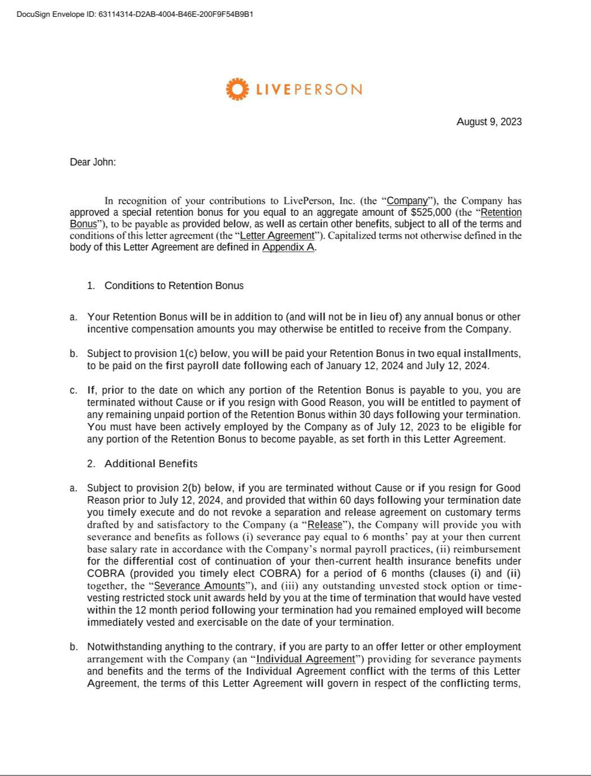

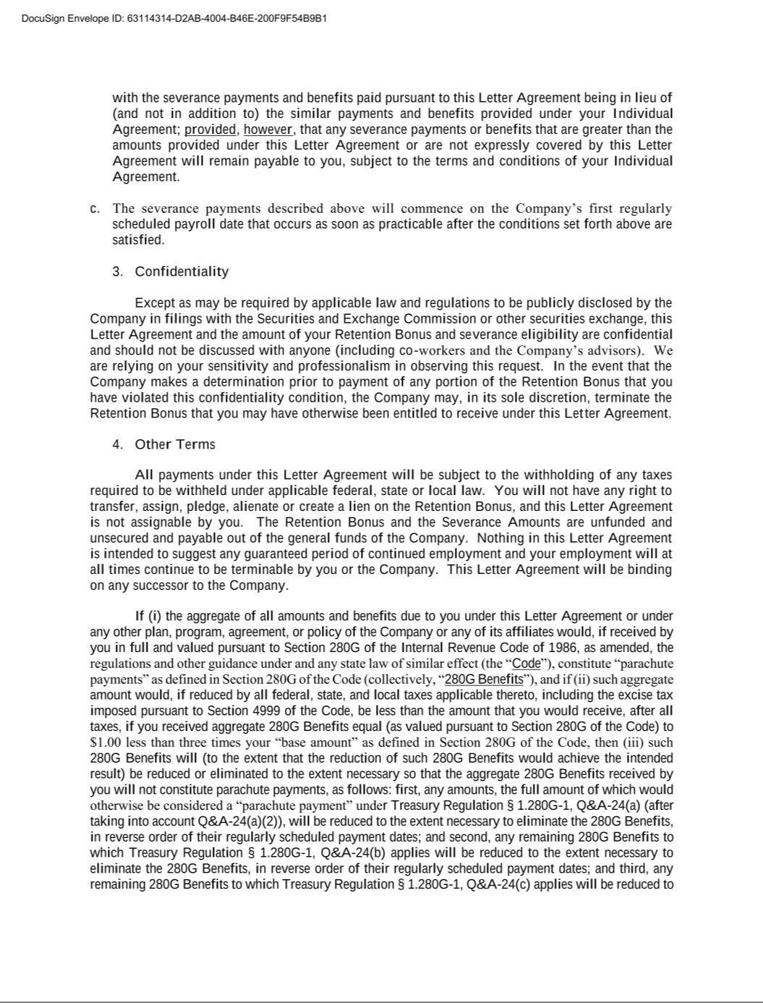

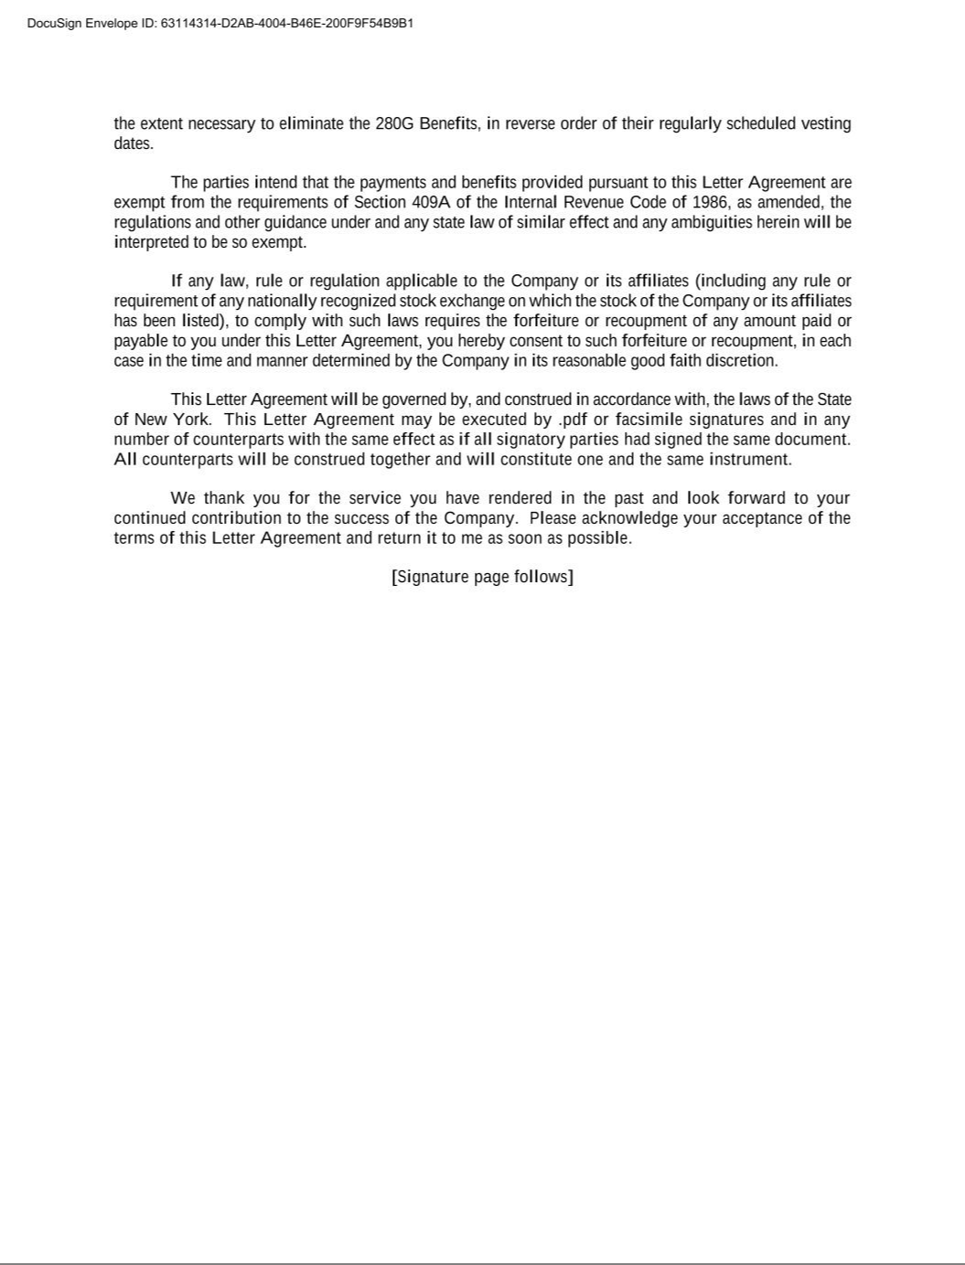

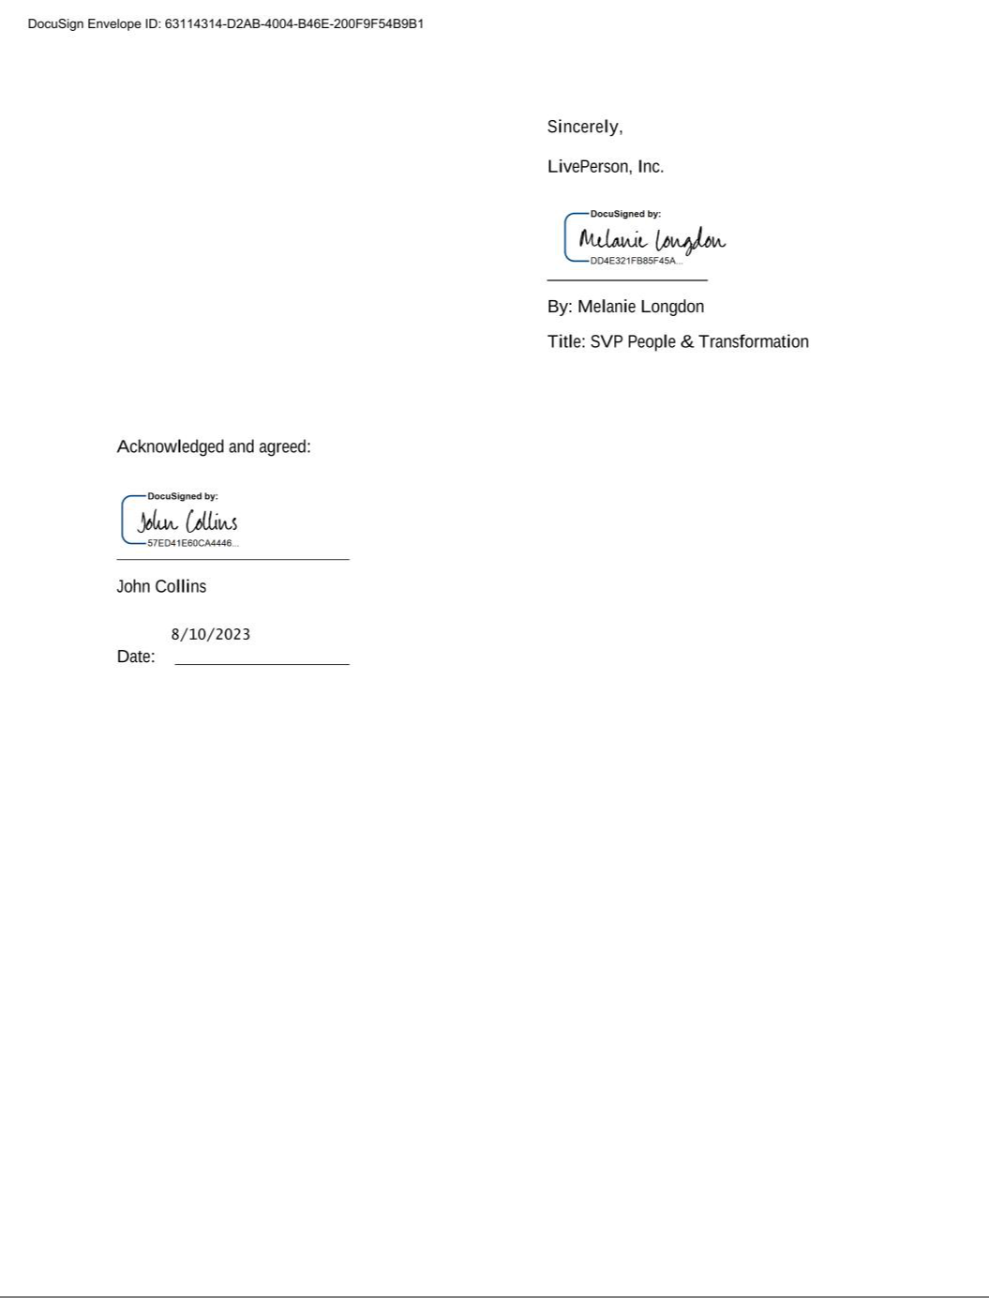

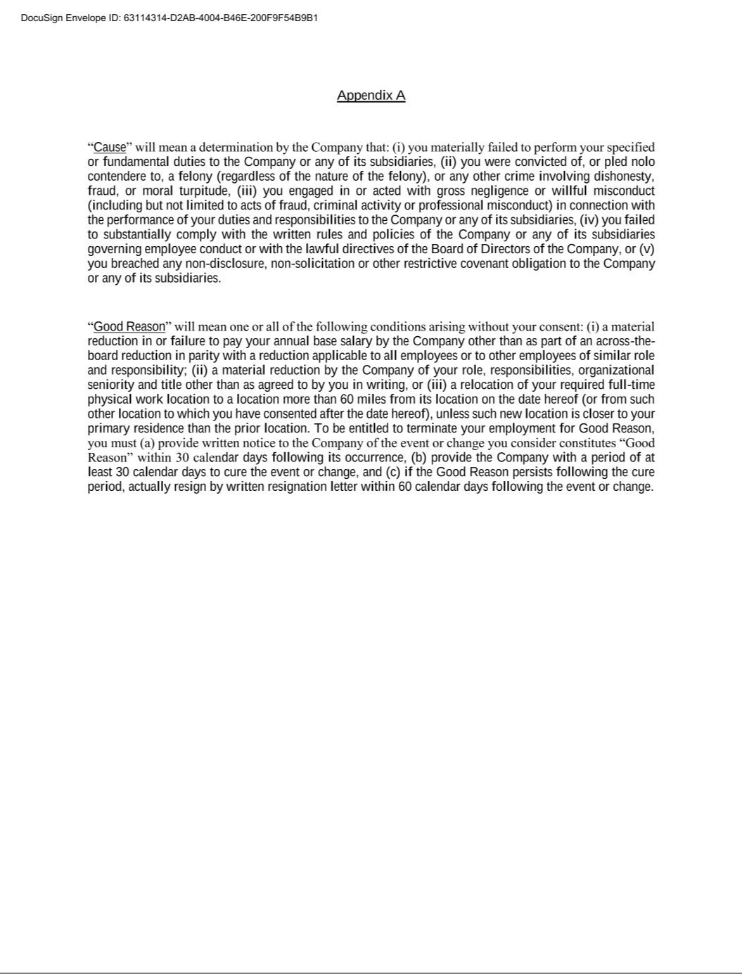

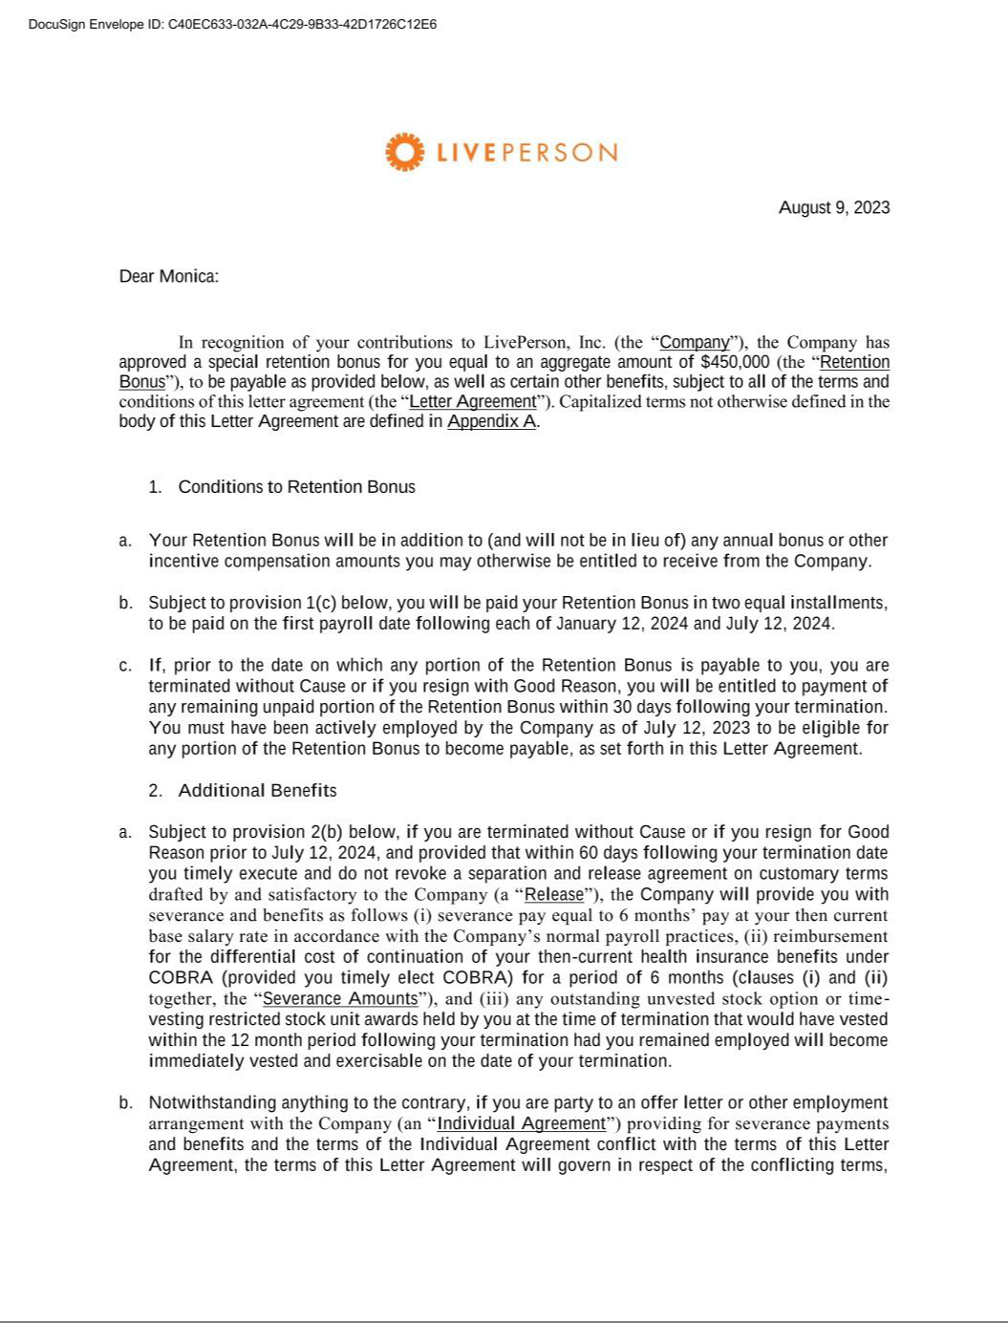

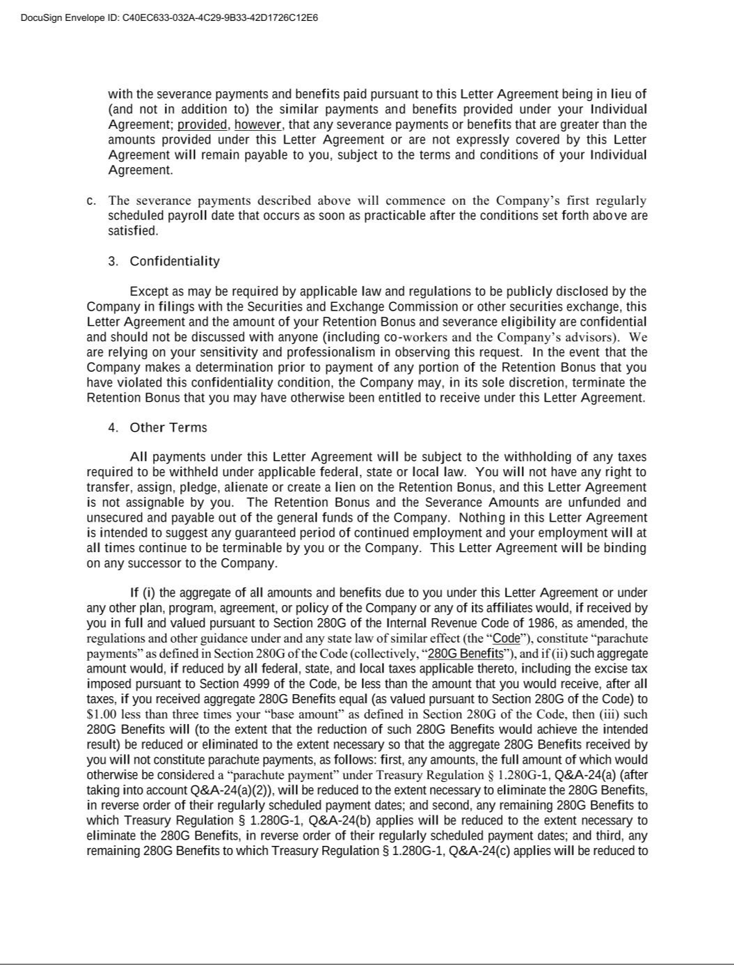

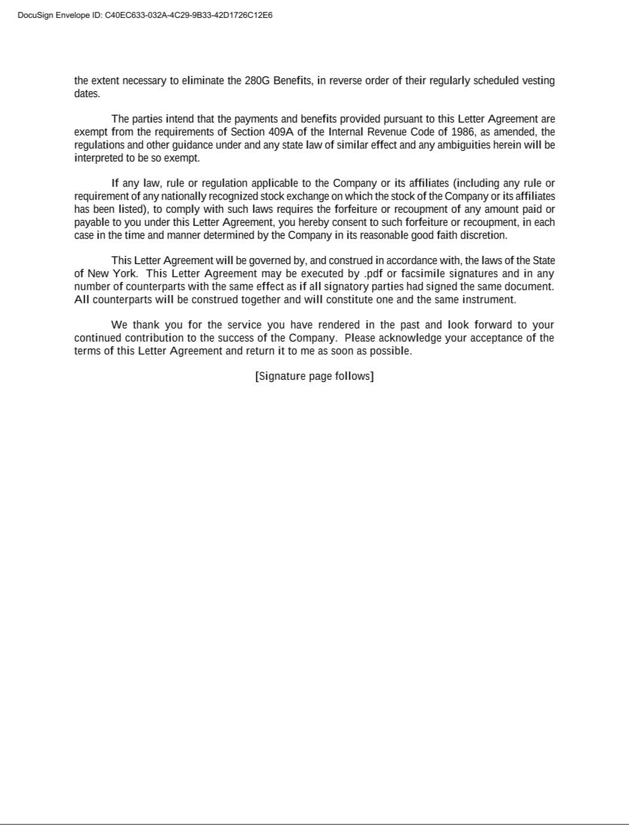

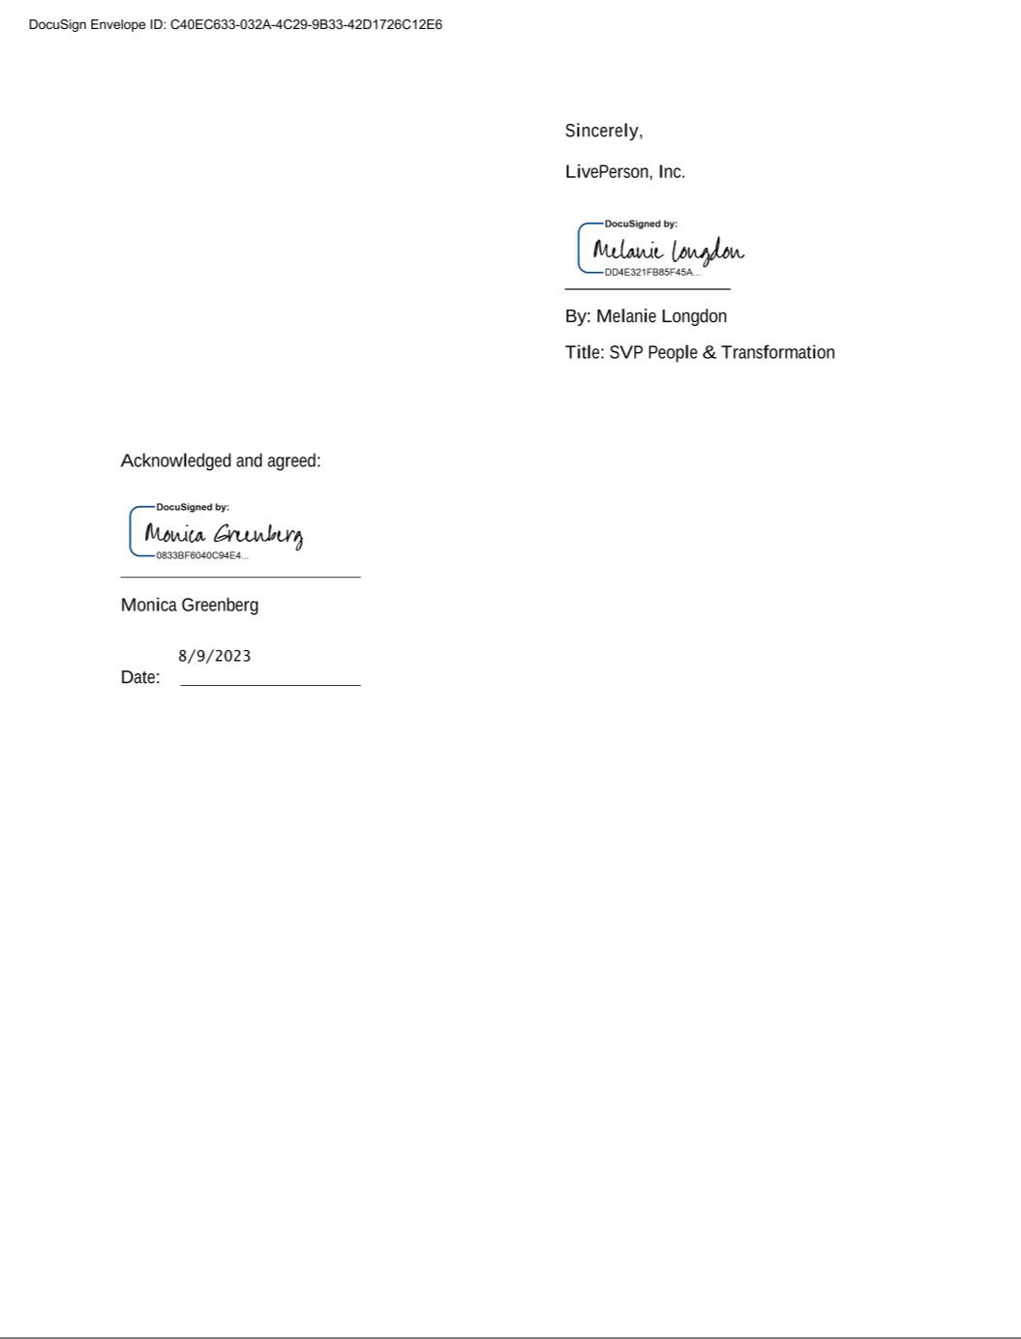

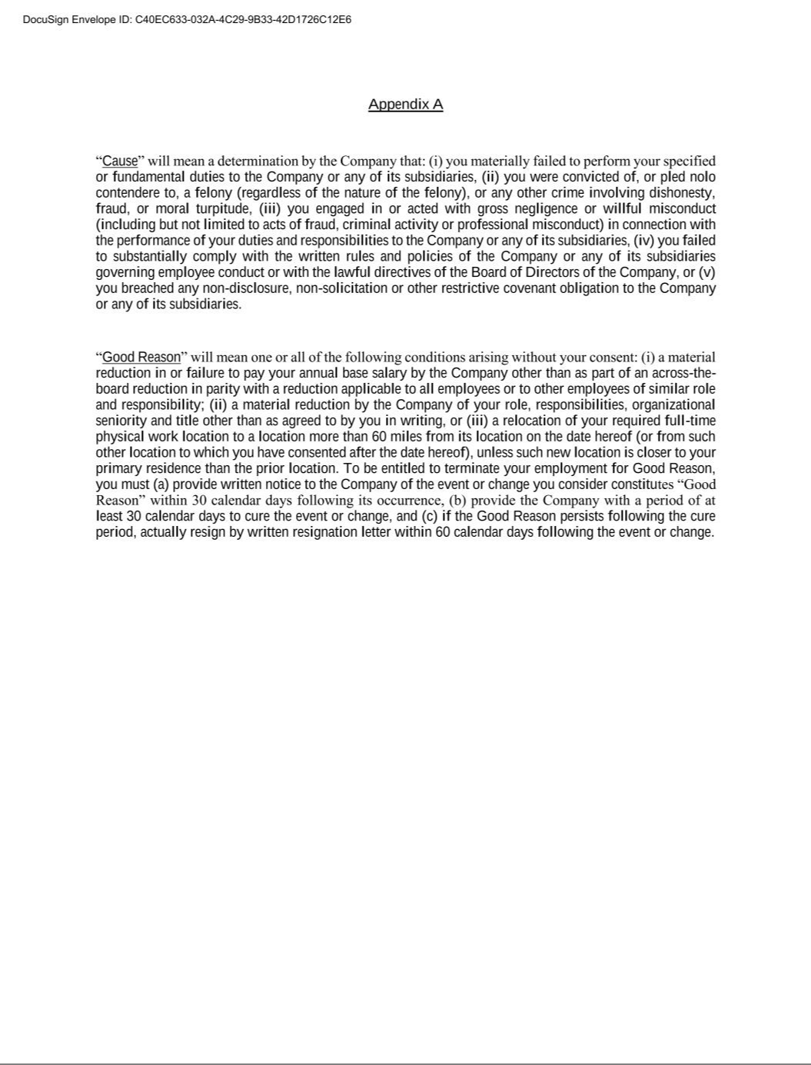

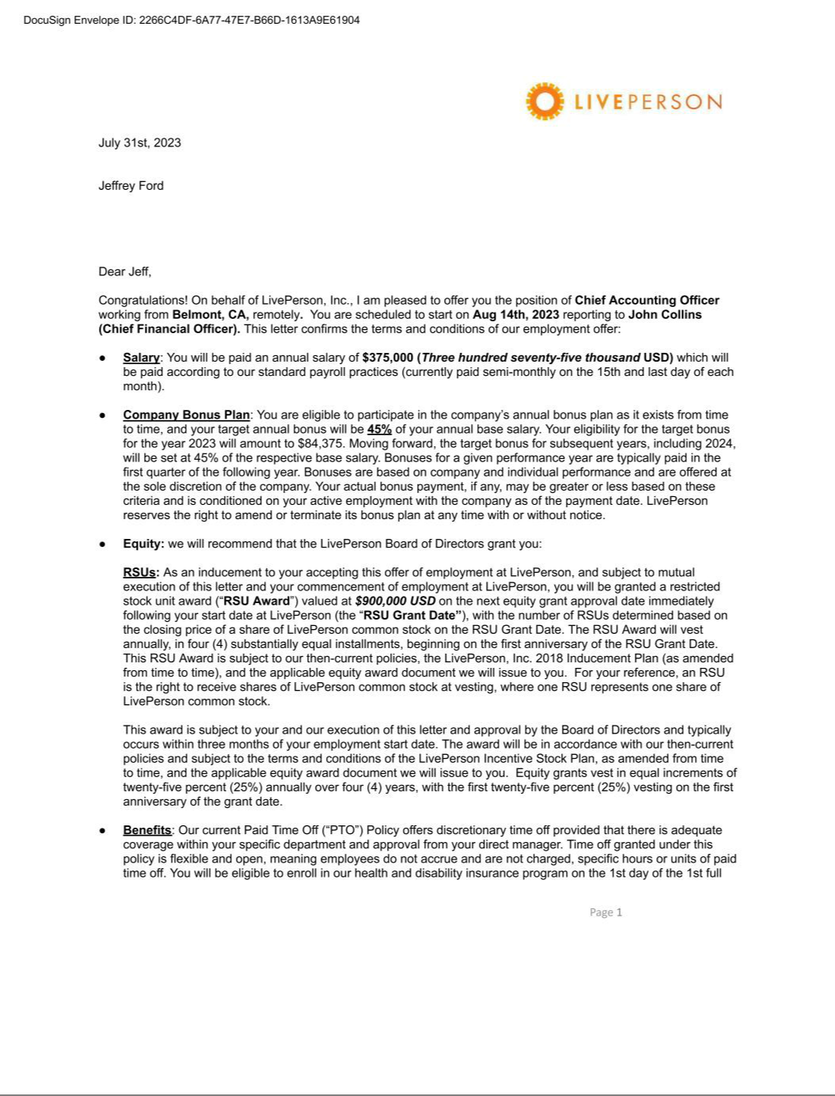

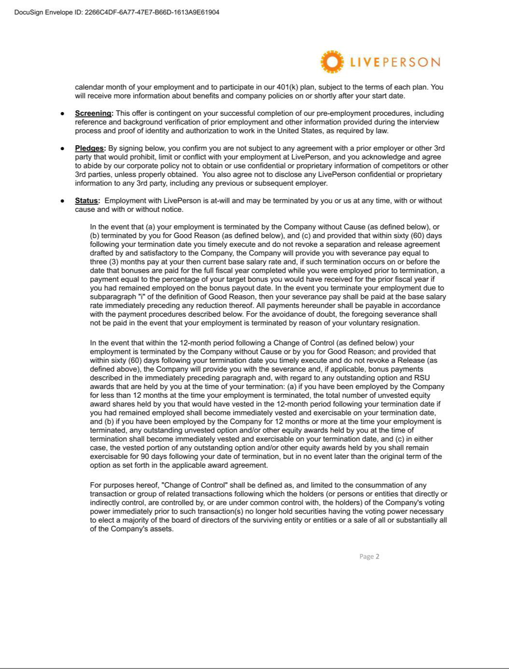

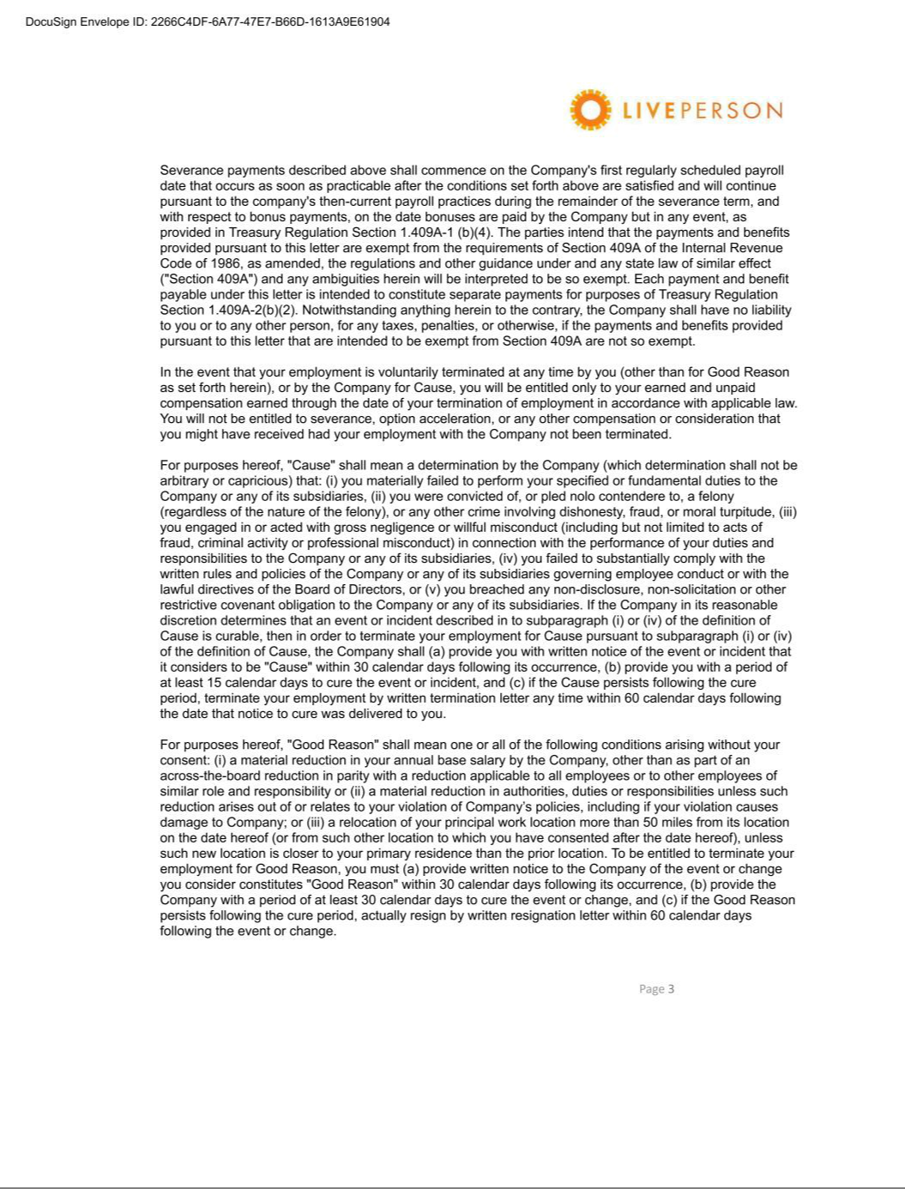



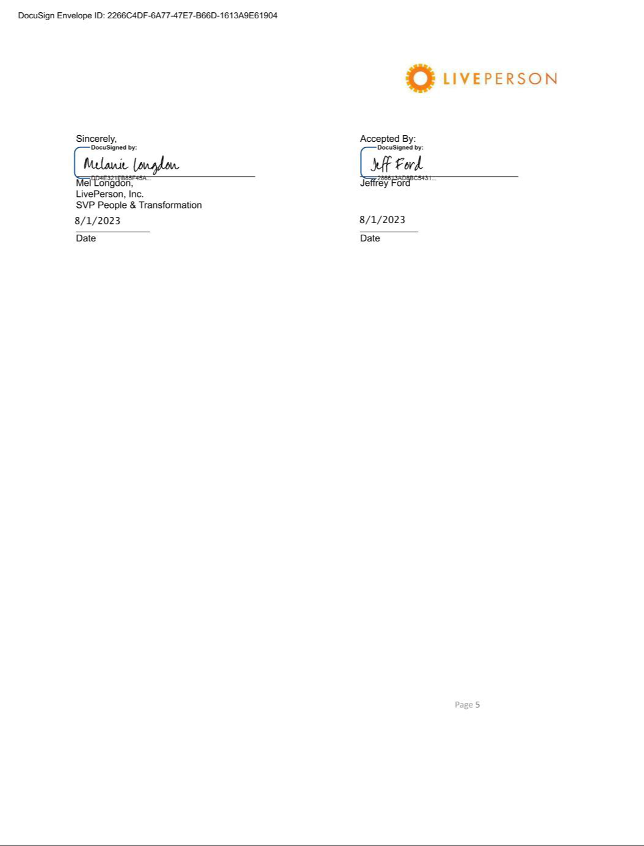

Exhibit 31.1

CERTIFICATIONS

I, John Collins, certify that:

- I have reviewed this Quarterly Report on Form 10-Q of LivePerson, Inc.;

- Based on my knowledge, this report does not contain any untrue statement of a material fact or omit to state a material fact necessary to make the statements made, in light of the circumstances under which such statements were made, not misleading with respect to the period covered by this report;

- Based on my knowledge, the financial statements, and other financial information included in this report, fairly present in all material respects the financial condition, results of operations and cash flows of the registrant as of, and for, the periods presented in this report;

- I am responsible for establishing and maintaining disclosure controls and procedures (as defined in Exchange Act Rules 13a-15(e) and 15d-15(e)) and internal control over financial reporting (as defined in Exchange Act Rules 13a-15(f) and 15d-15(f)) for the registrant and have:

- Designed such disclosure controls and procedures, or caused such disclosure controls and procedures to be designed under my supervision, to ensure that material information relating to the registrant, including its consolidated subsidiaries, is made known to us by others within those entities, particularly during the period in which this report is being prepared;

- Designed such internal control over financial reporting, or caused such internal control over financial reporting to be designed under my supervision, to provide reasonable assurance regarding the reliability of financial reporting and the preparation of financial statements for external purposes in accordance with generally accepted accounting principles;

- Evaluated the effectiveness of the registrant’s disclosure controls and procedures and presented in this report my conclusions about the effectiveness of the disclosure controls and procedures, as of the end of the period covered by this report based on such evaluation; and

- Disclosed in this report any change in the registrant’s internal control over financial reporting that occurred during the registrant’s most recent fiscal quarter (the registrant’s fourth fiscal quarter in the case of an annual report) that has materially affected, or is reasonably likely to materially affect, the registrant’s internal control over financial reporting; and

- I have disclosed, based on my most recent evaluation of internal control over financial reporting, to the registrant’s auditors and the audit committee of the registrant’s board of directors (or persons performing the equivalent functions):

- All significant deficiencies and material weaknesses in the design or operation of internal control over financial reporting which are reasonably likely to adversely affect the registrant’s ability to record, process, summarize and report financial information; and

- Any fraud, whether or not material, that involves management or other employees who have a significant role in the registrant’s internal control over financial reporting.

Date: | November 9, 2023 | By: | /s/ John Collins
 |  | Name: | John Collins
 |  | Title: | Interim Chief Executive Officer and Chief Financial Officer (Principal Executive Officer
 |  |  | and Principal Financial Officer)

Exhibit 32.1

CERTIFICATION PURSUANT TO

18 U.S.C. SECTION 1350,

AS ADOPTED PURSUANT TO

SECTION 906 OF THE SARBANES-OXLEY ACT OF 2002

I, John Collins, Interim Chief Executive Officer and Chief Financial Officer of LivePerson, Inc. (the “Company”), certify, pursuant to 18 U.S.C. Section 1350, as adopted pursuant to Section 906 of the Sarbanes-Oxley Act of 2002, that:

- the Quarterly Report of the Company on Form 10-Q for the period ended September 30, 2023, as filed with the Securities and Exchange Commission (the “Report”), fully complies with the requirements of Section 13(a) or 15(d) of the Securities Exchange Act of 1934; and

- the information contained in the Report fairly presents, in all material respects, the financial condition and results of operations of the Company.

Date: | November 9, 2023 | By: | /s/ John Collins
 |  | Name: | John Collins
 |  | Title: | Interim Chief Executive Officer and Chief Financial Officer (Principal Executive
 |  |  | Officer and Principal Financial Officer)

This certification shall not be deemed “filed” for purposes of Section 18 of the Securities Exchange Act of 1934, or otherwise subject to the liability of that section, nor shall it be deemed to be incorporated by reference into any filing under the Securities Act of 1933 or the Securities Exchange Act of 1934, except to the extent the Company specifically incorporates it by reference.

