UNITED STATES
SECURITIES AND EXCHANGE COMMISSION
Washington, D.C. 20549

SCHEDULE 14A
PROXY STATEMENT PURSUANT TO SECTION 14(a) OF THE
SECURITIES EXCHANGE ACT OF 1934

Filed by the Registrant ☒
Filed by a party other than the Registrant ☐
Check the appropriate box:

☐ | Preliminary Proxy Statement

☐ | Confidential, for Use of the Commission Only (as permitted by Rule 14a-6(e)(2))

☐ | Definitive Proxy Statement

☒ | Definitive Additional Materials

☐ | Soliciting Material Under §240.14a-12
LIVEPERSON, INC.
(Name of Registrant as Specified In Its Charter)
(Name of Person(s) Filing Proxy Statement, if other than the Registrant)
Payment of Filing Fee (Check all boxes that apply):

☒ | No fee required

☐ | Fee paid previously with preliminary materials

☐ | Fee computed on the table in exhibit required by Item 25(b) per Exchange Act Rules 14a-6(i)(1) and 0-11


For more information, please scan this code or visit www.proxyvote.com

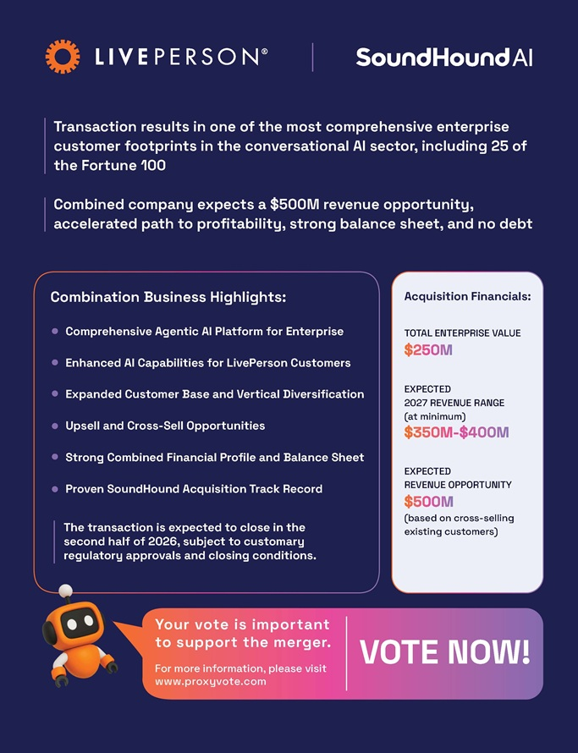
Transaction results in one of the most comprehensive enterprise customer footprints in the conversational AI sector, including 25 of the Fortune 100 Combined company expects a $500M revenue opportunity, accelerated path to profitability, strong balance sheet, and no debt Combination Business Highlights: Acquisition Financials: Comprehensive Agentic AI Platform for Enterprise TOTAL ENTERPRISE VALUE Enhanced AI Capabilities for LivePerson Customers Expanded Customer Base and Vertical Diversification EXPECTED 2027 REVENUE RANGE (at minimum) Upsell and Cross-Sell Opportunities Strong Combined Financial Profile and Balance Sheet EXPECTED Proven SoundHound Acquisition Track Record REVENUE OPPORTUNITY (based on cross-selling The transaction is expected to close in the existing customers) second half of 2026, subject to customary regulatory approvals and closing conditions. Your vote is important to support the merger. For more information, please visit www.proxyvote.com

